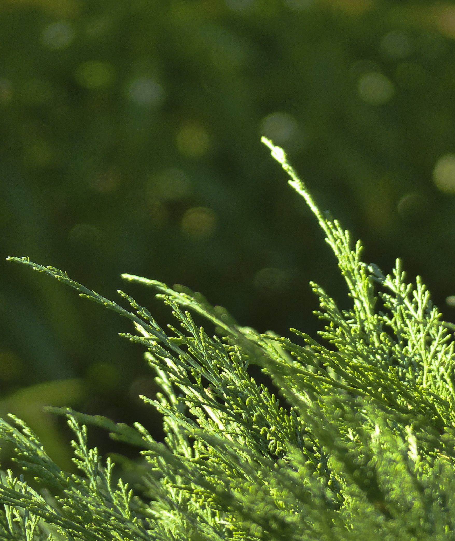

IT’S TIME

Indigenous Tools and Strategies on Tobacco: Interventions, Medicines   
and Education

A First Nations-specific toolkit for   
commercial tobacco cessation

**Helper’s Resources**



List of Resources

|  |  |
| --- | --- |
| Title | Page |
| Sign in Sheet | 3 |
| Evaluation of Sessions | 4 |
| Icebreaker Resource | 6 |
| Fact Sheet on Traditional Tobacco | 9 |
| Making a Traditional Tobacco Tie | 11 |
| Readiness Ruler | 12 |
| Decisional Balance Tool | 13 |
| Puzzle Pieces | 14 |
| Traditional Activities | 15 |
| Western-based Activities | 16 |
| Learning More about Commercial Tobacco Cessation Medication: Answer Key | 18 |
| What is the Medicine Wheel? | 21 |
| Automatic Thought Record | 22 |
| Certifications of Completion | 23 |

# Sign in Sheet

Session 1 2 3 4 5 6 (*circle one*)

Location: _______________________ Date: __________________________

|  |  |  |  |
| --- | --- | --- | --- |
|  | **Last Name** | **First Name** | **Contact Information**  **(if required)** |
| **1** |  |  |  |
| **2** |  |  |  |
| **3** |  |  |  |
| **4** |  |  |  |
| **5** |  |  |  |
| **6** |  |  |  |
| **7** |  |  |  |
| **8** |  |  |  |
| **9** |  |  |  |
| **10** |  |  |  |
| **11** |  |  |  |
| **12** |  |  |  |
| **13** |  |  |  |
| **14** |  |  |  |
| **15** |  |  |  |

# Evaluation of Sessions

Circle 1 2 3 4 5 6 (*circle one)*

Date: _______ /______ /________

Please help us improve our program by answering some questions about the circle you attended. We are interested in your honest opinions, whether they are positive or negative. We also welcome your comments and suggestions.

*Please circle your responses:*

1. **How would you rate your facilitator for this circle?**

Excellent Good Fair Poor

1. **Was the information discussed in the circle helpful to you?**

Yes, definitely Yes, generally No, not really No, definitely not

1. **Has this circle helped you to think about changing your commercial tobacco use?**

Yes, definitely Yes, generally No, not really No, definitely not

1. **Has attending the circle helped you to feel supported in quitting or reducing?**

Yes, definitely Yes, generally No, not really No, definitely not

1. **How helpful did you find this circle?**

Extremely helpful Very helpful Somewhat helpful Not at all helpful

**What did you like about the circle?**

Please turn over

**What did you not like about the circle?**

**What would you like to see next time in the circle?**

**Other comments?**

**Thank you for taking the time to complete this questionnaire.**

# Icebreaker Resource

The following table outlines icebreakers you may consider using to help participants in your circles to get to know one another.

|  |  |  |
| --- | --- | --- |
| **Name** | **Instructions** | **Resources** |
| *Toilet Paper Game* | * Take a roll of toilet paper and ask the participant how many squares they want, but don't tell them why. Set a limit from 5 to 10. * Count out the squares, rip after the last square and give all of the squares to the participant. * Repeat until all the participants have their desired amount. * Then go around and have each person share something about themselves for each square until they are finished. | Roll of toilet paper |
| *Draw Yourself!* | * Give each participant a piece of paper and a writing utensil. * Ask each person to draw themselves with their non-dominant hand while closing their eyes. * Once participants have finished drawing themselves, ask them to introduce themselves and share their drawing with the group. | Paper and something to write with |
| *Never Have I Ever* | * Begin the game by having the participants sit in a circle, with enough chairs for all but one player. * The first player stands in the center of the circle and says a simple statement beginning with, “Never have I ever. . .” * Now it is time to get up and change chairs. Anyone who has done whatever the first player says they have not done must find a new seat, along with the person in the middle. * One person will be left without a seat. This individual takes the place in the middle of the circle also tells something they have never done. * Play continues, with each person coming up with a new “Never have I ever . . .” phrase. | No resources required |
| *Two Truths and a Lie* | * Ask all players to arrange themselves in a circle. Instruct each player to think of three statements about themselves. Two must be true statements, and one must be false. * For each person, he or she shares the three statements (in any order) to the group. * The goal of the icebreaker game is to determine which statement is false. * The group votes on which one they feel is a lie, and at the end of each round, the person reveals which one was the lie. | No resources required |
| *Acting Out* | * Invite participants to quietly move around the room and await your instructions. As they are walking the leader calls out the name of a sport or activity. * When they hear the name they must stop immediately and hold a still ‘freeze frame’ illustrating or acting out the sport or action. | No resources required |
| *Catch Me if You Can* | * Have a stress ball (or rubber chicken or something funny) and throw it across the room calling out the participant’s name. * That person then throws the ball to another person calling out their name until everyone’s name has been called out. * This helps everyone remember each other’s name and usually results in some laughter if the item being thrown is unusual. | An item to throw around that is light and can be caught (e.g. stress ball) |
| *Sharing our Gifts* | * Pass around a wrapped gift box. * As each person holds the box they are to identify the gift that they would give to the person next to them and they can put anything in the box that they want. * Start with yourself as the facilitator to model the request. For instance as the facilitator you might say, “Sarah, I am giving you the gift of courage.” And pass the container to Sarah. * Sarah then provides her affirmation and passes it to the next member of the circle. | A wrapped gift box |
| *Getting to Know You* | * Give each participant a piece of paper and a writing utensil. * Ask them to write or draw something that they feel represents them, their passion, or that is meaningful to them (e.g., an animal, their children, a word that describes them, an activity). * Once everyone has finished writing or drawing, ask them to share what they put down on the paper with the group. | Paper and something to write with |

**Fact Sheet on Traditional Tobacco**

1. Tobacco has been used in Indigenous communities for thousands of years before contact with Europeans and the rise of recreational smoking. Tobacco was grown and cultivated with other natural herbs such as sweet grass and lavender.
2. Not all Indigenous Peoples across Canada use tobacco as a traditional, sacred part of their culture. This is because of the differences in culture, climate and geography. Plant products such as willow bark, sweet grass, cedar and sage were smoked in pipes and used instead of tobacco by some nations. The Inuit do not recognize tobacco as a sacred medicine.
3. There are two varieties of tobacco:
   * Nicotania rustica or Indian Tobacco – traditional
   * Nicotania tabacum or commercial tobacco - non-traditional
4. Traditional tobacco was:
   * cultivated separately from other crops
   * burnt over the fire
   * thrown on water
   * left on the ground
   * smoked in a pipe either by an individual or passed around a circle of people
   * chewed
5. Generally, traditional tobacco or the above substitutes were an important component of Indigenous cultures in two main aspects:

* Ceremonial
  + communication with the spirits (smoke)
  + thanking the Creator
  + praying for a good harvest or better fish catch
  + rites of passage ceremonies (birth, weddings, funerals)
  + sealing the peace with enemies (pipe)
* Medicinal
  + To treat earaches and snakebites
  + To purify the mind and heal the body.

1. Some nations have a “pipe carrier”, a special medicine person who uses tobacco the traditional way to communicate with the Creator.
2. Today, traditional tobacco is still regarded as sacred by most Aboriginal groups and retains its spiritual and, in some cases, medicinal value. However, because tobacco has been a vital part of Indigenous culture for so long, its traditional use is sometimes given as a justification for smoking or chewing commercial tobacco. Such confusion can hinder efforts to reduce the consumption and deal with the harmful effects of non-traditional tobacco use.

*Adapted from: “Building and Sustaining Partnerships: A Resource Guide to Address Non- Traditional Tobacco Use”, prepared for the First Nation and Inuit Health Branch, Health Canada. October (2003).*

**Making a Traditional Tobacco Tie**

If you are using the activity *Making a Traditional Tobacco Tie* (page 20 of the *Helper’s Guide*), instructions have been provided below to guide the activity.

Before the Circle

**Step 1:** Gather traditional tobacco or additive-free loose tobacco. Traditional tobacco can be purchased from Mother Earth Tobacco (<http://motherearthtobacco.com>), some First Nations gift shops or craft stores, and/or may be available in a community garden.

**Step 2:** Buy broad cloth from a fabric store. The colour of the fabric can be red, yellow, white, green, purple, or blue.

During the Circle

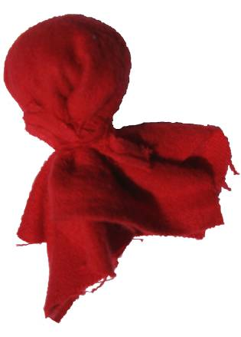**Step 3:** To assemble tobacco ties, ask participants to cut a piece of fabric into a square (approximately 4 x 4 inches). In the centre of the square piece of cloth, ask participants to put a small amount of traditional tobacco. Fold the ends of the cloth together and tie the tobacco with a piece of yarn or twine. If yarn or twine is not available, participants can use a strip of the fabric to close the tie. Tobacco ties will look like the visual included below:

While participants are putting together their tie, ask them to think about what this tie means to them. Will they use the tie as an offering to an Elder or in prayer? Ask them to remember to have good thoughts while they prepare the tie.

# Traditional Activities

The following table outlines some traditional activities you may consider implementing as part of your programming.

**Considerations:** If you are facilitating a traditional art-, bush- or water-based activity there are a number of considerations you will need to think about before offering the activity. Review this checklist to see if offering this activity will be feasible within your community and setting:

* Does your organization have the funds needed to provide the materials (e.g., hunting equipment, materials for beading, etc.)?
* Is there an Elder, knowledge keeper, or community member that can co-lead the activity with you and offer teachings?
* If you decide to go into the bush, can you provide transportation? Is the area for hunting or fishing easily accessible?
* How time intensive is the activity? You may need to offer over a full circle or over a series of circles. Repetition is often the key to supporting a positive healing journey.
* Does your group want to incorporate traditional ways to support their health and healing? Or would they prefer a Western-based approach?

|  |  |  |
| --- | --- | --- |
| **Types of Activities** | | |
| **Art-based Activities** | **Bush- or Water-based Activities** | **Ceremony** |
| * Singing * Storytelling * Drumming * Beadwork * Craft-making * Dancing * Drawing * Stenciling * Crocheting * Knitting * Photography * Making jewelry | * Hunting * Trapping * Fishing * Cooking traditional foods * Spending time in the bush * Going for walks or climbing hills * Medicine walk (identifying and gathering medicines) | * Smudging with sacred medicines and prayer * Fasting * Going to a sweat |

# Western-based Activities

The following table outlines some Western-based activities you may consider implementing as part of your programming.

**Considerations:** If you are facilitating one of the activities above there are some considerations you will need to think about before offering the activity. Review this checklist to see if offering this activity will be feasible within your community and setting:

* Does your organization have the funds needed to provide the materials (e.g., journals, resources needed for the chosen physical activity, etc.)?
* If you decide to engage in physical activity, can all members of the group safely participate?
* How time intensive is the activity? You may need to offer over a full circle or over a series of circles. Repetition is often the key to supporting a positive healing journey.
* Does your group want to incorporate Western-based ways to support their health and healing? Or would they prefer a traditional approach?

|  |  |
| --- | --- |
| **Types of Activities** | **Resources Required** |
| **Physical Activity** | |
| * Walking and tracking daily steps * Yoga/stretching * Hiking * Resistance/strength training * Running/jogging * Swimming * Curling * Tobogganing * Working in a garden * Cross country skiing * Snow shoeing * Dancing * Team sports (e.g., basketball, floor hockey, soccer, volleyball, baseball, dodgeball, Ultimate Frisbee, etc.) * Taking the stairs | * Pedometer and running shoes * Towel or yoga mat * Running or hiking shoes * Resistance bands * Running shoes * Access to pool and swimsuits * Access to curling club * Access to hills and sleds * Community garden and tools * Cross country skis * Snow shoes * Music * Access to community gym and relevant equipment |
| **Journaling** | |
| * Recounting daily events * Writing out thoughts * Expressing gratitude * Tracking eating and exercise * Exploring spirituality | * Notebooks and pens |
| **Relaxation and Mindfulness** | |
| * Guided relaxation * Breathing techniques * Progressive muscle relaxation * Body scan * Grounding * Creative visualization/imagery | Free resources:   * <https://www.calm.com/> * <http://marc.ucla.edu/mindful-meditations> * <http://herohealthroom.com/2014/12/08/free-guided-meditation-resources/> * <http://www.freemindfulness.org/download> |

# **What is the Medicine Wheel?**

The Medicine Wheel has many different meanings for First Nations and Métis peoples. For some, it can symbolize cycles of nature, the interconnections of all forms of life or the circular journey of human lives (University of Ottawa, 2009). The four quadrants in our representation of the Medicine Wheel (see below) refer to the four parts of a person, their health, and well-being – physical, mental, emotional, and spiritual.

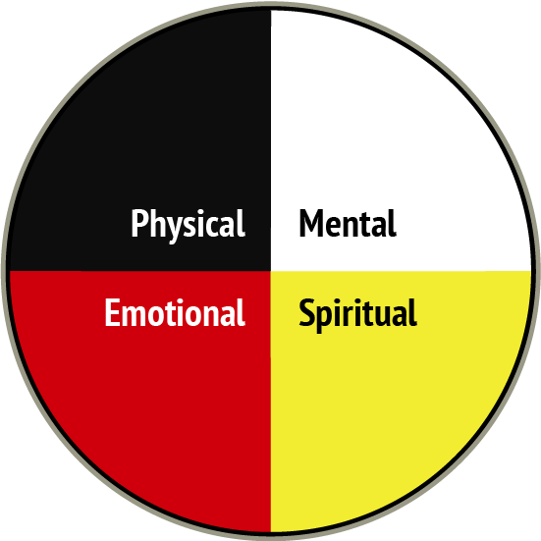

Traditional healers have said than an imbalance in any of the four quadrants, can affect one’s decisions which may lead to negative outcomes (University of Ottawa, 2009). It is important to note that the Medicine Wheel and its teachings are not relevant to all First Nations and Métis. For instance, the version provided in this toolkit includes colours traditional to the Algonquin people’s Medicine Wheel (yellow, red, black, and white).

For more information about the Medicine Wheel, refer to the following resources:

* Native Women’s Centre: <http://www.nativewomenscentre.com/files/Traditional_Teachings_Booklet.pdf>
* University of Regina: <https://www.uregina.ca/science/biology/people/faculty-research/gendron-fidji/documents-fidj/Medicine-Wheel-Booklet.pdf>

# True or False – Learning More about Commercial Tobacco Cessation Medication: *Answer Key*

|  |  |  |
| --- | --- | --- |
| **Statement** | **True or False?** | **Rationale** |
| 1. Nicotine is the harmful substances in cigarettes. | False | * Carbon monoxide and carcinogens cause harm, not nicotine * There are 60 cancer-causing chemicals in cigarette smoke; nicotine is not one of them * Nicotine is the addictive component in cigarette smoke |
| 1. Nicotine addiction is equally likely whether the nicotine comes from cigarettes, nicotine patch, gum, lozenge or inhaler. | False | * Cigarettes are far more addictive than nicotine replacement, primarily because of how they deliver nicotine. |
| 1. Nicotine Replacement Therapy (NRT) is a safe and clean delivery system of nicotine | True | * Provides the body with nicotine to help minimize withdrawal symptoms and cravings * Does not contain the toxins one gets from cigarettes * Shown to almost double quit rates * Most effective when combined with counselling or a support group * NRT is safer than smoking * NRT gum used for up to 5 years was not associated with increased hospitalization due to cardiovascular disease |
| 1. Smoking while on the NRT patch increases the risk of a heart attack. | False | * People tend to blame NRT for heart attacks. However, the heart attack was most likely caused by something else, such as years of smoking, poor diet and unhealthy lifestyle. |
| 1. NRT should not be used at the same time or in combination with Zyban® (bupropion) (*Zyban is another smoking cessation medication*) | False | * NRT and Zyban work differently * They can be used together or alone * Zyban is available by prescription only * Consult with your doctor |
| 1. Pregnant women should never use NRT | False | * NRT is safer for the fetus than smoking, and is appropriate for pregnant women who are unable to quit using behavioural interventions. |
| 1. People under age 18 can use NRT | True | * Most daily smokers begin smoking before age 18, and are already getting nicotine from cigarettes. * NRT should be considered for youth who are regular smokers who are unable or unwilling to quit using behavioural interventions. |
| 1. People using NRT can take more than what is recommended on the medication package. | True | * People who use heavy levels of commercial tobacco will likely benefit from higher doses of NRT as well as combination NRT. * The standard dosing for NRT may not work in clients with heavy commercial tobacco use and then they will feel the effects of withdrawal. |
| 1. NRT should only be used for a short time | False | * NRT should be used for as long as needed to maintain or prolong commercial tobacco abstinence. |
| 1. NRT should not be used by people who just want to cut down on the number of cigarettes they smoke. | False | * Nicotine replacement can be used by people who are not ready to quit as a way to reduce their smoking, and progress towards a longer-term goal of abstinence. |