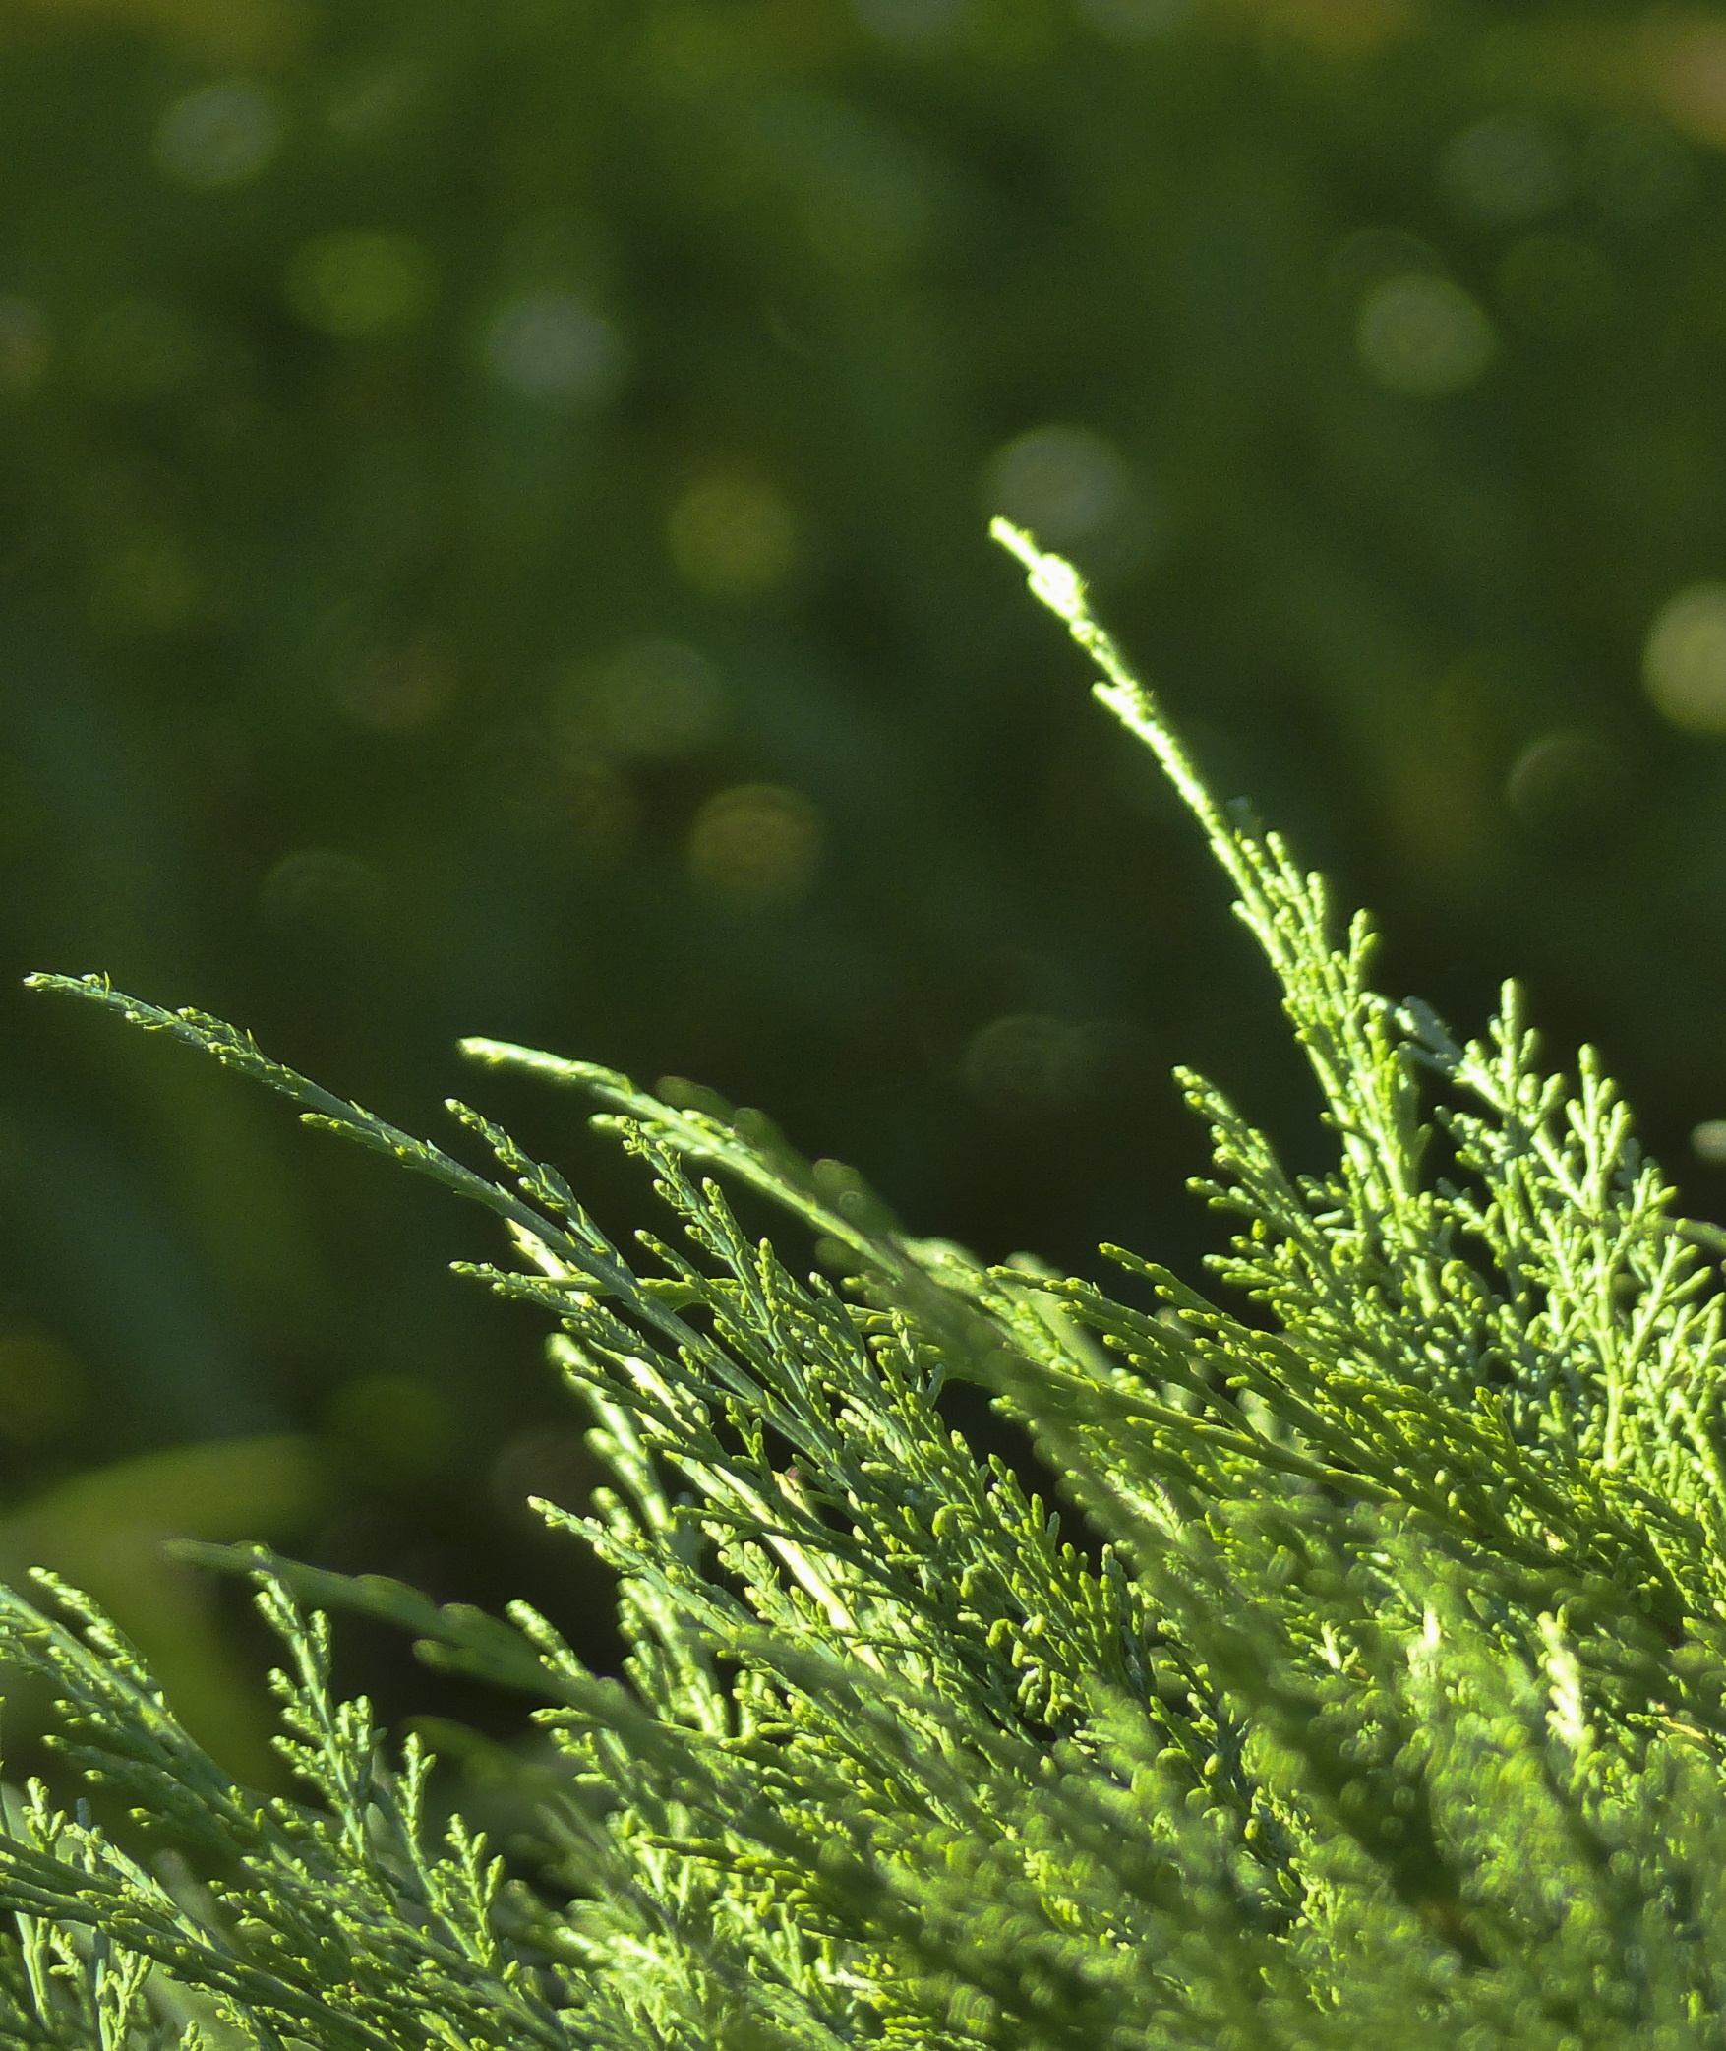

Helper’s Condensed Guide

IT’S TIME

Indigenous Tools and Strategies on Tobacco: Interventions, Medicines   
and Education

A First Nations-specific toolkit for   
commercial tobacco cessation

# Circle 1: Tobacco Use from Past to Present *(Pages 14 – 24 in Helper’s Guide)*

## Opening and Welcome (10 minutes)

Lead the group in an opening prayer or welcome participants to the circle. If an Elder, knowledge keeper or community member has been invited to participate, they may want to open the circle.

## Creating Group Guidelines (15 minutes)

**Goal:** Establish format and procedures (i.e., opening and closing protocols, guidelines)

* *Looking to Our Values*: Using community-specific values as a guide, collaboratively discuss guidelines for the circles.
* *Preparing for Our Journey*: Ask the participants to fill their canoe (or other relevant means of travel) with items they would like to bring with them on their journey through the circles (e.g., openness). Ask the participants to leave behind the items they would not like to bring with them on their journey through the circles (e.g., judgement).

## 

## Getting to Know You (15 minutes)

**Goal:** Group member introductions and emphasize role of group support for a common goal

* *Sharing Your Tobacco Story*: Invite participants to introduce themselves and share with the group their tobacco story.
* *Choose an Icebreaker*: Refer to *Helper’s Resources* for a list of icebreaker activities.

## The Sacredness of Traditional Tobacco (20 minutes)

**Goal:** Honouring traditional tobacco

* *Teachings on Traditional Tobacco*: Invite an Elder, knowledge keeper, or community member to share the teachings on traditional tobacco.
* *Making a Traditional Tobacco Tie*: Share teachings on traditional tobacco while asking participants to make their own tobacco tie (refer to *Helper’s Resources* for instructions).

## Impact of Commercial Tobacco (20 minutes)

**Goal:** History and impact of commercial tobacco in First Nations communities

* *Sharing the History and Impact of Commercial Tobacco Use*: Invite an Elder, knowledge keeper, or community member to share the history and impacts of tobacco on First Nations communities.
* *What does a Tobacco Cessation or Reduction Journey Look Like?*: Invite an Elder, knowledge keeper, or community member who has quit or reduced their commercial tobacco use to share what their experience was like.

## 

## Keeping Track of Your Journey (5 minutes)

**Goal:** Introduce importance of tracking a commercial tobacco cessation or reduction journey

* *Reviewing Tracking Sheets*: Give each participant a copy of the *Tracking Sheets* or ask them to turn to page 5 in their participant booklet. Review with participants the rationale behind tracking their commercial tobacco use.
* *There’s an app for that!*: Give each participant a copy of the *List of Apps* or ask them to turn to page 10 in their participant booklet. Review with participants the rationale behind tracking their commercial tobacco use.

## 

## Wrap-up and Closing (5 minutes)

As part of the closing, reiterate the opening words of welcome. Thank the group for having the courage to participate. End with a closing prayer (if applicable) or other good wishes.

# Circle 2: Exploring Your Commercial Tobacco Reduction or Cessation Journey *(Pages 25– 37 in Helper’s Guide)*

## Opening and Welcome (10 minutes)

Lead the group in an opening prayer or welcome participants to the circle. If an Elder, knowledge keeper or community member has been invited to participate, they may want to open the circle Lead the group in an icebreaker (refer to *Helper’s Resources*).

## Review from Circle 1 (10 minutes)

Revisit group guidelines and review the experience of tracking.

## 

## Exploring Your Journey (20 minutes)

**Goal:** Introduce the cognitive behavioural framework for assisting a commercial tobacco cessation or reduction journey

* *Exploring Readiness*: Give each participant a copy of the *Exploring Readiness* handout or ask them to turn to page 12 in their participant booklet. Ask participants to shade the areas of health and well-being that they would need to address in order to feel confident in reducing or quitting commercial tobacco use. Debrief.
* *Exploring Change*: Give each participant a copy of the *SWOC Analysis* handout or ask them to turn to page 13 in their participant booklet. Ask participants to write down their strengths, weaknesses, opportunities, and challenges as they relate to commercial tobacco reduction and cessation. Debrief.
* *How much is Commercial Tobacco Use Costing Me?*: Ask the group a general question about how much they think they spend on commercial tobacco per year. Have a brief discussion about how they came to that figure. Then ask each participant to calculate how much they spend on commercial tobacco in a year. Debrief.

## 

## Triggers and Coping Strategies (20 minutes)

**Goal:** Identify triggers for smoking and discuss coping strategies

* *Balancing Health and Well-being*: Give each participant a copy of the *Balancing Health and Well-being* handout or ask them to turn to page 14 in their participant booklet. Ask participants to write down their triggers to using tobacco and then identify a coping strategy for each. Debrief.
* *Piecing the Puzzle Together*: Ask participants to form groups of three. Give each group a full set of the puzzle pieces so they can put their puzzle together. As they work on the puzzle, ask them to talk about the triggers listed on each of the puzzle pieces and discuss coping strategies for each. Debrief.

## Making a Change (25 minutes)

**Goal:** Set first behavioural goal in preparation for tobacco cessation or reduction journey

* *Supporting Change*: As a group, discuss ways to support change at the individual, family and community level.
* *Starting the Journey*: Give each participant a copy of the *Making a Change* handout or ask them to turn to page 20 in their participant booklet. Ask participants to set a behavioural goal in preparation for commercial the tobacco use reduction or cessation. Debrief.

## Wrap-up and Closing (5 minutes)

As part of the closing, reiterate the opening words of welcome. Thank the group for having the courage to participate. End with a closing prayer (if applicable) or other good wishes.

# Circle 3: Preparing for the Commercial Tobacco Cessation or Reduction Journey *(Pages 38 – 49 in Helper’s Guide)*

## Opening and Welcome (10 minutes)

Lead the group in an opening prayer or welcome participants to the circle. If an Elder, knowledge keeper or community member has been invited to participate, they may want to open the circle Lead the group in an icebreaker (refer to *Helper’s Resources*).

## Review from Circle 2 (15 minutes)

Revisit group guidelines, review the behavioural goals set in the last circle, and review tracking sheets.

## Supporting Commercial Tobacco Cessation or Reduction (Part 1) (20 mins or longer)

**Goal:** Introduce commercial tobacco cessation or reduction strategies (psychosocial)

* *Culturally-specific Ways to Support Commercial Tobacco Cessation or Reduction*: Offer a traditional art-, bush- or water-based activity (refer to *Helper’s Resources*). Discussions around commercial tobacco use reduction or cessation can also be integrated throughout.
* *Western-based Approaches to Support Commercial Tobacco Cessation or Reduction*: Offer western-based approaches to health and wellness (refer to *Helper’s Resources*). Discussions around commercial tobacco use reduction or cessation can also be integrated throughout.
* *Traditional Ways to Address Stress*: Invite an Elder, knowledge keeper or community member to share teachings around the traditional ways community members handled stress or supported relaxation before commercial tobacco products were introduced.

## 

## Supporting Commercial Tobacco Cessation or Reduction (Part 2) (20 minutes)

**Goal:** Introduce commercial tobacco cessation or reduction strategies (pharmacological)

* *Discussing Medications for Commercial Tobacco Cessation*: Invite a prescriber to share information about medications for commercial tobacco cessation and reduction.
* *True or False – Learning More about Commercial Tobacco Cessation Medication*: Give each participant a copy of the *True or False – Learning More about Commercial Tobacco Cessation Medication* handout or ask them to turn to page 31 in their participant booklet. Complete the quiz as a group. Write down each of the responses on flip chart. Debrief responses.

## 

## Revisiting the Journey (20 minutes)

**Goal:** Developing/enhancing the cessation or reduction journey

* *Supporting Change*: Discuss with participants how quitting may impact other areas of life (e.g., substance use, mental health, physical activity, nutrition, etc.). Generate a list of areas participants would like to be mindful of and identify strategies or resources participants can turn to in order to feel supported.
* *Revisiting Your Journey*: Give each participant a copy of the *Making a Change (Part 2)* handout or ask them to turn to page 36 in their participant booklet. Ask participants to set a revised behavioural goal in preparation for commercial tobacco use reduction or cessation.

## Wrap-up and Closing (5 minutes)

As part of the closing, reiterate the opening words of welcome. Thank the group for having the courage to participate. End with a closing prayer (if applicable) or other good wishes.

# Circle 4: The Journey to Healing (Part 1) *(Pages 50 – 57 in Helper’s Guide)*

## Opening and Welcome (10 minutes)

Lead the group in an opening prayer or welcome participants to the circle. If an Elder, knowledge keeper or community member has been invited to participate, they may want to open the circle Lead the group in an icebreaker (refer to *Helper’s Resources*). Review guidelines from Circle 1.

## Sharing Your Experiences (30 minutes)

**Goal:** Discuss quit attempt experiences

* *How Quitting or Reducing Made Me Feel*: Spend some time exploring behavioural goals set during the previous circle. Using flip chart paper, map each of the participant’s journey’s using the visual of tree. Ask participants to share how they felt making a quit or reduction or attempt. As participants share, write their responses on the flip chart. Their past experiences can be written on the roots of the tree and their outcomes can be the leaves. Debrief.
* *Withdrawal from Quitting or Reducing*: Give each participant a copy of the *Withdrawal Symptoms* handout or ask them to turn to page 39 in their participant booklet. As a group, discuss the withdrawal symptoms listed and ask participants to add other withdrawal symptoms that are missing. As a group, come up with potential coping strategies. Debrief

## Revisiting Coping Strategies (25 minutes or longer)

**Goal:** Staying on the journey - develop/implement coping strategies

* *Culturally-specific Ways to Support Commercial Tobacco Cessation or Reduction*: Offer a traditional art-, bush- or water-based activity (refer to *Helper’s Resources*) as a coping strategy.
* *Western-based Approaches to Support Commercial Tobacco Cessation or Reduction*: Offer western-based approaches to health and wellness (refer to *Helper’s Resources*) as a coping strategy.
* *Revisiting Coping Strategies*: Revisit coping strategies identified in the second and third circle. Provide copies of the *Coping Strategies* handout or ask participants to turn to page 15in their participant booklets. Ask participants if they have used any of these coping strategies or identified additional coping strategies. Provide copies of the *Resources to Supporting Quitting or Reducing Commercial Tobacco Use* handout or ask participants to turn to page 33 in their participant booklets. Ask participants if they have used any of these resources and ask them to share their experiences with them.

## Thinking about Commercial Tobacco Use (20 minutes)

**Goal:** Discuss thoughts on commercial tobacco use

* *Thoughts on Commercial Tobacco Use (Part 1)*: On a piece of flip chart paper, draw a medicine wheel. In each of the quadrants, write the following key words: emotional, mental, spiritual, and physical. Ask participants to share potential thoughts they may have when considering to use commercial tobacco using the four core areas of health as a guide. Debrief.

## Wrap-up and Closing (5 minutes)

As part of the closing, reiterate the opening words of welcome. Thank the group for having the courage to participate. End with a closing prayer (if applicable) or other good wishes.

# Circle 5: The Journey to Healing (Part 2) *(Pages 58 – 67 in Helper’s Guide)*

## Opening and Welcome (10 minutes)

Lead the group in an opening prayer or welcome participants to the circle. If an Elder, knowledge keeper or community member has been invited to participate, they may want to open the circle Lead the group in an icebreaker (refer to *Helper’s Resources*). Review guidelines from Circle 1.

## Review from Circle 4 (15 minutes)

Revisit group guidelines, review the behavioural goals set in the last circle, and review tracking sheets.

## Coping with Difficult Situations (20 minutes or longer)

**Goal:** Identify high risk situations/triggers and review coping strategies

* *Weaving our Supports*: Ask one participant to share a high risk situation or trigger they may have experienced or think they will experience while holding a ball of yarn. Ask a second participant to identify a potential coping strategy. Ask the first participant to pass the ball of yarn to the second participant (while still holding on to the piece of the string). Continue passing the yarn back and forth to create a weaving of coping strategies. Debrief.
* *Culturally-specific Ways to Cope with Triggers*: Offer a traditional art-, bush- or water-based activity (refer to *Helper’s Resources*). Discussions around high risk situations/triggers can also be integrated throughout.
* *Western-based Approaches to Cope with Triggers*: Offer western-based approaches to health and wellness (refer to *Helper’s Resources*). Discussions around high risk situations/triggers can also be integrated throughout.

## Coping with Thoughts (20 minutes)

**Goal:** Introduce strategies to cope with thoughts

* *Thoughts on Commercial Tobacco Use (Part 2)*: Take the completed medicine wheel from the previous circle’s activity called *Thoughts on Commercial Tobacco Use* and post it for all participants to see**.** Ask participants to share strategies to counter the thoughts they had discussed during the previous circle. Debrief.
* *Challenging Counter Thoughts*: Have each participant identify a counter thought they may have when deciding whether or not to use commercial tobacco. Go through each thought as a group and work through the questions in the Automatic Thought Record (refer to *Helper’s Resources*).

## Planning for the Journey (20 minutes)

**Goal:** Discuss ways to continue on the journey

* *Sharing a Commercial Tobacco or Reducing Journey*: Invite an Elder, knowledge keeper, or community member who has quit or reduced their commercial tobacco use to share what their experience was like.
* *Developing a Wholistic Plan*: Provide copies of the *Developing a Wholistic Plan* handout or ask participants to turn to page 40 in their participant booklets. Ask participants to fill out the plan which considers areas beyond commercial tobacco use and to incorporate support at the individual, family, and community level. Debrief.

## Wrap-up and Closing (5 minutes)

As part of the closing, reiterate the opening words of welcome. Thank the group for having the courage to participate. End with a closing prayer (if applicable) or other good wishes.

# Circle 6: Continuing on the Journey *(Pages 68–72 in Helper’s Guide)*

## Opening and Welcome (10 minutes)

Lead the group in an opening prayer or welcome participants to the circle. If an Elder, knowledge keeper or community member has been invited to participate, they may want to open the circle Lead the group in an icebreaker (refer to *Helper’s Resources*). Review guidelines from Circle 1.

## Your Journey (25 minutes)

**Goal:** Reviewing commercial tobacco reduction or cessation journeys

* *Sharing Your Journey*: Spend some time exploring goals set by participants throughout the circles. On a piece of flip chart paper, map each of the participant’s journey’s using the visual of tree. Ask participants to share how they felt making a quit or reduction or attempt. As participants share, write their responses on the flip chart. Their past experiences can be written on the roots of the tree and their outcomes can be the leaves. Debrief.

## 

## Your Next Steps (10 minutes)

**Goal:** Planning next steps of the journey

* *Planning Next Steps*: As a group, review and discuss the plans that have been made throughout the circles in regards to strategies, supports, and resources for commercial tobacco cessation or reduction. Write down their responses on flip chart paper. Ask the group if they foresee any challenges or have concerns with their plans. Invite participants to provide feedback and make adjustments as necessary.

## 

## Our Celebration (45 minutes)

**Goal:** Celebrating courage

* *A Celebration of Courage*: Host a celebration, feast, or ceremony to celebrate participants. If participants have not quit or reduced, they will still be celebrated for attending and continuing on the journey. You may consider inviting participant’s family, friends, and community members to the celebration to discuss how they can help to support participants once the circles are finished. At the ceremony, present each of the participants with a certificate acknowledging their achievements over the course of the circles. If appropriate, you may also want to offer a gift of acknowledgment. You may consider inviting an Elder, knowledge keeper, or community member to attend, share teachings, acknowledge their support, and hand out the certificates and gifts to participants.

## Wrap-up and Closing (5 minutes)

As part of the closing, reiterate the opening words of welcome. Thank the group for having the courage to participate. End with a closing prayer (if applicable) or other good wishes.