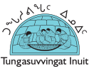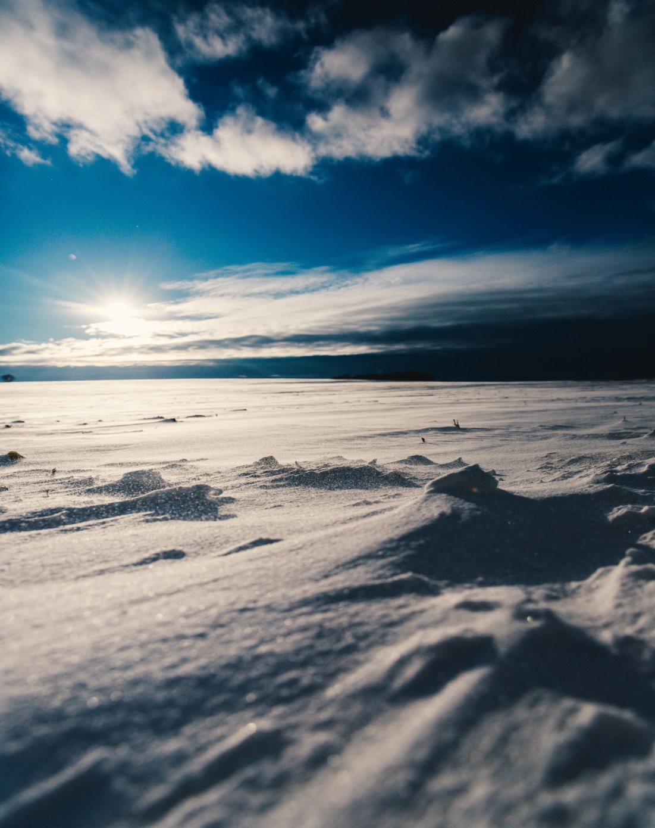

**Participant Booklet**

IT’S TIME

Indigenous Tools and Strategies on Tobacco: Interventions, Medicines and Education

An Inuit-specific toolkit for tobacco cessation



**Participant Resources**

**Congratulations!**

Quitting or reducing tobacco use is an important change in your life. **You *can* quit or reduce your tobacco use.** For many people, the decision to quit or reduce tobacco use is a difficult one. They also don’t take advantage of resources that can help them to quit. You have taken these initial steps. Congratulations!



**Table of Contents**

|  |  |
| --- | --- |
| Title | Page |
| Inuit Qaujimajatuqangit | 4 |
| The Impact of Tobacco Use | 6 |
| Tracking Sheets | 7 |
| List of Cessation Apps | 12 |
| Exploring Readiness | 13 |
| Strengths, Weaknesses, Opportunities, Challenges (SWOC) Analysis | 14 |
| Balancing Health and Well-being | 15 |
| Coping Strategies | 16 |
| Making a Change (Part 1) | 22 |
| Medication for Tobacco Cessation | 23 |
| True or False? | 33 |
| Resources to Support Quitting | 35 |
| Making a Change (Part 2) | 40 |
| Withdrawal Symptoms | 41 |
| Developing a Wholistic Plan | 42 |

**Note: What is Cessation?**

Throughout this booklet, you will see that we have included the word “cessation”. This word means to end or stop. Tobacco cessation refers to quitting, stopping, or cutting down tobacco use.

**Inuit Qaujimajatuqangit**

|  |  |
| --- | --- |
| **Value** | **Description** |
| **Inuuqatigiitsiarniq**  ᐃᓅᖃᑎᒌᑦᓯᐊᕐᓂᖅ | Respecting others, relationships and caring for people. |
| **Tunnganarniq**  ᑐᙵᓇᕐᓂᖅ | Fostering good spirits by being open, welcoming and inclusive. |
| **Pijitsirniq**  ᐱᔨᑦᓯᕐᓂᖅ | Serving and providing for family and/or community. |
| **Aajiiqatigiinniq**  ᐊᔩᖃᑎᒌᓐᓂᖅ | Decision making through discussion and consensus. |
| **Pilimmaksarniq/ Pijariuqsarniq**  ᐱᓕᒻᒪᒃᓴᕐᓂᖅ/  ᐱᔭᕆᐊᖅᓴᓂᖅ | Development of skills through observation, mentoring, practice, and effort. |
| **Piliriqatigiinniq/ Ikajuqtigiinniq**  ᐱᓕᕆᖃᑎᒌᖕᓂᖅ/  ᐃᑲᔪᖃᑎᒌᖕᓂᖅ | Working together for a common cause. |
| **Qanuqtuurniq**  ᖃᓄᖅᑑᕐᓂᖅ | Being innovative and resourceful. |
| **Avatittinnik Kamatsiarniq**  ᐊᕙᑎᑦᑎᓐᓂᒃ ᑲᒪᑦᓯᐊᕐᓂᖅ | Respect and care for the land, animals and the environment. |

Thinking about Inuit Qaujimajatuqangit, in what ways do the principles impact your tobacco use?

________________________________________________________

________________________________________________________________________________________________________________________________________________________________________________________________________________________________________________________________________________________

________________________________________________________________________________________________________________________________________________________________________________________________________________________________________________________________________________________

________________________________________________________________________________________________________________________________________________________________________

________________________________________________________________________________________________________________

**The Impact of Tobacco Use**

As you think about the possibility of quitting or reducing your tobacco use, you may be wondering how tobacco use impacts your body, your family, your community, and the environment.

Check out the following links below which include activities and resources to help you learn more about the impacts of tobacco use.

**Tobacco and Your Body**

<http://www.nuquits.gov.nu.ca/tobacco-101/tobacco-and-your-body>

**Second-hand Smoke**

<http://www.nuquits.gov.nu.ca/tobacco-101/second-hand-smoke>

**Tobacco and the Environment**

<http://www.nuquits.gov.nu.ca/tobacco-101/tobacco-environment>



|  |  |  |  |  |  |  |
| --- | --- | --- | --- | --- | --- | --- |
| **Tracking Sheets** | | | | | | |
| **Date & Time** | **What am I doing now?** | **Mood** | | | **Rating** | **# Smoked** | |
|  | *Where, what, with who?* | ☺ | 😐 | ☹ | 5 4 3 2 1  Must No  have need |  | |
| Monday 8:00am | Eating breakfast at home with my daughter |  | √ |  | 4 | 1 | |
|  |  |  |  |  |  |  | |
|  |  |  |  |  |  |  | |
|  |  |  |  |  |  |  | |
|  |  |  |  |  |  |  | |
| **Date & Time** | **What am I doing now?** | **Mood** | | | **Rating** | **# Smoked** | |
|  | *Where, what, with who?* | ☺ | 😐 | ☹ | 5 4 3 2 1  Must No  have need |  | |
|  |  |  |  |  |  |  | |
|  |  |  |  |  |  |  | |
|  |  |  |  |  |  |  | |
|  |  |  |  |  |  |  | |
|  |  |  |  |  |  |  | |
| **Date & Time** | **What am I doing now?** | **Mood** | | | **Rating** | **# Smoked** | |
|  | *Where, what, with who?* | ☺ | 😐 | ☹ | 5 4 3 2 1  Must No  have need |  | |
|  |  |  |  |  |  |  | |
|  |  |  |  |  |  |  | |
|  |  |  |  |  |  |  | |
|  |  |  |  |  |  |  | |
|  |  |  |  |  |  |  | |
|  |  |  |  |  |  |  | |
| **Date & Time** | **What am I doing now?** | **Mood** | | | **Rating** | **# Smoked** | |
|  | *Where, what, with who?* | ☺ | 😐 | ☹ | 5 4 3 2 1  Must No  have need |  | |
|  |  |  |  |  |  |  | |
|  |  |  |  |  |  |  | |
|  |  |  |  |  |  |  | |
|  |  |  |  |  |  |  | |
|  |  |  |  |  |  |  | |
| **Date & Time** | **What am I doing now?** | **Mood** | | | **Rating** | **# Smoked** | |
|  | *Where, what, with who?* | ☺ | 😐 | ☹ | 5 4 3 2 1  Must No  have need |  | |
|  |  |  |  |  |  |  | |
|  |  |  |  |  |  |  | |
|  |  |  |  |  |  |  | |
|  |  |  |  |  |  |  | |
|  |  |  |  |  |  |  | |
|  |  |  |  |  |  |  | |

**List of Cessation Apps**

|  |  |
| --- | --- |
| **Name** | **Link** |
| **My Change Plan** | Google Play: <https://play.google.com/store/apps/details?id=com.camh.my_change_plan&hl=en_CA&gl=US&pli=1>  Apple Store: <https://apps.apple.com/ca/app/mychangeplan/id1405709545> |
| **LIVESTRONG: My Quit Coach** | <https://itunes.apple.com/us/app/livestrong-myquit-coach-dare-to-quit-smoking/id383122255?mt=8> |
| **Quit Smoking** | <https://play.google.com/store/apps/details?id=com.azati.quit&hl=en> |
| **Quit Now!** | <https://play.google.com/store/apps/details?id=com.azati.quit&hl=en> |
| **Butt Out** | <https://play.google.com/store/apps/details?id=com.ellisapps.buttout&hl=en> |
| **Smoke Free** | <https://itunes.apple.com/ca/app/smoke-free-quit-smoking-now-and-stop-for-good/id577767592?mt=8> |

**Exploring Readiness**

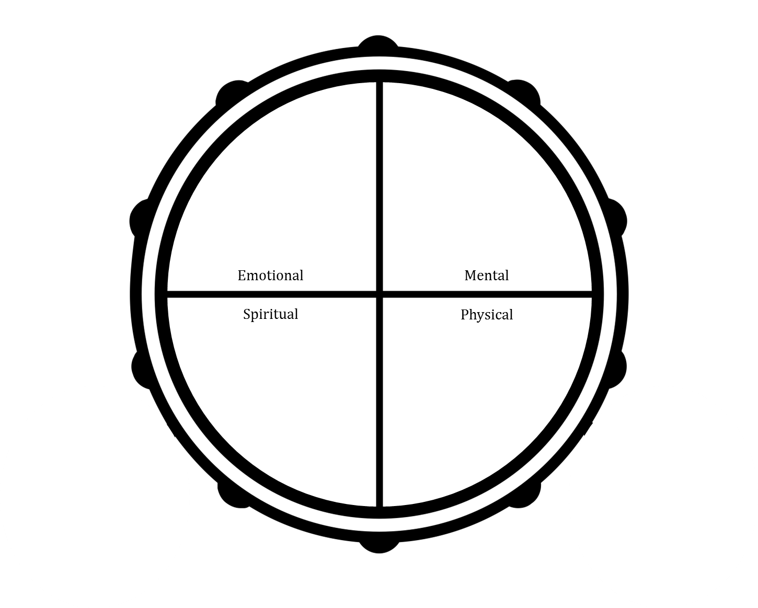Shade the areas you would like to work on to feel confident about quitting or reducing your tobacco use.

**Strengths, Weaknesses, Opportunities, Challenges   
(SWOC) Analysis**

Write down your strengths, weaknesses, opportunities, and challenges as they relate to quitting or reducing your tobacco use.

|  |  |
| --- | --- |
| **Strengths** | **Weaknesses** |
| *Example: I have quit using other substances* | *Example: I smoke to cope with stress* |
| **Opportunities** | **Challenges** |
| *Example: My partner quit smoking* | *Example: I smoke with my friends* |

**Balancing Health and Well-being**

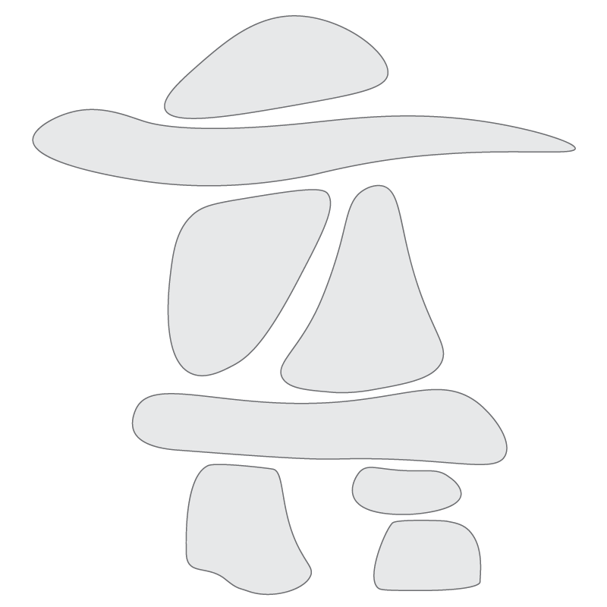Write down your triggers to using tobacco and identify a coping strategy for each inside the inuksuk. An example could be: *My partner smokes inside the house. I will ask them if they can smoke outside.*

**Coping Strategies**

|  |  |  |
| --- | --- | --- |
| **Things I Can Do** | **Things That Can Help** | **Coping with Feelings** |
| Visit an Elder and offer to be a helper  Go out on the land  Go hunting or fishing  Sit by the water  Avoid people or places that trigger problematic coping strategies (i.e. tobacco use, drinking, drug use, self-harm)  Phone someone for support | Talk to an Elder about Inuit Qaujimajatuqangit  Think kind thoughts about yourself  Remember the positive things about using healthy coping strategies  Remember the negative consequences of using problematic coping strategies  Tell yourself that feelings, even difficult feelings, are normal | Talk to an Elder  Read books or websites on self-growth or recovery  Ask yourself what you are feeling (go through a checklist of your common “feeling triggers” –am I lonely, sad, anxious, scared)  Give yourself permission to feel emotions (don’t judge your feelings) |
| **Things I Can Do** | **Things That Can Help** | **Coping with Feelings** |
| Identify and avoid high-risk situations  Take a “buddy” when going to a risky place /situation  Leave risky situations, or limit how long you stay  Go for a walk or hike  Go get ice/ fresh water for drinking  Read a book  Sew, crochet or knit | Distract yourself by thinking about something else  Recognize when you are making self-defeating statements  Plan ahead for any risky situations  Think about your future goals and how to achieve them.  Remind yourself that you only have to worry about what you have control over today  Remind yourself that you are in the present and the past cannot hurt you now | Express your feelings (cry, smile, etc.,)  Ask for support  Talk to someone about your feelings  Find a creative outlet for feelings (music, drawing, painting, poetry etc.,)  Get a journal and write to yourself  Take time to soothe / nurture yourself |
| **Things I Can Do** | **Things That Can Help** | **Coping with Feelings** |
| Exercise or do something physical  Fix sleds or qajaq/ kayaks  Play Inuit games  Stand tall and feel your body’s strength  Remind yourself that you are a strong person.  Hold onto something to ground yourself (e.g., chair you are sitting in, key ring, picture etc.) | Make a commitment to yourself and remind yourself of it  Think that you are in charge of whatever decisions you make about your safety  Tell yourself that you are doing well so far and don’t want to interfere with the progress  Monitor your use and urges to use problematic coping strategies  Post a copy of Inuit Qaujimajatuqangit where you can review it each day | Praise yourself for the progress you have made  Use affirmations  Light candles to help you to focus on your thoughts and feelings  Write a letter to someone about how you are feeling (it is better to not send the letter, keep it, burn it, bury it, flush it)  Get a punching bag, or hit a pillow or bed, scream into a pillow |
| **Things I Can Do** | **Things That Can Help** | **Coping with Feelings** |
| Clean or do housework  Do volunteer work  Try meditation or deep breathing  Practice saying no with both your voice and body language  Stay in contact with supportive people  Take care of yourself if you are hungry, thirsty or tired | Think about the times in your life where you have felt good about yourself - try to get in touch with the feelings of strength  that went along with those events  When a negative belief about yourself pops into your head, try to remember where it really came from—who originally planted those beliefs? Think about challenging them with other information that you know about yourself, which proves the beliefs to be false. | Throw rocks in the water  Talk to a pet / spend time with animals  Go to a spiritual place (anyplace you define as spiritual)  Create a safe or sacred place in your home  Be kind to yourself |
| **Things I Can Do** | **Things That Can Help** | **Coping with Feelings** |
| Keep a visual reminder of the negative consequences of your problematic coping strategies (e.g., photos)  Keep visual reminders or written lists of the positive effects of the changes you’ve made.  Reward yourself for your efforts  Go to a support group  Listen to music, sing, or dance | See previous pages | If you are afraid of being overwhelmed by your emotions, imagine them coming through a tap where you are able to control the flow |
| **Things I Can Do** | **Things That Can Help** | **Coping with Feelings** |
| Practice being kind to yourself  Learn Inuktitut  Cook and eat nutritious food | See previous pages | See previous pages |

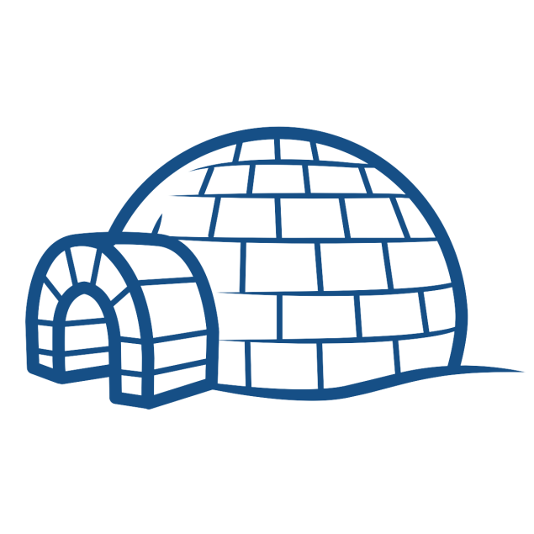

**Making a Change (Part 1)**

|  |
| --- |
| **The behaviour I want to/need to change is:** |
|  |
| **This is what I will do to make the change:** |
|  |
| **I will make this change by:** |
|  |

**Tip:** If you are not ready to quit tobacco, think about what another change could be. Some examples might be to not smoke in your car/ snowmobile/ four wheeler/ boat, to smoke outside your house, or not to smoke for a three hour period each day for a week. What are some changes that make sense for you?

**Medication for Tobacco Cessation**

**Nicotine Replacement Therapy (NRT)**

* NRT is a group of smoking cessation aids that provide clean nicotine in different forms
* Works by replacing a portion of the nicotine in your cigarettes so that your withdrawal symptoms are minimized
* With less severe withdrawal symptoms you face an easier time quitting smoking
* Available over the counter

**Why Use Nicotine Replacement Therapy (NRT)?**

* Doubles your chances of successfully quitting
* Safer to use than tobacco – no long-term negative health effects have been found for NRT
* Works well in combination with other strategies (such as changing what you do, how you think about smoking, and how you feel about smoking and quitting)

|  |  |  |
| --- | --- | --- |
| **Types of Nicotine Replacement Therapy (NRT)** | | |
| **Type of NRT** | **How it Works** | **Side Effects** |
| *Nicotine Patch* | * Delivers a continuous dose of nicotine throughout the day * Available in the following doses:   + 24 hours: 21, 14 & 7 mg | * May cause sleep disturbance or nightmares * May cause skin irritation * Reaction to the adhesive * Nicotine can be an irritant but this is not an allergy * Talk to your pharmacist about medicated creams that may help (aloe, hydrocortisone) |
| **Type of NRT** | **How it Works** | **Side Effects** |
| *Nicotine Gum* | * Come in different flavours: mint, fruit, cinnamon * Delivers nicotine through the lining of the mouth * Available in the following doses: 4 & 2 mg | * Upset stomach * Nausea/vomiting * Dizziness * Mouth/throat irritation * Hiccups |
| **Type of NRT** | **How it Works** | **Side Effects** |
| *Nicotine Lozenge* | * Come in different flavours: mint, fruit, cinnamon * Delivers nicotine through the lining of the mouth * Available in the following doses: 4, 2 & 1 mg | * Upset stomach * Nausea/vomiting * Dizziness * Mouth/throat irritation * Hiccups |
| **Type of NRT** | **How it Works** | **Side Effects** |
| *Nicotine Inhaler* | * Small, tube-shaped mouthpiece * Delivers nicotine through “puffing” * Absorbed in the mouth, throat and upper respiratory tract * Available in a 10 mg dose | * Throat & mouth irritation * Headache * Nausea * Indigestion |
| **Type of NRT** | **How it Works** | **Side Effects** |
| *Nicotine Mouth Spray* | * Small, portable dispenser * Delivers nicotine through a fine mist that is sprayed directly into the mouth * Nicotine is quickly absorbed in the mouth * Available dose is 1 mg / spray | * Tingling lips * Hiccups |

**Important:** *If you recently experienced any of the following please consult with your doctor before starting NRT: stroke, heart attack, worsening angina or arrhythmia.*

|  |  |  |  |
| --- | --- | --- | --- |
| **Types of Prescription Medications for Tobacco Cessation** | | | |
| **Type** | **How it Works** | **Why Use it?** | **Side Effects** |
| *Zyban (bupropion)* | * It comes in tablet form. * It is only available by prescription from your physician or pharmacist * It does not contain nicotine. The medicinal ingredient in Zyban is bupropion | * Can double your chances of quitting smoking * Convenient: you take the tablets only once or twice a day * Can be combined with counselling support or NRT to improve success rate in some cases | * Dry mouth * Insomnia |
| **Type** | **How it Works** | **Why Use it?** | **Side Effects** |
| *Zyban (bupropion)* | * Can minimize your experience of withdrawal symptoms, which can make quitting easier for you * Dosage form: 300mg tablets | (see page 27) | (see page 27) |
| **Type** | **How it Works** | **Why Use it?** | **Side Effects** |
| *Champix (varenicline)* | * It comes in tablet form. * Available only by prescription from your physician or pharmacist * It does not contain nicotine. The medicinal ingredient is varenicline tartrate | * Increases your chances of quitting smoking; as good as either NRT or Zyban, or better * Convenient: you take the tablets only once or twice a day | * Nausea/ vomiting * Abnormal dreams * GI issues |
| **Type** | **How it Works** | **Why Use it?** | **Side Effects** |
| *Champix (varenicline)* | * Reduces cravings for cigarettes so quitting is made easier * Decreases the pleasurable effects of smoking so you are not as tempted to light up * Dosage form: 0.5mg & 1mg tablets | * Does not interact with too many other drugs, which makes it more suitable for some people who are on other medications | (see page 29) |

**Important:** *Use only under the supervision of a health care provider so that they can monitor any changes in your health.*

**True or False?**

**Tobacco Cessation Medication**

How much do you know about medications to help people quit smoking?

Take this True-or-False quiz and find out.

|  |  |
| --- | --- |
| **Statement** | **True or False?** |
| 1. Nicotine is the harmful substances in cigarettes. |  |
| 1. Nicotine addiction is equally likely whether the nicotine comes from cigarettes, nicotine patch, gum, lozenge or inhaler. |  |
| 1. Nicotine Replacement Therapy (NRT) is a safe and clean delivery system of nicotine. |  |
| 1. Smoking while on the NRT patch increases the risk of a heart attack. |  |
| 1. NRT should not be used at the same time or in combination with Zyban® (bupropion) (*Zyban is another smoking cessation medication*) |  |
| 1. Pregnant women should never use NRT |  |
| 1. People under age 18 can use NRT |  |
| 1. People using NRT can take more than what is recommended on the medication package. |  |
| 1. NRT should only be used for a short time |  |
| 1. NRT should not be used by people who just want to cut down on the number of cigarettes they smoke. |  |

(1)False (2) False (3) True (4) False (5) False (6) False (7) True (8) True (9) False (10) False

**Resources to Support Quitting or Reducing Tobacco Use**

**Counselling Support**

**(Available to Everyone)**

***First Nations and Inuit Hope for Wellness Line***

Crisis intervention counselling available 24/7

Counselling is available in Inuktitut on request

1-855-242-3310

***National Residential School Crisis Line***

Provides support to former residential school survivors

Mental health and crisis referral services available 24/7

1-866-925-4419

**Tobacco Cessation Support**

**(Available by Province/Territory)**

***Alberta***

<https://www.albertaquits.ca/>

1-866-710-7848

***British Columbia***

<https://www.quitnow.ca/>

1-877-455-2233

***Manitoba***

<http://www.smokershelpline.ca/>

1-877-513-5333

***New Brunswick***

<http://www.smokershelpline.ca/>

1-877-513-5333

***Newfoundland and Labrador***

<https://www.smokershelp.net/>

1-800-363-5864

***Northwest Territories***

<http://www.hss.gov.nt.ca/en/services/nwt-quitline>

1-866-286-5099

***Nova Scotia***

<https://tobaccofree.novascotia.ca/>

1-902-700-7700

***Nunavut***

<http://www.nuquits.gov.nu.ca/>

1-866-368-7848

***Ontario***

<http://www.smokershelpline.ca/>

1-877-513-5333

***Prince Edward Island***

<http://www.smokershelpline.ca/>

1-877-513-5333

***Quebec***

<https://tobaccofreequebec.ca/iquitnow/>

1-866-527-7383

***Saskatchewan***

<http://www.smokershelpline.ca/>

1-877-513-5333

***Yukon***

<https://www.quitpath.ca/>

1-877-513-5333

**Websites**

<http://www.naho.ca/inuittobaccofree/>

[www.cancer.ca](http://www.cancer.ca)

[www.heartandstroke.ca](http://www.heartandstroke.ca)

[www.lung.ca/quit](http://www.lung.ca/quit)

[www.smoke-free.ca](http://www.smoke-free.ca)

[www.gosmokefree.gc.ca](http://www.gosmokefree.gc.ca)

[www.info-tabac.ca](http://www.info-tabac.ca) (FRENCH)

[www.stopsmokingcenter.net](http://www.stopsmokingcenter.net)

[www.pregnets.org](http://www.pregnets.org)

**Social Media**

***Recommended YouTube Channels***

National Aboriginal Health Organization: <https://www.youtube.com/user/NAHOnews>

Pauktuutit: <https://www.youtube.com/user/Pauktuutit>

Tobacco Has No Place Here: <https://www.youtube.com/channel/UCiJ5y4nDw5-WbMi5DeDRBjA>

Nunatsiavut Tobacco Control Strategy: <https://www.youtube.com/channel/UCx-WUZk2FmdZDSUfhGYCviQ>

The TEACH Project: <https://www.youtube.com/user/teachproject>

***Recommended Facebook Pages***

Healthy First Nations and Inuit (English): <https://www.facebook.com/HealthyFirstNationsandInuit/>

Healthy First Nations and Inuit (French): <https://www.facebook.com/PremieresNationsetInuitsensante>

National Aboriginal Health Organization: <https://www.facebook.com/National-Aboriginal-Health-Organization-NAHO-206234329443069/>

Inuit Tapiriit Kanatami: <https://www.facebook.com/inuittapiriitkanatami/>

Tungasuvvingat Inuit: <https://www.facebook.com/Tungasuvvingat-Inuit-467184610123628/>

Tobacco Has No Place Here: <https://www.facebook.com/TobaccoHasNoPlaceHere/>

**Community**

Contact your local public health unit to inquire about resources in your community.

Speak to your healthcare provider or community health worker about quitting smoking.

Refer to CBC North, local radio ads, local news, or posters in your community regarding supports for quitting or reducing tobacco use.

**Making a Change (Part 2)**

Think about the first change you made around your tobacco use. Is there another change you would like to make to support your tobacco cessation or reduction journey? Or would you like to modify the first change you made?

|  |
| --- |
| **The behaviour I want to/need to change is:** |
|  |
| **This is what I will do to make the change:** |
|  |
| **I will make this change by:** |
|  |

**Withdrawal Symptoms**

Every person will experience very different withdrawal symptoms. Here are some things you may experience when quitting smoking. Are any missing? What are some coping strategies you can use to address these symptoms?

|  |  |
| --- | --- |
| **Possible Withdrawal Symptoms** | **Possible Coping Strategies** |
| Irritability |  |
| Difficulty concentrating |  |
| Headaches |  |
| Coughing |  |
| Clumsiness |  |
| Dizziness |  |
| Craving to smoke |  |
| Diarrhea/constipation |  |
| Feeling tired |  |
| Shakiness |  |
| Nausea |  |
| Sweating |  |
| Changes in appetite |  |
| Sadness |  |
|  |  |
|  |  |
|  |  |

**Developing a Wholistic Plan**

When thinking about quitting or reducing your tobacco use over the long-term, there may be other areas of your life you would like to focus on as well. Some examples could be: other substance use, mental health, exercise, eating well, housing, job, etc.

With you at the centre of the plan, take this opportunity to begin thinking about other areas of your life that you would like to focus on in addition to quitting or reducing tobacco.

Think about the supports that can help you in making these changes.

|  |
| --- |
| **What can I do to make some changes?** |
| *Example: Go for a walk* |
| **How can my family and friends help?** |
| *Example: Ask my partner to smoke outside* |
| **What is available in my community?** |
| *Example: Go to a support group for mental health counselling* |

**Notes**

________________________________________________________________________________________________________________________________________________________________________________________________________________________________________________________________________________________

________________________________________________________________________________________________________________________________________________________________________________________________________________________________________________________________________________________

________________________________________________________________________________________________________________________________________________________________________________________________________________________________________________________________________________________

________________________________________________________________________________________________________________________________________________________________________________________________________________________________________________________________________________________

________________________________________________________________________________________________________________________________________________________________________________________________________________________________________________________________________________________

________________________________________________________________________________________________________________________________________________________________________________________________________________________________________________________________________________________

________________________________________________________________________________________________________________________________________________________________________________________________________________________________________________________________________________________

________________________________________________________________________________________________________________________________________________________________________________________________________________________________________________________________________________________

________________________________________________________________________________________________________________________________________________________________________________________________________________________________________________________________________________________

________________________________________________________________________________________________________________________________________________________________________________________________________________________________________________________________________________________

________________________________________________________________________________________________________________________________________________________________________________________________________________________________________________________________________________________

________________________________________________________________________________________________________________________________________________________________________________________________________________________________________________________________________________________

________________________________________________________________________________________________________________________________________________________________________________________________________________________________________________________________________________________

________________________________________________________________________________________________________________________________________________________________________________________________________________________________________________________________________________________

________________________________________________________________________________________________________________________________________________________________________________________________________________________________________________________________________________________

________________________________________________________________________________________________________________________________________________________________________________________________________________________________________________________________________________________

________________________________________________________________________________________________________________________________________________________________________________________________________________________________________________________________________________________

**________________________________________________________**

________________________________________________________________________________________________________________________________________________________________________________________________________________________________________________________________________________________

________________________________________________________________________________________________________________________________________________________________________________________________________________________________________________________________________________________

________________________________________________________________________________________________________________________________________________________________________________________________________________________________________________________________________________________

________________________________________________________________________________________________________________________________________________________________________________________________________________________________________________________________________________________

________________________________________________________________________________________________________________________________________________________________________________________________________________________________________________________________________________________

________________________________________________________________________________________________________________________________________________________________________________________________________________________________