

Helper’s Guide

IT’S TIME

Indigenous Tools and Strategies on Tobacco: Interventions, Medicines and Education

An Inuit-specific toolkit for tobacco cessation

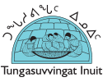

# Acknowledgements

We are grateful to the following people who have generously shared their time, experience, and wisdom as co-authors of this resource.

## Members of the Engagement Circle

Alison Benedict, CAMH Aboriginal Engagement and Outreach

Anita Uuttuvak, Tungasuvvingat Inuit

Annie Buchan, Pauktuutit Inuit Women of Canada

Beverly Hunter, Nunatsiavut Government

Brenda Saunders, Nunatsiavut Government

Carolyn Michelin, Nunatsiavut Government

Cassie Jararuse, Nunatsiavut Government

Chelsea Pridham, Labrador Grenfell Health

Christine Lund, Tungasuvvingat Inuit

Edward Allen, Nunatsiavut Government

Elsie Russell, Nunatsiavut Government

Gillian Harding, Nunatsiavut Government

Grant Gear, Nunatsiavut Government

Janice Allen-Parsons, Nunatsiavut Government

Kaila de Boer, Nunatsiavut Government

Katharine Irngaut, CAMH Aboriginal Engagement and Outreach

Kelly Jacobs, Nunatsiavut Government

James Smith-Sparling, Government of Nunavut

Laura Baikie, Government of Nunavut

Lisa Beedie, Cancer Care Ontario’s – Aboriginal Tobacco Program

Looee Okalik, Inuit Tapiriit Kanatami

Mary B Andersen, Nunatsiavut Government

Mary Sheppard, Labrador Grenfell Health

Megan Barker, CAMH Nicotine Dependence Service

Meaghan Norris, Labrador Grenfell Health

Michelle Halligan, Canadian Partnership Against Cancer

Miriam Lyall, Nunatsiavut Government

Murray Walters, Labrador Grenfell Health

Nadine Pierce, Labrador Grenfell Health

Peter Selby, CAMH Nicotine Dependence Service

Rachel Saunders, Nunatsiavut Government

Renee Linklater, CAMH Aboriginal Engagement and Outreach

Richard Steiner, Cancer Care Ontario’s – Aboriginal Tobacco Program

Ron Lyall, Nunatsiavut Government

Rosa Dragonetti, CAMH Nicotine Dependence Service

Sophie Keelan, Pauktuutit Inuit Women of Canada

Susan Saksagiak, Nunatsiavut Government

Travis Ford, Nunatsiavut Government

## Content Writing and Review

Alexandra Andric, CAMH Nicotine Dependence Service

Anita Uuttuvak, Tungasuvvingat Inuit

Annie Buchan, Pauktuutit Inuit Women of Canada

Carolyn Roberts, The Ottawa Hospital

Christine Lund, Tungasuvvingat Inuit

David Bard, Ottawa Public Health

Gillian Harding, Nunatsiavut Government

Kaila de Boer, Nunatsiavut Government

Laura Baikie, Government of Nunavut

Looee Okalik, Inuit Tapiriit Kanatami

Megan Barker, CAMH Nicotine Dependence Service

Natalie Lloyd, Ottawa, ON

Sarah Waters, Alberta Health Services

Travis Ford, Nunatsiavut Government

*All of these materials can be freely copied, shared, and adapted. Feel free to supplement the toolkit with your own materials.*

Funding for this project was generously provided by the bhasin consulting inc. Fund for Inclusion in Mental Health.

**Table of Contents**

Overview of the Toolkit 7

Background 7

About this Resource 8

Format of the Sessions 9

Facilitating a Session 10

Tips and Suggestions 11

Supporting Documents 12

Note on Cultural Diversity 13

Session 1: Tobacco Use from Past to Present 14

Helper’s Checklist 14

Materials Required 14

Handouts Required 14

Summary of Session 1 14

Opening and Welcome 15

Creating Group Guidelines 16

Getting to Know You 17

Impact of Tobacco 18

The Tobacco Reduction or Cessation Journey 19

Keeping Track of Your Journey 20

Wrap-up and Closing 21

Session 2: Exploring Your Tobacco Reduction or Cessation Journey 22

Helper’s Checklist 22

Materials Required 22

Handouts Required 22

Summary of Session 2 22

Opening and Welcome 23

Review from Session 1 24

Exploring Your Journey 25

Triggers and Coping Strategies 28

Making a Change 30

Wrap-up and Closing 33

Session 3: Preparing for the Tobacco Cessation or Reduction Journey 34

Helper’s Checklist 34

Materials Required 34

Handouts Required 34

Summary of Session 3 34

Opening and Welcome 36

Review from Session 2 37

Supporting Tobacco Cessation or Reduction (Part 1) 37

Supporting Tobacco Cessation or Reduction (Part 2) 40

Revisiting the Journey 42

Wrap-up and Closing 44

Session 4: The Journey to Healing (Part 1) 45

Helper’s Checklist 45

Materials Required 45

Handouts Required 45

Summary of Session 4 45

Opening and Welcome 46

Sharing Your Experiences 47

Revisiting Coping Strategies 49

Thinking about Tobacco Use 51

Wrap-up and Closing 52

Session 5: The Journey to Healing (Part 2) 54

Helper’s Checklist 54

Materials Required 54

Handouts Required 54

Summary of Session 5 54

Opening and Welcome 55

Review from Session 4 56

Coping with Difficult Situations 57

Coping with Thoughts 59

Planning for the Journey 61

Wrap-up and Closing 62

Session 6: Continuing on the Journey 64

Helper’s Checklist 64

Materials Required 64

Summary of Session 6 64

Opening and Welcome 65

Your Journey 66

Your Next Steps 67

Our Celebration 68

Wrap-up and Closing 69

References 70

# Overview of the Toolkit

## Background

In 2010, the TEACH (Training Enhancement in Applied Cessation Counselling and Health) Project at CAMH (Centre for Addiction and Mental Health) partnered with an Engagement Circle of First Nations frontline workers, health care professionals, educators and Elders to develop ITS TIME (Indigenous Tools and Strategies on Tobacco: Interventions, Medicines and Education), a toolkit to support healthcare providers and community workers to offer commercial tobacco interventions with First Nations.

Since the launch of the toolkit in 2010, TEACH has received multiple training requests to build capacity in commercial tobacco interventions in First Nations, Inuit, and Métis communities. Feedback from participants of the ITS TIME trainings has highlighted the need to review the toolkit and discuss new ways of retooling content to reflect Indigenous ways of learning, knowing, healing and recovery. Participants have also indicated the need for an open and inclusive review process, which includes the voices of First Nations, Inuit and Métis peoples in order to take into account unique needs and concerns, cultural, geographic, and linguistic diversities.

In March 2016, in collaboration with Cancer Care Ontario’s Aboriginal Tobacco Program (CCO-ATP), CAMH’s Aboriginal Engagement and Outreach Program (CAMH-AEO), and the Canadian Partnership Against Cancer (CPAC), TEACH widely disseminated an invitation to First Nations, Inuit, and Métis stakeholders, Elders, healthcare providers, educators and community members to participate in the review of the ITS TIME toolkit. A total of 56 individuals formed the Engagement Circle, representing multiple provinces and territories including Ontario, Quebec, Newfoundland and Labrador, Northwest Territories, and Nunavut. Three opportunities were provided for Engagement Circle members to offer their feedback (an in-person meeting, a training, and electronic reviews). This was to ensure a process that was open, inclusive, and reflective of diverse voices and opinions.

One of the key pieces of feedback from the Engagement Circle was that the teachings and activities in the toolkit were not always applicable to Inuit. Accordingly, it was decided that separate toolkits may help to foster buy-in from Inuit to participate in tobacco cessation or reduction activities tailored to their point of view.

In November 2016, TEACH partnered with Tungasuvvingat Inuit (TI) to apply for a small amount of funding to develop and pilot an Inuit version of the ITS TIME toolkit, based on the feedback provided in March 2016. TEACH and TI were successful recipients of this funding and proceeded with the development of this toolkit and piloting the materials with:

* Healthcare providers and community health workers (collectively known as helpers) that work with Inuit (feedback will be collected through an online survey)
* A group of Inuit in Ottawa looking to reduce or quit smoking (feedback will be collected during a focus group).

The evaluation and piloting of the materials will begin in April 2017.

## About this Resource

This toolkit designed to facilitate knowledge transfer and increase capacity in health and wellness for Inuit. Although tobacco was never part of Inuit culture, its introduction by settlers has had devastating impacts. Tobacco is currently the leading cause of preventable death in Canada and North America, and tobacco use prevalence among Inuit is two times higher than the general Canadian population. Culturally-relevant and safe interventions that encourage people to address their use of tobacco are of vital importance.

**This resource is designed for helpers interested in supporting Inuit in quitting or reducing tobacco use.**

The development of this toolkit has been informed by the guiding principle of Two Eyed Seeing (Marshall, 2004), whereby the strengths of both evidence-based practice (Western knowledge) and wise-based practice (Inuit Ways of Knowing) have been combined in order to support tobacco reduction or cessation through a strengths-based and wholistic[1] approach:

* **Evidence-based practice**: This toolkit has been informed by Dermody, Wardell, and Hendershot’s (2015) Group Cognitive Behavioural Therapy for Smoking Cessation Manual and CAN-ADAPTT Guidelines (2011).
* **Wise-based practice**: This toolkit incorporates Inuit Qaujimajatuqangit (IQ) Principles, the core societal values and beliefs among Inuit, traditional activities, and teachings to support wholistic health and healing.

The development of this resource was informed by the guidance, review, knowledge and consensus-building of a group of Inuit helpers, stakeholders, community members, and Elders through an Engagement Circle (or advisory committee). Please refer to page 6 of this document which outlines the Engagement Circle development process in more detail.

## Format of the Sessions

The purpose of this toolkit is to support helpers in offering tobacco interventions with Inuit. It is organized into six sessions with each session focusing on specific learning outcomes. The goal of the sessions will be to support Inuit in:

* Preparing for their tobacco cessation or reduction journey (e.g., thinking about quitting or reducing).
* Mapping their tobacco cessation or reduction journey (e.g., developing a plan to quit or reduce).
* Staying with their tobacco cessation or reduction journey (e.g., learning ways to prevent resuming smoking).

The six sessions can be offered in a variety of practice and community settings and can also be tailored to individual or group settings. Note: If sessions are offered in a group format it is recommended that the group size be around 6 – 10 individuals.

Individuals who would likely benefit from these sessions include those who are:

* Planning to quit or reduce tobacco use in the next 30 days or are in the early stages of a quit or reduction attempt (e.g., who have quit tobacco use the past week).
* Able to engage in cognitive work (i.e., have no active psychoses, no severe intellectual or learning impairments, and have a relatively stable living situation).

This toolkit outlines six 90 minute sessions of cognitive behavioural therapy (evidence-based practice) incorporating Inuit Ways of Knowing (wise-based practice) throughout. The sessions are designed to be offered sequentially as each session will build on material offered in previous sessions. However, we acknowledge that it may be challenging for helpers to offer each of the sessions in a sequential format. Therefore, helpers are welcome to pick and choose activities that are relevant and feasible to offer within their setting. Additionally, some activities that we have suggested may not be appropriate for all practice settings due to cost, geography, availability of a community Elder, etc. Throughout the toolkit, we have provided multiple suggestions for activities that can achieve the same outcomes. It is up to helpers to decide what they think will work best for the individuals they work with and their setting.

If helpers decide to offer the sessions as they have been developed, the overall structure of each session includes the following:

* An opening to welcome participants (15-20 minutes)
* The discussion of new concepts and implementation of activities which may include psychoeducation, cognitive behavioural skills learning, sharing teachings, engaging in traditional activities, etc. (60 minutes)
* A closing to end the session in a good way (5-10 minutes)

All participants will be asked to make a quit or a behavioural goal regarding their tobacco use (e.g., reducing cigarettes per day, making their home smoke-free, etc.). The sessions are designed to facilitate a quit attempt between sessions 3 and 4, although participants can elect for an alternative timeline if preferred.

## Facilitating a Session

These sessions can be delivered in either group or individual formats. With individual counselling, the close focus and privacy may be what the individual prefers. However, group counselling can be effective in helping people empathize and support one another. Choosing between individual and group counselling will depend partly on an individual’s characteristics and preferences, and partly on what kind of service helpers can feasibly offer. This frequently depends on considerations such as what resources are available in a helper’s clinical setting (e.g., staffing, financial support, etc.). The focus of this toolkit is on how these sessions can be used in a group setting, although helpers can offer sessions or specific activities from the sessions in an individual format if that is their preference.

If the session is being offered as a group, the following structure may be useful for helpers to guide their approach to group facilitation. *These are suggestions, not prescriptions*. The helper can:

1. Introduce themselves as the facilitator.
   1. **Note**: If it is feasible to do so, you may consider co-facilitation options with peers or members/helpers that have already reached a particular goal (i.e. has quit smoking).
2. Lead the group in an opening prayer or welcome participants to the session. This could also include traditional protocols such as lighting the kudlik/qulliq (oil lamp). The way to open the session should be relevant to the community. If an Elder has been invited to participate, they may want to open the session.
3. Provide or review logistical information, which can include:
   1. Sign-in (if using): Direct participants to sign-in sheet on resource table (optional and based on community preference);
   2. Breaks: Discuss when breaks will happen and protocols around smoking during breaks;
   3. Washrooms: Indicate location and provide directions.
4. Describe or review the structure of the session and the intended learning outcomes.
5. Invite questions (based on structure or proceedings of last session).
6. Icebreaker activity (refer to *Helper’s Resources* in this toolkit for icebreaker ideas).
7. Invite the participants to introduce themselves in a way that is comfortable for them.
8. Facilitate the session (refer to pages 13-68 which describes each of the sessions in more detail).
9. Lead the group in a closing prayer or other closing activity to end the session. The way to close the session should be relevant to the community. If an Elder has been invited to participate, they may want to close the session.

### Tips and Suggestions

The following tips and suggestions are designed to support helpers with some of the logistics of setting up and facilitating the sessions. We recognize that each community and group is unique so helpers should adapt and tailor these suggestions to best fit the group that they are working with.

Room Setup

A circle style is recommended for the room setup. Facilitating the sessions within a circle helps to reduce power imbalances as everyone enters the circle as equals (including helpers). If you are going to ask members to sign in before entering the circle, have a registration table outside the venue room.

Group Guidelines for Session

We have provided some suggested guidelines that can be offered as a starting point with input from the participants.

1. Be respectful of other member’s processes of change, healing and recovery from tobacco – everyone uses different strategies to reduce or quit smoking. There is no “right way” to progress through cessation.
2. Be respectful of others’ goals – not everyone will have an abstinence goal. No matter what a person’s goal, support should be provided for any change that is occurring.
3. Confidentiality – whatever is said in the group stays in the group and should not be discussed with other people in the community.
4. Try not to smoke with other members of the group. Smoking can be a very social activity. We ask that members try not to smoke with each other so they do not become triggers for each other.
5. Arrive on time and stay for the entire session. If you cannot come to the session, notify the facilitator in advance.
6. No one has to participate and disclose any information if they don’t feel comfortable. Some people may just want to come and listen.

**Note**: In addition to setting guidelines for the session, it is important for helpers to check in with the group if guidelines are not respected. For example, if it is agreed upon that participants will listen to one another and a participant begins to whisper or speak when someone is talking, the helper must pause the group and take a moment to revisit the guidelines. This is to ensure participants feel supported in their ability to share within a safe and respectful environment.

## Supporting Documents

The activities for each session are outlined in pages 13-68 of this toolkit. During the development phase of this toolkit, some members of our Engagement Circle indicated that they wanted a detailed, step-by-step guide, while others wanted “everything on a single page”. For facilitators who would prefer not to use the detailed toolkit, we have included one-page summaries of key activities and discussion for helpers to use as a guide for each of the six sessions (Tab 2). We have tried to co-create a resource that is totally flexible and adaptable to the preferences of different helper’s styles, as well as the needs of different communities and groups.

There are also two additional sections of this toolkit to support delivery of the sessions:

* **Helper’s Resources** (Tab 3) which includes sample sign in sheets, evaluation forms, suggestions for ice breakers activities, wise- and evidence-based approaches to support tobacco cessation or reduction, answer keys to support activities, and a template for Certificates of Completion. It is up to helpers to decide if they think these resources will be helpful in their offering of the sessions. We have also included a resource regarding the history of Inuit in Canada as a way to support those helpers who may wish to further their knowledge and understanding of the history of contact, colonization, resiliency, and strength of Inuit.
* **Participant Booklet** (Tab 4)which includes information, handouts and worksheets that correspond to the content of each session. You may choose to give copies of the complete participants’ booklet to everyone in the session, or just use selected handouts that are relevant to the content and discussion you plan to cover in any of the session (in other words, either give out the participants’ workbook and ask people to bring it to every session, or distribute the handouts to the group as you go along). As a third option, you may choose not to use any handouts at all!

All of the toolkit resources can be downloaded electronically from TEACH (www.teachproject.ca) and Tungasuvvingat Inuit (<http://tungasuvvingatinuit.ca>). All of these materials can be freely copied, shared and adapted. We have provided word documents of each of the resources for helpers to customize according to their settings. Helpers are encouraged to supplement the toolkit resources with their own materials.

## Note on Cultural Diversity

We acknowledge the diversity among Inuit in Canada in regards to geography, language, protocols, traditional activities, and teachings. We have tried to include representation from each of the Inuit regions (i.e., Nunatsiavut, Nunavik, Nunavut, Inuvialuit) and from urban Inuit living in the South (e.g., Ottawa) in the development and review of these materials to ensure cultural appropriateness for a range of Inuit. However, there may be instances where we have chosen a word, teaching, or activity that may not be culturally relevant or appropriate for all Inuit. Helpers should keep this in mind when offering sessions or choosing activities to offer with Inuit. Helpers can customize the language, teachings, or activities to meet the needs of their community – the resources are meant to be flexible and adaptable. While we have strived to produce a resource where everyone feels included, we welcome your comments, corrections, and suggestions.

We hope that helpers find this resource helpful in their tobacco cessation work, and wish helpers the best of luck in sharing their wisdom, expertise and experience with others in their region, communities, and organizations!

*Image provided courtesy of Cancer Care Ontario*

Qujannamiik, Nakurmiik, Nakummek, Ma’na, and Quana!

# Session 1: Tobacco Use from Past to Present

## Helper’s Checklist

**Important Note:** All of the following activities and resources are optional in the sense that you can (and should) tailor the session to the needs of your group and community.

### Materials Required

* Name tags (if using)
* Sign in sheets
* Pens (for participants to make notes or fill out handouts)
* Flip chart and markers
* Computer with audio and projector (if playing videos)
* Internet access (if sharing online videos or websites)
* Refreshments (if feasible)
* Any materials required for the icebreaker session (refer to *Helper’s Resources* for ideas)
* Evaluations (refer to *Helper’s Resources* for copies)

### Handouts Required

You may decide to give the entire participant booklet to participants which they can then bring with them to each session. If this option is not feasible, you can provide participants with the handouts required for session 1 which include:

* Inuit Qaujimajatuqangit
* Tracking Sheets
* List of Apps

|  |  |  |
| --- | --- | --- |
| Summary of Session 1 | | |
| Goal | **Content and Activities** | **Preparation** |
|  | Opening and Welcome  *10 minutes* | * Invite an Elder or community member to open the session (if preferred) * Print a copy of the sign-in sheet (if using) * Print copies of the participant booklet (if you are not using individual handouts) |
| *Establish format and procedures (i.e., opening and closing protocols, guidelines for the sessions)* | Creating Group Guidelines  *15 minutes* | * Print copies of *Inuit Qaujimajatuqangit* * Flip chart and markers |
| *Group member introductions and emphasize role of group support for a common goal* | Getting to Know You  *15 minutes* | * If you have chosen an icebreaker, refer to *Helper’s Resources* for more details on preparation |
| *Discuss the history and impact of tobacco in Inuit communities* | Impact of Tobacco  *20 minutes* | * Invite an Elder or community member to share the history and impact of tobacco on Inuit * Print copies of *Our Ancestor’s Never Smoked* * Choose YouTube videos to share with the group   + Computer, projector, internet connection, computer audio (e.g., external speakers) |
| *Sharing more about tobacco use and quitting* | The Tobacco Reduction or Cessation Journey  *20 minutes* | * Invite an Elder or community member to share their tobacco reduction or cessation journeys * Choose YouTube videos to share with the group   + Computer, projector, internet connection, computer audio (e.g., external speakers) |
| *Introduce importance of tracking a tobacco cessation or reduction journey* | Keeping Track of Your Journey  *5 minutes* | * Print copies of *Tracking Sheets* * Print copies of *List of Apps* |
|  | Wrap-up and Closing  *5 minutes* | * Print copies of the *Evaluations* (if using) * Invite an Elder or community member to close the session (if preferred) |

## Opening and Welcome

**Approximate Time:** 10 minutes

* Introduce yourself as the helper for the session.
* Lead the group in an opening prayer or welcome participants to the session. The way to open the session should be relevant to the community. If an Elder has been invited to participate, they may want to open the session.
* Provide or review logistical information, which can include:
  + Sign-in (if using): Direct participants to sign-in sheet on resource table (optional and based on community preference);
  + Breaks: Discuss when breaks will happen and protocols around smoking during breaks;
  + Washrooms: Indicate location and provide directions.
  + Refreshments: Indicate if there are any available to participants (e.g., snacks, water, etc.).
* Describe the structure of the session, intended learning outcomes, and overall content for the session. Here is an example introduction to the content and structure of the session: *Thank you for coming today to explore and talk about tobacco reduction and cessation. We will meet together for six different sessions, and each session has its own theme. This session (session 1) is called: “Tobacco Use from Past to Present”. In this session, we will talk about history and impact of tobacco use in Inuit communities and explore what a tobacco reduction or cessation journey make look like. In the other sessions we will discuss ways in which you can begin to think about your own tobacco reduction or cessation journey, explore coping with triggers for tobacco use, prepare for your own tobacco reduction or cessation journey, discuss strategies to support quitting, and prepare for staying with the journey after these sessions have ended. Everyone’s voice is important, since we all have experience with tobacco – either ourselves or with our families, friends and community. In this way we all have teachings to share and we can all learn from one another. Everyone is welcome here, even if you are smoking. This is a journey and we want you to keep coming to the sessions, regardless of where you are in your journey.*

## Creating Group Guidelines

**Approximate Time:** 15 minutes

**Goal:** Establish format and procedures (i.e., opening and closing protocols, guidelines)

To provide a safe and positive group experience, it is important to determine guidelines with participants in a collaborative way. We have recommended two approaches you may want to use in developing guidelines with the group.

#### Option A: Looking to Our Values

**Instructions:** Using Inuit Qaujimajatuqangit as a guide, collaboratively discuss guidelines for the sessions. For example, Inuuqatigiittiarniq refers to respecting others, relationships and caring for people (Government of Nunavut, n.d.). A guideline that is reflective of Inuuqatigiittiarniq could be to respect other group member’s confidentiality by not sharing information that is shared in the group with other individuals outside of the group.

**Materials Required:** Flip chart and markers to write down responses. You may want to hand out the Inuit Qaujimajatuqangit so participants can keep a copy for themselves. A copy of Inuit Qaujimajatuqangit can be found in the *Participant Booklet* (page 4).

#### Option B: Preparing for Our Journey

**Instructions:** A creative way to discuss group guidelines is to frame the discussion as if the group was preparing to go out on the land. Ask the participants to fill their qamutik/komatik (sled) with items they would like to bring with them on their journey through the sessions (e.g., openness, respect for one another, etc.). Ask the participants to leave behind the items they would not like to bring with them on their journey through the sessions (e.g., judgement, breaking confidentiality, etc.). You may also incorporate Inuit Qaujimajatuqangit in this discussion.

**Materials Required:** Flip chart and markers to write down responses. You may want to hand out the Inuit Qaujimajatuqangit so participants can keep a copy for themselves (if you plan to discuss them during this activity). A copy of Inuit Qaujimajatuqangit can be found in the *Participant Booklet* (page 4).

## Getting to Know You

**Approximate Time:** 15 minutes

**Goal:** Group member introductions and emphasize role of group support for a common goal

It is important to provide an opportunity for participants to get to know one another in order to create an environment where everyone feels safe to share their experiences and work towards a common goal. Group counselling can be effective in helping people empathize and support one another. However, in order to feel comfortable in supporting one another, time should be provided for participant introductions.

If your community is small, the participants may already know each other – keep in mind whether or not the participants will trust others to keep sensitive information confidential or feel emotionally and physically safe with other group members. In certain circumstances where trust or safety concerns are barriers to treatment goals, it your responsibility to work with participant(s) to determine the feasibility of moving forward with a group format or exploring treatment alternatives such as individual counselling.

We have provided two approaches you may want to use in facilitating participant introductions. **Note:** if you have another format you prefer to use for introductions, please use whatever feels the most comfortable to you and makes sense for your community.

#### Option A: Sharing Your Tobacco Story

**Instructions:** Invite participants to introduce themselves (e.g., name, where they are from, why they joined the group, or anything else they would like to share) and share with the group their tobacco story. The participants can share any (or all) of the following: when and why they started smoking, any information on past quit attempts, what may have worked to help them quit or reduce in the past, what did not work, and why they have joined the group now.

**Materials Required:** None.

#### Option B: Choose an Icebreaker

**Instructions:** If you would prefer not to use Option A or your own introduction activity, you could also replace this activity with one of the icebreaker activities we have provided in this resource – refer to *Helper’s Resources* for more information.

**Materials Required:** This will depend on the icebreaker you choose.

## Impact of Tobacco

**Approximate Time:** 20 minutes

**Goal:** History and impact of tobacco in Inuit communities

Inuit were a tobacco-free culture until they were introduced to tobacco through trading with European whalers. Since the 1940s, tobacco use has become highly prevalent among Inuit, leading to devastating impacts on health, social life, and the environment. Connecting the history of colonization to current tobacco use is very important. Many Inuit feel the intergenerational impacts of colonization on health and well-being. Substance use, tobacco use included, is often one way people may cope with the impacts of trauma. For this section of the session, we have provided an approach you may want to use to start the conversation around the history and impact of tobacco use in Inuit communities.

#### Option A: Sharing the History and Impact of Tobacco Use

**Instructions:** Before the session, invite an Elder or community member to share the history and impacts of tobacco on Inuit. After stories or teachings are shared, the Elder or community member may invite participants to reflect on what was shared.

We acknowledge that there are some communities where it may be difficult to find and/or ask an Elder or community member to speak on these issues. If this is not possible in your community, you may consider using the following resources to start the conversation:

* *Our Ancestor’s Never Smoked* – Developed by Pauktuutit, this downloadable resource includes Elder’s reflections about how tobacco has affected Inuit communities. The resource includes artwork, quotations, and full transcripts from interviews conducted with Elder’s from Puvirnituq and Aklavik. To modify this activity, you may choose to share some of the reflections provided by Elders in this document. Visit <https://www.pauktuutit.ca/project/ancestors-never-smoked-book/> for more information.
* *YouTube Videos* which share Elder reflections about how tobacco has affected Inuit communities are available on the following YouTube channels:
  + National Aboriginal Health Organization: <https://www.youtube.com/user/NAHOnews>
  + Pauktuutit: <https://www.youtube.com/user/Pauktuutit>
  + Tobacco Has No Place Here: <https://www.youtube.com/channel/UCiJ5y4nDw5-WbMi5DeDRBjA>
  + Nunatsiavut Tobacco Control Strategy: <https://www.youtube.com/channel/UCx-WUZk2FmdZDSUfhGYCviQ>

**Materials Required:** If you are inviting an Elder or community member to the session than no materials are required for this activity. However, you will need to contact the Elder or community member before the session and prepare them in advance so that they are aware of the purpose of the session and what their role will be. If you are sharing reflections from *Our Ancestor’s Never Smoked*, you may need to print out specific sections or share the resource on a computer with projector. If you are sharing videos of Elder reflections through YouTube, you will need a computer, projector, internet access, and computer audio (e.g., external speakers).

## The Tobacco Reduction or Cessation Journey

**Approximate Time:** 20 minutes

**Goal:** Sharing more about tobacco use and quitting

Participants of the session may not know people in their life who have quit or reduced their tobacco use. Hearing about other people’s quit or reduction attempts can sometimes be helpful in preparing individuals for their own journeys.

For this section of the session, we have provided an approach you may want to use to start the conversation around what reducing or quitting smoking could look like and what participants may expect.

#### Option A: What does a Tobacco Cessation or Reduction Journey Look Like?

**Instructions:** Before the session, invite an Elder or community member who has quit or reduced their tobacco use to share what their experience was like. If you’re working with a peer co-facilitator, this would be an ideal activity for them to lead and share their story. After stories are shared, you may invite participants to reflect on what was said or ask questions.

If this option is not possible to coordinate, you may invite a participant of the session who has had experience with a past quit or reduction attempt to share their story. Alternatively, you may decide to show a video or play an audio recording of a story. You can access video recordings through the YouTube Channels of the National Aboriginal Health Organization, Pauktuutit, Tobacco Has No Place Here, and the Nunatsiavut Tobacco Control Strategy (refer to page 18 for the links to these channels). **Note:** if you show a video or play an audio recording of a story, make sure to have a few stories available to demonstrate the flexibility of a tobacco cessation or reduction journey.

**Materials Required:** If you are inviting an Elder or community member to the session than no materials are required for this activity. However, you will need to contact the Elder or community member before the session and prepare them in advance so that they are aware of the purpose of the session and what their role will be. If you are sharing videos through YouTube, you will need a computer, projector, internet access, and computer audio (e.g., external speakers).

## Keeping Track of Your Journey

**Approximate Time:** 5 minutes

**Goal:** Introduce importance of tracking a tobacco cessation or reduction journey

Keeping track of tobacco use can help participants understand their tobacco use patterns and triggers (e.g., emotions, thoughts, people, places, things) and make connections between triggers and tobacco use as coping strategies. We have provided two approaches you may want to use to discuss tracking tobacco use.

#### Option A: Reviewing Tracking Sheets

Instructions: Give each participant a copy of the *Tracking Sheets* or ask them to turn to page 7 in their participant booklet. Review with participants the rationale behind tracking their tobacco use. Recommend that participants complete their entry before they light their cigarette and keep their tracking sheets near their cigarettes/packs to serve as a reminder. Ask participants if they can bring their completed tracking sheets to the next session.

**Materials Required:** You will need copies of the participant booklet or copies of the *Tracking Sheets*.

#### Option B: There’s an app for that!

Instructions: Some participants may not be interested in filling out or carrying around tracking sheets with them. However, there are mobile apps available where participants can document their tobacco use if this this preferred. Give each participant a copy of the *List of Apps* or ask them to turn to page 12 in their participant booklet. Review with participants the rationale behind tracking their tobacco use. Recommend that participants complete their entry before they light their cigarette and keep their phone with them to serve as a reminder. Ask participants if they can bring their phone with them to the next session so they can access their tracking through their preferred app.

**Materials Required:** You will need copies of the participant booklet or copies of the *List of Apps* handout.

## Wrap-up and Closing

**Approximate Time:** 5 minutes

This can be done orally as part of the session.

If you are handing out session evaluations (refer to *Helper’s Resources* for a sample Evaluation template), encourage participants to complete the evaluation. **Tip:** if you choose to hand out a paper copy have the participants fill it out while still in the session before you close.

As part of the closing, reiterate the opening words of welcome. Thank the group for having the courage to participate. End with a closing prayer (if applicable) or other good wishes.

# Session 2: Exploring Your Tobacco Reduction or Cessation Journey

## Helper’s Checklist

**Important Note:** All of the following activities and resources are optional in the sense that you can (and should) tailor the session to the needs of your group and community.

### Materials Required

* Name tags (if using)
* Sign in sheets
* Pens (for participants to make notes or fill out handouts)
* Flip chart and markers
* Refreshments (if feasible)
* Any materials required for the icebreaker session (refer to *Helper’s Resources* for ideas)
* Calculator (if using the activity *How much is Tobacco Use Costing Me?*)
* Puzzle pieces (if using)
* Markers and labels to create cigarette pack reminders (if using)
* Any materials to create a personalized “quit kit” (if using)
* Evaluations (refer to *Helper’s Resources* for copies)

### Handouts Required

You may decide to give the entire participant booklet to participants which they can then bring with them to each session. If this option is not feasible, you can provide participants with the handouts required for session 1 which include:

* Inuit Qaujimajatuqangit
* Exploring Readiness
* Strengths, Weaknesses, Opportunities, Challenges (SWOC) Analysis
* Balancing Health and Well-being
* Coping Strategies
* Making a Change (Part 1)

|  |  |  |
| --- | --- | --- |
| Summary of Session 2 | | |
| Goal | **Content and Activities** | **Preparation** |
|  | Opening and Welcome  *10 minutes* | * Invite an Elder or community member to open the session (if preferred) * Print a copy of the sign-in sheet (if using) * Print copies of the participant booklet (if you are not using individual handouts) * If you have chosen an icebreaker, refer to *Helper’s Resources* for more details on preparation |
|  | Review from Session 1  *10 minutes* | * Flip chart and markers |
| *Introduce the cognitive behavioural framework for assisting a tobacco cessation or reduction journey* | Exploring Your Journey  *20 minutes* | * Print copies of *Inuit Qaujimajatuqangit* * Print copies of *Exploring Readiness* * Print copies of the *Strengths, Weaknesses, Opportunities, Challenges* (*SWOC) Analysis* * Flip chart and markers * Blank paper and pens * Calculators |
| *Identify triggers for smoking and discuss coping strategies* | Triggers and Coping Strategies  *20 minutes* | * Print copies of *Balancing Health and Well-being* * Print copies of *Coping Strategies* * Puzzle pieces |
| *Set first behavioural goal in preparation for tobacco cessation or reduction journey* | Making a Change  *25 minutes* | * Markers and labels to create cigarette pack reminders * Items to include in a personalized quit kit (e.g., water, fidget toys, sugar-free gum and candies) * Print copies of *Making a Change (Part 1)* * Flip chart and markers |
|  | Wrap-up and Closing  *5 minutes* | * Print copies of the *Evaluations* (if using) * Invite an Elder or community member to close the session (if preferred) |

## Opening and Welcome

**Approximate Time:** 10 minutes

* Introduce yourself as the helper for the session.
* Lead the group in an opening prayer or welcome participants to the session. The way to open the session should be relevant to the community. If an Elder has been invited to participate, they may want to open the session.
* Provide or review logistical information, which can include:
  + Sign-in (if using): Direct participants to sign-in sheet on resource table (optional and based on community preference);
  + Breaks: Discuss when breaks will happen and protocols around smoking during breaks;
  + Washrooms: Indicate location and provide directions.
  + Refreshments: Indicate if there are any available to participants (e.g., snacks, water, etc.).
* Describe the structure of the session, intended learning outcomes, and overall content for the session. Here is an example introduction to the content and structure of the session: *Thank you for coming today to continue our conversation and exploration of tobacco reduction and cessation. Last session, we talked about the history and impact of tobacco use in Inuit communities and explored what a tobacco reduction or cessation journey make look like. In this session, we will discuss ways in which you could begin to think about your own tobacco reduction or cessation journey, talk about triggers to using tobacco and discuss ways to cope with these triggers. We will also discuss the possibility of making a change with tobacco use. In the other sessions we will explore preparing for your own tobacco reduction or cessation journey, discuss strategies to support quitting, and preparing for staying with the journey after these sessions have ended. A reminder as well that we all have teachings to share and we can learn from each other. We are all students and we are all teachers.*
* Invite the participants to introduce themselves again (if there are new members). Participants can provide their name or in a way that is most comfortable to them.
* Lead the group in an icebreaker activity – refer to *Helper’s Resources* for more information,

## Review from Session 1

**Approximate Time:** 10 minutes

* Review the group guidelines developed from the previous session. Ask the participants if they would like to make any changes to the guidelines.
* In the previous session, you introduced the participants to the importance of tracking their tobacco use. Spend the first part of session 2 reviewing the experience of tracking using the following questions to guide the conversation. **Note:** You may want to write down responses on flip chart:
  + What was tracking your tobacco use like? What did you learn (e.g., patterns, triggers).
  + How did tracking effect your tobacco use (e.g., did you use less?)
  + Was tracking difficult? What could make it easier?
  + To end the discussion, reinforce the importance of tracking (e.g., can help identify triggers for use and make help to reduce automatic tobacco use).

## Exploring Your Journey

**Approximate Time:** 20 minutes

**Goal:** Introduce the cognitive behavioural framework for assisting a tobacco cessation or reduction journey

#### Being ambivalent about quitting or reducing tobacco use is a normal part of the journey. However, according to the cognitive behavioural framework, it is important to explore this ambivalence by identifying it, understanding the source of it, and addressing the source of it.

We have provided three approaches you may want to use to explore ambivalence with participants in the group. **Note:** Some of the activities may require the participant to write down information about themselves in their booklets and/or handouts you provide. If there are group members with differing literacy abilities, you may choose to modify the activities so that they can meet the needs of all participants (e.g., supporting participants in writing down their responses, asking individuals to share responses verbally, etc.).

#### Option A: Connecting Our Values

**Instructions:** Give each participant a copy of the *Inuit Qaujimajatuqangit* handout or ask them to turn to page 4 in their participant booklet. Ask participants to review the Inuit Qaujimajatuqangit and think about and/or write down how the principles impact their tobacco use. Some questions to consider could include:

* Is your tobacco use aligned with and/or go against Inuit Qaujimajatuqangit? How so?
* How could quitting or reducing impact Inuit Qaujimajatuqangit?

Once participants have thought about or written down how Inuit Qaujimajatuqangit impacts their tobacco use, debrief their responses with the larger group. You may decide to write down their responses on flip chart so you can make connections between shared experiences and reflections.

#### Materials Required: You will need copies of the participant booklet or the Inuit Qaujimajatuqangit handout, pens for writing, flip chart and markers (if using).

#### Option B: Exploring Readiness

**Instructions:** Give each participant a copy of the *Exploring Readiness* handout or ask them to turn to page 13 in their participant booklet. Ask participants to shade the areas of health and well-being that they would need to address in order to feel confident in reducing or quitting tobacco use.

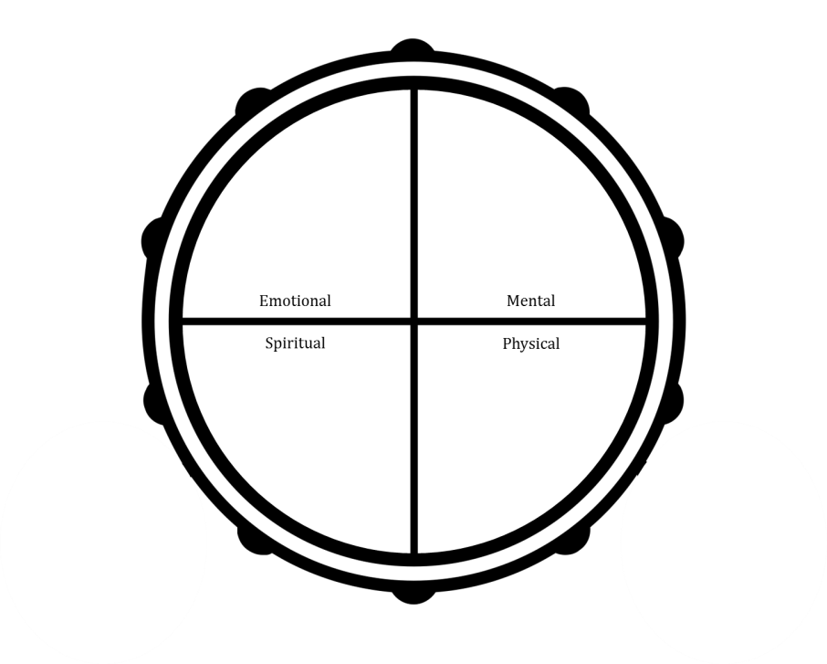

Once participants have shaded in the relevant areas, debrief the following questions with the group:

* *“Based on the areas you have shaded, how important is it for you to reduce or quit tobacco use”?* This elicits reasons for changing
* *“What would you need to do in order to achieve balance in these four areas of health so you could feel confident in reducing or quitting tobacco use?”* This elicits actions they could take

You may decide to write down their responses on flip chart so you can make connections between shared experiences and reflections.

**Note:** This exercise is based on the *Readiness Ruler* (Miller and Rollnick, 2013). If you would prefer to use the Readiness Ruler to support this activity, refer to *Helper’s Resources*.

**Materials Required:** You will need copies of the participant booklet or the *Exploring Readiness* handout, pens for writing, flip chart and markers (if using).

#### Option C: Exploring Change

Instructions: Give each participant a copy of the *Strengths, Weaknesses, Opportunities, Challenges (SWOC) Analysis* handout or ask them to turn to page 14 in their participant booklet. Ask participants to write down their strengths, weaknesses, opportunities, and challenges as they relate to tobacco reduction and cessation.

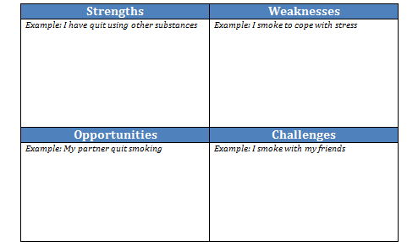

Once participants have written down their responses, debrief the activity by asking participants to share their responses with the larger group. You may decide to write down their responses on flip chart so you can make connections between shared experiences and reflections.

**Note:** This exercise is based on the *Decisional Balance* (Sobell and Sobell, 2011). If you would prefer to use the Decisional Balance to support this activity, refer to *Helper’s Resources*.

**Materials Required:** You will need copies of the participant booklet or the *Strengths, Weaknesses, Opportunities, Challenges* (*SWOC) Analysis* handout, pens for writing, flip chart and markers (if using).

#### Option D: How much is Tobacco Use Costing Me?

**Instructions:** This can be facilitated in a large group with each person doing their own calculations. Begin by asking the group a general question about how much they think they spend on tobacco per year. Have a brief discussion about how they came to that figure. Then ask each participant to do their own calculation. No one will be asked to share this publicly unless they volunteer.

* Step 1: Ask participants to write down the cost of 1 pack of cigarettes.
* Step 2: Ask them to multiply the cost of 1 pack by the number of packs they use in a week.
* Step 3: Ask them to multiply that number by 52 weeks.
* Step 4: Ask them to multiply that number by the number of years they have been using tobacco
* Step 5: In the large group, brainstorm what they could buy or do with the money they spend. You could begin by writing the following statement on a flip chart: *“If I had ____ dollars I would….”*

**Note:** Depending on the math skills in the group you may want to do the calculation for them. You will need to know the cost of a pack of cigarettes in your community.

**Materials Required:** You will need copies of the participant booklet (which includes blank pages to make notes) or you can hand out pieces of blank paper, pens for writing, flip chart and markers (if using), calculators (2 or 3 – phone calculators can also be used if preferred).

## Triggers and Coping Strategies

**Approximate Time:** 20 minutes

**Goal:** Identify triggers for smoking and discuss coping strategies

Identifying challenging situations or feelings is an important first step towards being able to develop a way to cope with triggers to use tobacco. It can be challenge for a person who uses tobacco in many different settings or in response to many different feelings to come up with triggers to tobacco use. However, the process of identifying the feelings, times of day, events, or situations is key to coming up with a plan. Simply opening up the conversation can give a person the opportunity to think about and plan for the situations that may be difficult for them. We have recommended two approaches you may want to use to discuss triggers and coping strategies with the group.

#### Option A: Balancing Health and Well-being

**Instructions:** Give each participant a copy of the *Balancing Health and Well-being* handout or ask them to turn to page 15 in their participant booklet. Ask participants to write down their triggers to using tobacco and then identify a coping strategy for each.



*My partner smokes inside the house. I will ask them if they can smoke outside.*

Once participants have written down their responses, debrief the activity by asking participants to share their responses with the larger group. You may decide to write down their responses on flip chart so you can make connections between shared experiences and reflections.

**Note:** If participants are having difficulty coming up with coping strategies, ask them refer to page 16 in their booklet for examples of coping strategies, or provide a copy of the *Coping Strategies* handout.

**Materials Required:** You will need copies of the participant booklet or the *Balancing Health and Well-being* handout, pens for writing, flip chart and markers (if using).

#### Option B: Piecing the Puzzle Together

**Instructions:** Ask participants to form groups of three. Give each group a full set of the puzzle pieces so they can put their puzzle together. As they work on the puzzle, ask them to talk about the triggers listed on each of the puzzle pieces and discuss coping strategies for each.

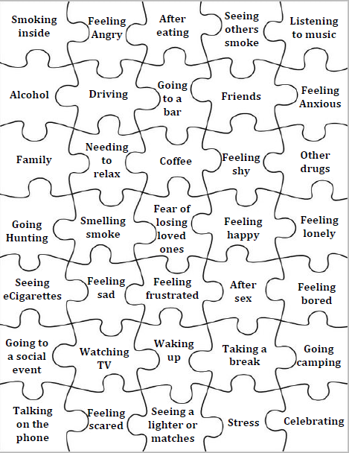

Once participants have completed their puzzles, debrief the activity by asking participants to share their coping strategies with the larger group. You may decide to write down their responses on flip chart so you can make connections between shared experiences and reflections.

**Note:** If participants are having difficulty coming up with coping strategies, ask them refer to page 16 in their booklet for examples of coping strategies, or provide a copy of the *Coping Strategies* handout.

**Materials Required:** You will need the puzzle pieces (template for printing is provided in *Helper’s Resources*) and flip chart and markers (if using).

## Making a Change

**Approximate Time:** 25 minutes

**Goal:** Set first behavioural goal in preparation for tobacco cessation or reduction journey

Making a decision to change can be an intimidating process, particularly when it involves giving up a long-term behaviour, such as tobacco use. Therefore, the emphasis on following activities is to continue to build motivation by focusing on the tools and strategies that can be helpful in supporting quitting or reducing tobacco use.

Below, we have provided activities you can use to discuss the possibility of making a change to tobacco use. We recommend that you offer both activities (i.e., Part 1 and Part 2). Part 2 of the activity will ask participants to set a behavioural goal in preparation for their tobacco cessation or reduction journey.

#### Part 1: Supporting Change

**Instructions:** This activity will provide participants with the opportunity to discuss ways to support change at the individual, family and community level. The activity can take place in three parts:

1. Individual Level – handout labels (or something sticky that participants can write on) and markers to participants. Ask them to create their own sticker they can place on their cigarette pack. This sticker can serve as a reminder for them not to smoke, include coping strategies, or supports to reach out to instead of smoking. Participants can personalize their sticker to meet their needs. If you have the resources to do so, you could also have participants create their own “quit kits”. These kits could include items to occupy their hands and mouth when they feel cravings. Items could include bottles of water, fidget toys, and sugar-free gum or candies. Additionally, you may also consider including tailored dosing of cessation medications.
2. Family Level – lead a discussion with the group about family tobacco use and how this may be a barrier to change. Write responses on flip chart paper. Discussion points could include:
   1. Impact of second and third-hand smoke on family members and pets. Some Inuk have described associating their parental bond with the smell of smoke. You may consider guiding participants through the impact of second and third-hand smoke through their senses:
      1. Sight: smoke in the air, nicotine stains on walls and surfaces while cleaning.
      2. Smell: infant and childhood memories associated with smoke and relationships to parents and family members, the lack of choice sometimes for pets to experience fresh air.
      3. Taste: increasing salt in food may affect children and other family member’s palates.
      4. Touch: burns and singes, sticky walls and surfaces from nicotine.
      5. Hearing: triggers of sounds of lighters and sucking in related to stress.
   2. Identifying coping strategies.

**Note:** there is a growing evidence of the linkages to early childhood trauma and early onset of smoking (Felitti et al., 1998). When one addresses their tobacco addiction it is important to recognize there could be unresolved childhood trauma that may also need to be addressed.

* 1. Discussing sharing tobacco with family members including youth and young children.

**Note:** this topic may be difficult to discuss, particular in regions where there is housing insecurity and overcrowding issues. The purpose of this discussion is to foster shared support among group members around some of the challenges they may be faced with in changing their tobacco use.

1. Community Level – lead a discussion with the group around community-specific supports that may help with tobacco use reduction or cessation.

**Note:** It will be your responsibility to generate a list of useful community-specific supports based on what is available in the community (e.g., opportunities for physical activity, upcoming community events, quit and win contests, quit lines, etc.).

**Materials Required:** You will need labels and markers to create the stickers, items for the quit kits, and flip chart and markers (if using).

#### Part 2: Starting the Journey

**Instructions:** Give each participant a copy of the *Making a Change (Part 1)* handout or ask them to turn to page 22 in their participant booklet. Ask participants to set a behavioural goal in preparation for the tobacco use reduction or cessation. **Note:** For a person who is not yet ready to change their tobacco use, the focus of this activity can remain on barriers to change, as well as possible strategies for overcoming those barriers. A behavioural goal for someone not ready to quit or reduce might focus on a goal to smoke outside to prevent other people and animals in the home from the effects of second-hand smoke. If tobacco use is a way to cope with stress, the person’s goal might be to first try one or two other useful strategies for stress management before having a cigarette, and noting how helpful these alternative strategies are.

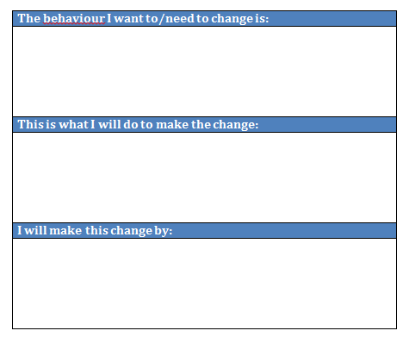

Once participants have written down their responses, debrief the activity with the group through a strength-based approach. Invite participants to share their goal with the group or they may choose to keep their goal private if that is their preference. It is very important to let participants know that if they do not meet their goal following the session, that does not make them a failure and will not impact their ability to participate in future sessions.

**Materials Required:** You will need copies of the participant booklet or the *Making a Change (Part 1)* handout, pens for writing, and flip chart and markers (if using).

## Wrap-up and Closing

**Approximate Time:** 5 minutes

This can be done orally as part of the session.

If you are handing out session evaluations (refer to *Helper’s Resources* for a sample Evaluation template), encourage participants to complete the evaluation. **Tip:** if you choose to hand out a paper copy have the participants fill it out while still in the session before you close.

As part of the closing, reiterate the opening words of welcome. Thank the group for having the courage to participate. End with a closing prayer (if applicable) or other good wishes.

# Session 3: Preparing for the Tobacco Cessation or Reduction Journey

## Helper’s Checklist

**Important Note:** All of the following activities and resources are optional in the sense that you can (and should) tailor the session to the needs of your group and community.

### Materials Required

* Name tags (if using)
* Sign in sheets
* Pens (for participants to make notes or fill out handouts)
* Flip chart and markers
* Computer with audio and projector (if playing videos)
* Internet access (if sharing online videos or websites)
* Refreshments (if feasible)
* Any materials required for the icebreaker session (refer to *Helper’s Resources* for ideas)
* Any materials required for traditional Inuit activities (refer to *Helper’s Resources* for ideas)
* Any materials required for Western-based activities refer to *Helper’s Resources* for ideas)
* Samples of pharmacotherapy for tobacco cessation (e.g., patch, gum, inhaler, spray, lozenge)
* Answer Key for True or False – Learning More about Tobacco Cessation Medication(refer to *Helper’s Resources* for a copy)
* Evaluations (refer to *Helper’s Resources* for copies)

### Handouts Required

You may decide to give the entire participant booklet to participants which they can then bring with them to each session. If this option is not feasible, you can provide participants with the handouts required for session 1 which include:

* Medication for Tobacco Cessation
* True or False – Learning More about Tobacco Cessation Medication
* Resources to Supporting Quitting or Reducing
* Making a Change (Part 2)

|  |  |  |
| --- | --- | --- |
| Summary of Session 3 | | |
| Goal | **Content and Activities** | **Preparation** |
|  | Opening and Welcome  *10 minutes* | * Invite an Elder or community member to open the session (if preferred) * Print a copy of the sign-in sheet (if using) * Print copies of the participant booklet (if you are not using individual handouts) * If you have chosen an icebreaker, refer to *Helper’s Resources* for more details on preparation |
|  | Review from Session 2  *15 minutes* | * Flip chart and markers |
| *Introduce tobacco cessation or reduction strategies (psychosocial)* | Supporting Tobacco Cessation or Reduction (Part 1)  *20 minutes* | * Any materials required for traditional Inuit activities (refer to *Helper’s Resources* for ideas) * Any materials required for Western-based activities (refer to *Helper’s Resources* for ideas) * Invite an Elder or community member to share teachings on traditional ways to deal with stress |
| *Introduce tobacco cessation or reduction strategies (pharmacological)* | Supporting Tobacco Cessation or Reduction (Part 2)  *20 minutes* | * Invite a physician, nurse practitioner, or nurse to share information on medications for tobacco cessation OR * Choose YouTube videos to share with the group   + Computer, projector, internet connection, computer audio (e.g., external speakers) * Print copies of *Medication for Tobacco Cessation* * Print copies of *True or False – Learning More about Tobacco Cessation Medication* and a copy of the *Answer Key* for yourself * Flip chart and markers |
| *Developing/enhancing cessation or reduction journey* | Revisiting the Journey  *20 minutes* | * Print copies of *Resources to Supporting Quitting or Reducing Tobacco Use* * Print copies of *Making a Change (Part 2)* * Flip chart and markers |
|  | Wrap-up and Closing  *5 minutes* | * Print copies of the *Evaluations* (if using) * Invite an Elder, or community member to close the session (if preferred) |

## Opening and Welcome

**Approximate Time:** 10 minutes

* Introduce yourself as the helper for the session.
* Lead the group in an opening prayer or welcome participants to the session. The way to open the session should be relevant to the community. If an Elder has been invited to participate, they may want to open the session.
* Provide or review logistical information, which can include:
  + Sign-in (if using): Direct participants to sign-in sheet on resource table (optional and based on community preference);
  + Breaks: Discuss when breaks will happen and protocols around smoking during breaks;
  + Washrooms: Indicate location and provide directions.
  + Refreshments: Indicate if there are any available to participants (e.g., snacks, water, etc.).
* Describe the structure of the session, intended learning outcomes, and overall content for the session. Here is an example introduction to the content and structure of the session: *Thank you for coming to this third of six sessions focused on tobacco use. As you might recall, each session has its own theme. The theme for the first session was exploring the history and impact of tobacco use in Inuit communities and what a tobacco cessation or reduction journey may look like. In the second session we discussed ways in which you could begin to think about your own tobacco reduction or cessation journey, talked about triggers to using tobacco, discussed ways to cope with these triggers, and the possibility of making a change with tobacco use. Today, we will explore preparing for your own tobacco reduction or cessation journey. In the last few sessions we will discuss strategies to support quitting, and prepare for staying with the journey after these sessions have ended. Everyone’s voice is important, since we all have experience with tobacco – either ourselves or with our families, friends and community. In this way we all have teachings to share and we can all learn.*
* Invite the participants to introduce themselves again (if there are new members). Participants can provide their name or in a way that is most comfortable to them.
* Lead the group in an icebreaker activity – refer to *Helper’s Resources* for more information,

## Review from Session 2

**Approximate Time:** 15 minutes

* Review the group guidelines developed from session 1. Ask the participants if they would like to make any changes to the guidelines.
* In the previous session, you asked participants to set a behavioural goal related to their tobacco use. Spend some time exploring goals with participants using the following questions to guide the conversation. **Note:** You may want to write down responses on flip chart:
  + How did it go this week? What did you learn?
  + Where are you getting stuck? What was challenging? (this can help elicit support from other group members as well)
  + To end the discussion, remember to emphasis that change is an ongoing process and it will not always be easy. Make sure participants know that if they did not meet their goal, that this does not make them a failure and will not impact their ability to participate in future sessions.
* In the first week you also introduced the participants to the importance of tracking their tobacco use. Spend a few minutes reviewing the experience of tracking using the following questions to guide the conversation. **Note:** You may want to write down responses on flip chart:
  + Did you learn anything new? Any surprises? (e.g., patterns, triggers).
  + To end the discussion, reinforce the importance of tracking (e.g., can help identify triggers for use and make help to reduce automatic tobacco use).

## Supporting Tobacco Cessation or Reduction (Part 1)

**Approximate Time:** 20 minutes

**Goal:** Introduce tobacco cessation or reduction strategies (psychosocial)

Every moment someone decides not to smoke is a win however; quitting tobacco use can be a long and difficult journey to healing. Many individuals will require intensive and ongoing psychosocial support in their quitting journey which may go beyond the sessions you can provide. Psychosocial support can involve evidence- or wise-based approaches to health and wellness or a combination of both.

We have provided three possible ways you can offer psychosocial support during the session. **Note:** Some of these activities could take up a whole session or be offered over multiple sessions. We have provided time, resource, and community considerations under these activities so you can choose the option that would work best for your community and setting.

#### Option A: Culturally-specific Ways to Support Tobacco Cessation or Reduction

**Instructions:** Incorporating culturally-specific ways to support tobacco cessation or reduction may be essential to your participant’s well-being. As such, you may decide to offer a traditional art-, land- or sea-based activity. Engaging the group in a traditional approach to health and healing may increase participation, help keep their hands busy, and their minds off tobacco use. You may choose to invite an Elder or community member to facilitate the activity. Teachings can be provided while participants are engaged in the activity. Discussions around tobacco use reduction or cessation can also be integrated throughout.

**Considerations:** If you are facilitating a traditional art-, land- or sea-based activity there are a number of considerations you will need to think about before offering the activity. Review this checklist to see if offering this activity will be feasible within your community and setting:

* Does your organization have the funds needed to provide the materials (e.g., hunting equipment, materials for carving, etc.)?
* Is there an Elder or community member than can co-lead the activity with you and offer teachings?
* If you decide to go out on the land, can you provide transportation? Is the area for hunting or fishing easily accessible?
* How time intensive is the activity? You may need to offer over a full session or over a series of sessions. Repetition is often the key to supporting a positive healing journey.
* Does your group want to incorporate traditional ways to support their health and healing? Or would they prefer a Western-based approach?

**Materials Required:** Any materials required for traditional Inuit activities (refer to *Helper’s Resources* for ideas).

#### Option B: Western-based Approaches to Support Tobacco Cessation or Reduction

**Instructions:** Western-based approaches to health and wellness may be of interest to your group. Some options could potentially include leading the participants in:

* Meditation and mindfulness – deep breathing, body scans, guided meditation
* Physical Activity – walking group, stretching, physically active games
* Journaling – writing down thoughts and feelings, poems, stories, etc.

**Considerations:** If you are facilitating one of the activities above there are some considerations you will need to think about before offering the activity. Review this checklist to see if offering this activity will be feasible within your community and setting:

* Does your organization have the funds needed to provide the materials (e.g., journals, resources needed for the chosen physical activity, etc.)?
* If you decide to engage in physical activity, can all members of the group safely participate?
* How time intensive is the activity? You may need to offer over a full session or over a series of sessions. Repetition is often the key to supporting a positive healing journey.
* Does your group want to incorporate Western-based ways to support their health and healing? Or would they prefer a traditional approach?

**Materials Required:** Any materials required for Western-based activities (refer to *Helper’s Resources* for ideas).

#### Option B: Traditional Ways to Address Stress

**Instructions:** Before the session, invite an Elder or community member to share teachings around the traditional ways Inuit handled stress or supported relaxation before tobacco products were introduced to them. After stories or teachings are shared, the Elder or community member may invite participants to reflect on what was shared.

We acknowledge that there are some communities where it may be difficult to find and/or ask an Elder or community member to speak on these issues. If this is not possible in your community, you may consider discussing the following points to start the conversation:

Traditionally Inuit dealt with stress in different ways:

* Sometimes women chewed on hides to soften them up or worked on skins as a form of stress relief.
* Sometimes men would work on tools for hunting or go out hunting to relieve stress.
* Other forms of stress relief included going for walks, sewing, hunting, climbing hills, fixing sod houses/tents, sleds, or qajaq/kayaks, boots, putting up hides, playing Inuit games, singing, being outdoors, going for hikes to read the weather, talking to Elders, or going get ice/fresh water for drinking.

**Materials Required:** If you are inviting an Elder or community member to the session than no materials are required for this activity. However, you will need to contact the Elder or community member before the session and prepare them in advance so that they are aware of the purpose of the session and what their role will be.

## Supporting Tobacco Cessation or Reduction (Part 2)

**Approximate Time:** 20 minutes

**Goal:** Introduce tobacco cessation or reduction strategies (pharmacological)

In order to increase the chances of quitting or reducing successfully, a comprehensive approach to tobacco use is recommended. This also includes addressing the biological effects resulting from withdrawal from nicotine. Participants may need to use medications in order to support them in quitting or reducing their tobacco use.

We have provided two approaches you may want to use in discussing medications for tobacco cessation with participants.

#### Option A: Discussing Medications for Tobacco Cessation

**Instructions:** Before the session, invite a prescriber (e.g., doctor, nurse practitioner, pharmacist, etc.) to share information about medications for tobacco cessation and reduction. If possible ask the prescriber to bring samples of medication with them so that participants can see them and touch them. Some topics to cover could include:

* Differences between nicotine replacement therapy (NRT) and prescription medications (e.g., bupropion and varenicline).
* Withdrawal side effects and potential side effects from medication
* Ways medication can be helpful in supporting tobacco cessation and reduction
* Medication access and coverage (e.g., Non-insured Health Benefits)

After information is shared, invite participants to reflect on what was shared or ask questions. **Note:** If relevant to your group, you also may wish to incorporate a discussion about traditional medicines that can support tobacco cessation and withdrawal side effects. This can be the role of the prescriber to discuss or you may consider inviting an Elder or community member to share teachings on traditional medicines. Examples have been provided below:

|  |  |
| --- | --- |
| **Traditional Medicines** | **Potential Withdrawal Symptom** |
| Heated stones | Pain joints or aches |
| Skins or seal fat | Sore throat or cough |
| Fresh water | Headaches |

If you cannot invite a prescriber to share information about medications, you may consider using the following resources to start the conversation:

Non-insured Health Benefits for First Nations and Inuit: <https://www.canada.ca/en/health-canada/services/non-insured-health-benefits-first-nations-inuit.html>

Cessation Aids and Coverage in Canada (Canadian Partnership Against Cancer): <https://content.cancerview.ca/download/cv/prevention_and_screening/tobacco_cessation/documents/cessationaidcoverage2pdf?attachment=0>

Tobacco Has No Place Here (information on each of the medications for smoking cessation): <http://www.nuquits.gov.nu.ca/quit-tools/quit-aids>

Tobacco Has No Place Here (downloadable resources with infographics about medication available in English, Inuktitut, French, and Inuinnaqtun): <http://www.nuquits.gov.nu.ca/quit-tools/quit-resources>

Government of Northwest Territories (information on each of the medications for smoking cessation): <http://www.nuquits.gov.nu.ca/tobacco-101>

TEACH Project YouTube Channel (includes videos on how to use each of the nicotine replacement therapies): <https://www.youtube.com/user/teachproject/videos>

**Materials Required:** If you are inviting a prescriber (e.g., doctor, nurse practitioner, pharmacist, etc.) to the session then you will need to contact them before the session and prepare them in advance so that they are aware of the purpose of the session and what their role will be.You will need copies of the participant booklet or the *Medication for Tobacco Cessation* handout (page 23 in the *Participant Booklet*), pens for writing, flip chart and markers (if using). If you are sharing print and/or electronic resources, you may need to print out specific sections or share the resource on a computer with projector. If you are sharing videos through YouTube, you will need a computer, projector, internet access, and computer audio (e.g., external speakers).

#### Option B: True or False – Learning More about Tobacco Cessation Medication

**Instructions:** Give each participant a copy of the *True or False – Learning More about Tobacco Cessation Medication* handout or ask them to turn to page 33 in their participant booklet. Complete the quiz as a group. Write down each of the responses on flip chart. Once you have completed the quiz as a group, take up each of the answers by using the *Answer Key* (provided in *Helper’s Resources*) as a guide. Have a discussion about each of the responses and invite participants to ask additional questions.

**Note:** You can also ask participants to complete the quiz individually and then take up the answers as a group if that is preferred.

**Materials Required:** You will need copies of the participant booklet or the *True or False – Learning More about Tobacco Cessation Medication* handout, the *Answer Key* (refer to *Helper’s Resources*), pens for writing, flip chart and markers (if using).

## Revisiting the Journey

**Approximate Time:** 20 minutes

**Goal:** Developing/enhancing cessation or reduction journey

Making a decision to change can be an intimidating process, particularly when it involves giving up a long-term behaviour, such as tobacco use. Similar to session 2, the emphasis on following activities is to continue to build motivation by focusing on the tools and strategies that can be helpful in supporting quitting or reducing tobacco use.

Below, we have provided activities you can use to discuss the possibility of making a change to tobacco use. We recommend that you offer both activities (i.e., Part 1 and Part 2). Part 2 of the activity will ask participants to set a revised behavioural goal in preparation for their tobacco cessation or reduction journey.

#### Part 1: Supporting Change

**Instructions:** This activity will provide participants with the opportunity to discuss how tobacco cessation or reduction may impact multiple areas of their life. Discuss with participants how quitting may impact other areas of life (e.g., substance use, mental health, physical activity, nutrition, etc.). Generate a list of areas participants would like to be mindful of and identify strategies or resources participants can turn to in order to feel supported.

Revisit coping strategies identified in the second session (e.g., individual, family, and community level) and modify if necessary. Provide copies of the *Resources to Supporting Quitting or Reducing Tobacco Use* handout or ask participants to turn to page 35 in their participant booklets. Discuss the resources listed and invite questions from the participants. **Note:** If there are any community-specific supports to include, it will be your responsibility to update this handout so that it is relevant to the participants.

**Materials Required:** You will need labels copies of the participant booklet or the *Resources to Supporting Quitting or Reducing Tobacco Use* handout, pens for writing, and flip chart and markers (if using).

#### Part 2: Revisiting Your Journey

**Instructions:** Give each participant a copy of the *Making a Change (Part 2)* handout or ask them to turn to page 40 in their participant booklet. Ask participants to set a revised behavioural goal in preparation for the tobacco use reduction or cessation. **Note:** For a person who is not yet ready to change their tobacco use, the focus of this activity can remain on barriers to change, as well as possible strategies for overcoming those barriers. A behavioural goal for someone not ready to quit or reduce might focus on a goal to smoke outside to prevent other people and animals in the home from the effects of second-hand smoke. If tobacco use is a way to cope with stress, the person’s goal might be to first try one or two other useful strategies for stress management before having a cigarette, and noting how helpful these alternative strategies are.



Once participants have written down their responses, debrief the activity with the group through a strength-based approach. Invite participants to share their goal with the group or they may choose to keep their goal private if that is their preference. It is very important to let participants know that if they do not meet their goal following the session, that does not make them a failure and will not impact their ability to participate in future sessions.

**Materials Required:** You will need copies of the participant booklet or the *Making a Change (Part 2)* handout, pens for writing, and flip chart and markers (if using).

## Wrap-up and Closing

**Approximate Time:** 5 minutes

This can be done orally as part of the session.

If you are handing out session evaluations (refer to *Helper’s Resources* for a sample Evaluation template), encourage participants to complete the evaluation. **Tip:** if you choose to hand out a paper copy have the participants fill it out while still in the session before you close.

As part of the closing, reiterate the opening words of welcome. Thank the group for having the courage to participate. End with a closing prayer (if applicable) or other good wishes.

# Session 4: The Journey to Healing (Part 1)

## Helper’s Checklist

**Important Note:** All of the following activities and resources are optional in the sense that you can (and should) tailor the session to the needs of your group and community.

### Materials Required

* Name tags
* Sign in sheets
* Pens
* Flip chart and markers
* Refreshments
* Any materials required for the icebreaker session (refer to *Helper’s Resources* for ideas)
* Any materials required for traditional Inuit activities (refer to *Helper’s Resources* for ideas)
* Any materials required for Western-based activities (refer to *Helper’s Resources* for ideas)
* Evaluations (refer to *Helper’s Resources* for copies)

### Handouts Required

You may decide to give the entire participant booklet to participants which they can then bring with them to each session. If this option is not feasible, you can provide participants with the handouts required for session 4 which include:

* Withdrawal Symptoms
* Coping Strategies

|  |  |  |
| --- | --- | --- |
| Summary of Session 4 | | |
| Goal | **Content and Activities** | **Preparation** |
|  | Opening and Welcome  *10 minutes* | * Invite an Elder or community member to open the session (if preferred) * Print a copy of the sign-in sheet (if using) * Print copies of the participant booklet (if you are not using individual handouts) * If you have chosen an icebreaker, refer to *Helper’s Resources* for more details on preparation |
| *Discuss quit attempt experiences* | Sharing Your Experiences  *30 minutes* | * Print copies of *Withdrawal Symptoms* * Flip chart and markers |
| *Staying on the journey - develop/implement coping strategies* | Revisiting Coping Strategies  *25 minutes* | * Print copies of *Coping Strategies* * Print copies of *Resources to Supporting Quitting or Reducing Tobacco Use* * Flip chart and markers * Any materials required for traditional Inuit activities (refer to *Helper’s Resources* for ideas) * Any materials required for Western-based activities (refer to *Helper’s Resources* for ideas) |
| *Discuss thoughts on tobacco use* | Thinking About Tobacco Use  *20 minutes* | * Flip chart and markers |
|  | Wrap-up and Closing  *5 minutes* | * Print copies of the *Evaluations* (if using) * Invite an Elder, Knowledge Keeper or Community Member to close the session (if preferred) |

## Opening and Welcome

**Approximate Time:** 10 minutes

* Introduce yourself as the helper for the session.
* Lead the group in an opening prayer or welcome participants to the session. The way to open the session should be relevant to the community. If an Elder has been invited to participate, they may want to open the session.
* Provide or review logistical information, which can include:
  + Sign-in (if using): Direct participants to sign-in sheet on resource table (optional and based on community preference);
  + Breaks: Discuss when breaks will happen and protocols around smoking during breaks;
  + Washrooms: Indicate location and provide directions.
  + Refreshments: Indicate if there are any available to participants (e.g., snacks, water, etc.).
* Describe the structure of the session, intended learning outcomes, and overall content for the session. Here is an example introduction to the content and structure of the session: *Thank you for coming to this fourth of six sessions focused on tobacco use. As a quick review, the first session explored the history and impact of tobacco use in Inuit communities and what a tobacco cessation or reduction journey may look like. In the second session we discussed ways in which you could begin to think about your own tobacco reduction or cessation journey, talked about triggers to using tobacco, discussed ways to cope with these triggers, and the possibility of making a change with tobacco use. Last session, we explored preparing for your own tobacco reduction or cessation journey. In today’s session we will discuss strategies to support quitting. In the final two sessions we will prepare for staying with the journey after these sessions have ended. Everyone’s voice is important, since we all have experience with tobacco – either ourselves or with our families, friends and community. In this way we all have teachings to share and we can all learn.*
* Invite the participants to introduce themselves again (if there are new members). Participants can provide their name or in a way that is most comfortable to them.
* Lead the group in an icebreaker activity – refer to *Helper’s Resources* for more information.
* Review the group guidelines developed from session 1. Ask the participants if they would like to make any changes to the guidelines.

**Note:** This session does not include a designated time for *Review of Session 2* as a discussion around quit or reduction attempts will be included as part of the activities for this session.

## Sharing Your Experiences

**Approximate Time:** 30 minutes

**Goal:** Discuss quit attempt experiences

In the previous session, you asked participants to set a behavioural goal related to their tobacco use. Setting a goal can be difficult and many of your group members may not be ready to quit or reduce their tobacco use. As well, participants may feel shame or sense of failure in not being able to achieve the goal they set for themselves. Accordingly, it is important to reinforce with group members a strengths-based approach to goal setting. Providing participants with the opportunity to share their experiences will help others to see that they are not alone in their journey – there are other group members who may have faced similar challenges in trying to meet the goal they set for themselves.

We have provided two approaches you may want to use in discussing quit or reduction attempt experiences. **Note:** We recommend that you offer both approaches however if you can only choose one, offer Option A. It is important to revisit the goals set from the previous session.

#### Option A: How Quitting or Reducing Made Me Feel

**Instructions:** Spend some time exploring goals set during the previous session. You may want to set up the discussion with the following statement: *We expect people may be at different places and important to remember quitting or reducing is process and learning experience and it’s the effort that counts. So, want to be supportive of everyone where they are – some may have had an easier time than others, some may have smoked, others not. So, whatever your experience, remember we’re all in this together.*

To guide the conversation use the following prompts. Make sure to provide positive reinforcement and feedback to each participant:

* + How did it go this week?
  + What was challenging? (this can help elicit support from other group members as well)
  + What was helpful?

On a piece of flip chart paper, draw an iceberg. Below the surface of the water write the following key words: emotional, mental, spiritual. Above the water write the following key word: physical.

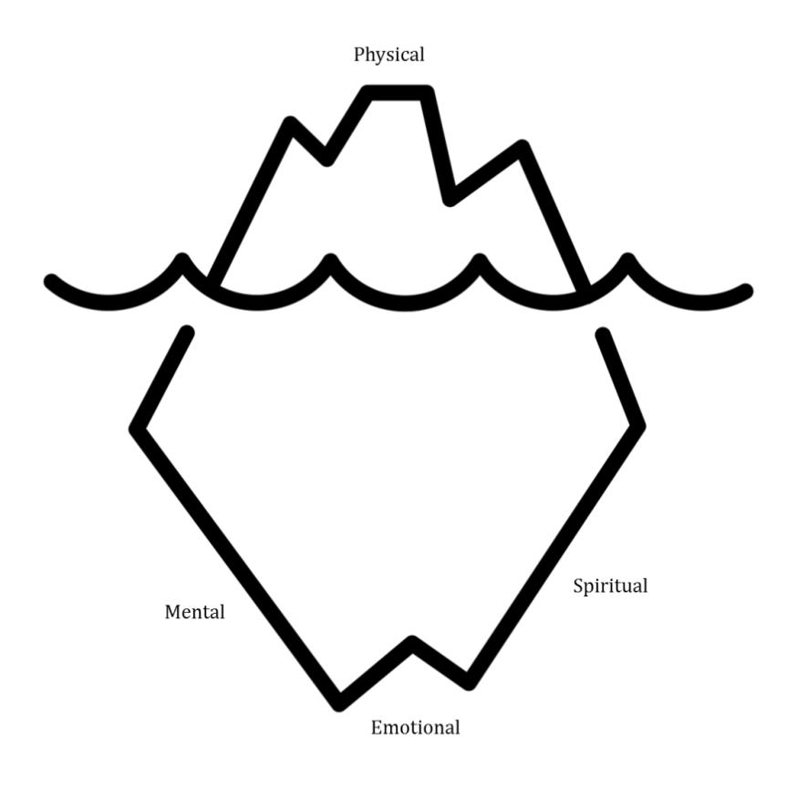

Ask participants to share how they felt making a quit or reduction attempt using the four core areas of health as a guide. Their responses can be both positive and negative. As participants share, write their responses on the flip chart under each of the core areas of health. Highlight the connections between shared experiences and reflections.

**Materials:** You will need flip chart and markers.

#### Option B: Withdrawal from Quitting or Reducing

**Instructions:** Give each participant a copy of the *Withdrawal Symptoms* handout or ask them to turn to page 41 in their participant booklet. As a group, discuss the withdrawal symptoms listed and ask participants to add other withdrawal symptoms that are missing and identify withdrawal symptoms they may have experienced. Write these withdrawal symptoms on flip chart paper for participants to see. As a group, come up with potential coping strategies to address each of the withdrawal symptoms. **Note:** it is important that you stress that everyone is different and not everyone will experience withdrawal the same.

**Materials Required:** You will need copies of the participant booklet or the *Withdrawal Symptoms* handout, pens for writing, flip chart and markers (if using).

## Revisiting Coping Strategies

**Approximate Time:** 25 minutes

**Goal:** Staying on the journey - develop/implement coping strategies

Quitting tobacco use can be a long and difficult journey to healing. Many individuals will require intensive and ongoing psychosocial support in their quitting journey which may go beyond the sessions you can provide. Psychosocial support can involve evidence- or wise-based approaches to health and wellness or a combination of both.

We have provided three possible ways you can offer psychosocial support during the session. **Note:** Some of these activities could take up a whole session or be offered over multiple sessions. We have provided time, resource, and community considerations under these activities so you can choose the option that would work best for your community and setting.

#### Option A: Culturally-specific Ways to Support Tobacco Cessation or Reduction

**Instructions:** Incorporating culturally-specific ways to support tobacco cessation or reduction may be essential to your participant’s well-being. As such, you may decide to offer a traditional art-, land- or sea-based activity. Engaging the group in a traditional approach to health and healing may increase participation, help keep their hands busy, and their minds off tobacco use. You may choose to invite an Elder or community member to facilitate the activity. Teachings can be provided while participants are engaged in the activity. Discussions around tobacco use reduction or cessation can also be integrated throughout.

**Considerations:** If you are facilitating a traditional art-, land- or sea-based activity there are a number of considerations you will need to think about before offering the activity. Review this checklist to see if offering this activity will be feasible within your community and setting:

* Does your organization have the funds needed to provide the materials (e.g., hunting equipment, materials for carving, etc.)?
* Is there an Elder or community member that can co-lead the activity with you and offer teachings?
* If you decide to go out on the land, can you provide transportation? Is the area for hunting or fishing easily accessible?
* How time intensive is the activity? You may need to offer over a full session or over a series of sessions. Repetition is often the key to supporting a positive healing journey.
* Does your group want to incorporate traditional ways to support their health and healing? Or would they prefer a Western-based approach?

**Materials Required:** Any materials required for traditional Inuit activities (refer to *Helper’s Resources* for ideas).

#### Option B: Western-based Approaches to Support Tobacco Cessation or Reduction

**Instructions:** Western-based approaches to health and wellness may be of interest to your group. Some options could potentially include leading the participants in:

* Meditation and mindfulness – deep breathing, body scans, guided meditation
* Physical Activity – walking group, stretching, physically active games
* Journaling – writing down thoughts and feelings, poems, stories, etc.

**Considerations:** If you are facilitating one of the activities above there are some considerations you will need to think about before offering the activity. Review this checklist to see if offering this activity will be feasible within your community and setting:

* Does your organization have the funds needed to provide the materials (e.g., journals, resources needed for the chosen physical activity, etc.)?
* If you decide to engage in physical activity, can all members of the group safely participate?
* How time intensive is the activity? You may need to offer over a full session or over a series of sessions. Repetition is often the key to supporting a positive healing journey.
* Does your group want to incorporate Western-based ways to support their health and healing? Or would they prefer a traditional approach?

**Materials Required:** Any materials required for Western-based activities (refer to *Helper’s Resources* for ideas).

#### Option C: Revisiting Coping Strategies

**Instructions:** Revisit coping strategies identified in the second and third session (e.g., individual, family, and community level) and modify if necessary. Provide copies of the *Coping Strategies* handout or ask participants to turn to page 16 in their participant booklets. Ask participants if they have used any of these coping strategies or identified additional coping strategies. Invite them to share their experiences with the group.

Provide copies of the *Resources to Supporting Quitting or Reducing Tobacco Use* handout or ask participants to turn to page 35 in their participant booklets. Ask participants if they have used any of these resources and ask them to share their experiences with them. Ask participants if they have found any other supports that they have found helpful and invite them to share information about these resources with the group. **Note:** If there are any community-specific supports to include, it will be your responsibility to update this handout so that it is relevant to the participants.

**Materials Required:** You will need copies of the participant booklet or the *Coping Strategies* handout and the *Resources to Supporting Quitting or Reducing Tobacco Use* handout, pens for writing, and flip chart and markers (if using).

## Thinking about Tobacco Use

**Approximate Time:** 20 minutes

**Goal:** Discuss thoughts on tobacco use

When individuals are quitting or reducing smoking, thoughts that counter their ability to do so will occur. It is important to discuss these counter thoughts with individuals so they can recognize them and respond to them in a different way instead of smoking.

We have provided one approach you can use in exploring ways to deal with counter thoughts about tobacco use.

#### Option A: Thoughts on Tobacco Use (Part 1)

**Instructions:** On a piece of flip chart paper, draw a drum (qilaujjaq) and divide it into four quadrants. In each of the quadrants, write the following key words: emotional, mental, spiritual, and physical.

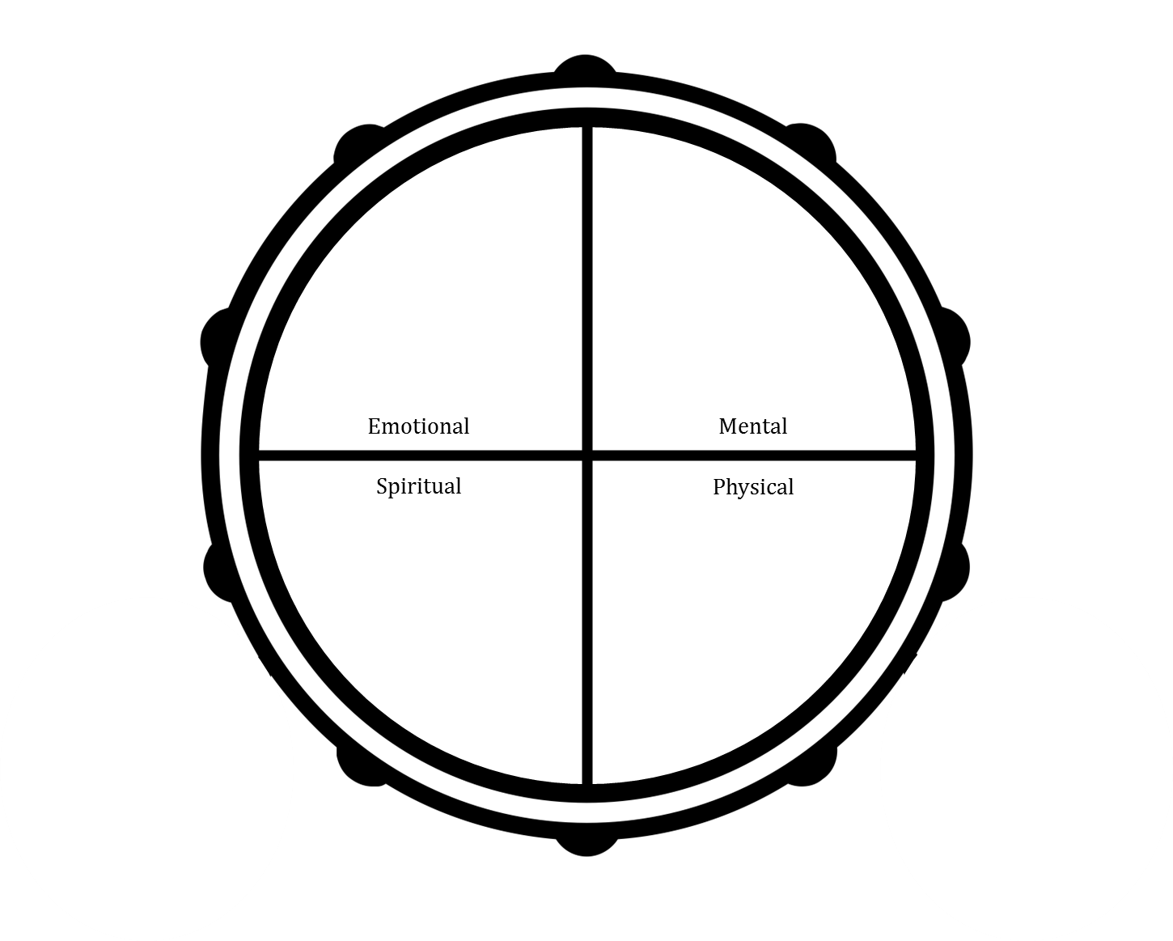

Ask participants to share potential thoughts they may have when considering to use tobacco using the four core areas of health as a guide. Their responses can be both positive and negative. As participants share, write their responses on the flip chart under each of the core areas of health. Highlight the connections between shared experiences and reflections.

**Note:** Save this flip chart for the next session. You will need to refer back to it in order to complete the follow up part of this activity (refer to page 58 for more information).

**Materials:** You will need flip chart and markers.

## Wrap-up and Closing

**Approximate Time:** 5 minutes

This can be done orally as part of the session.

If you are handing out session evaluations (refer to *Helper’s Resources* for a sample Evaluation template), encourage participants to complete the evaluation. **Tip:** if you choose to hand out a paper copy have the participants fill it out while still in the session before you close.

As part of the closing, reiterate the opening words of welcome. Thank the group for having the courage to participate. End with a closing prayer (if applicable) or other good wishes.

*Image provided courtesy of Cancer Care Ontario*

# Session 5: The Journey to Healing (Part 2)

## Helper’s Checklist

**Important Note:** All of the following activities and resources are optional in the sense that you can (and should) tailor the session to the needs of your group and community.

### Materials Required

* Name tags
* Sign in sheets
* Pens
* Flip chart and markers
* Computer with audio and projector (if playing videos)
* Internet access (if sharing online videos or websites)
* Refreshments (if feasible)
* Any materials required for the icebreaker session (refer to *Helper’s Resources* for ideas)
* A ball of yarn or string
* Any materials required for traditional Inuit activities (refer to *Helper’s Resources* for ideas)
* Any materials required for Western-based activities (refer to *Helper’s Resources* for ideas)
* Evaluations (refer to *Helper’s Resources* for copies)

### Handouts Required

You may decide to give the entire participant booklet to participants which they can then bring with them to each session. If this option is not feasible, you can provide participants with the handouts required for session 5 which include:

* Developing a Wholistic Plan

|  |  |  |
| --- | --- | --- |
| Summary of Session 5 | | |
| Goal | **Content and Activities** | **Preparation** |
|  | Opening and Welcome  *10 minutes* | * Invite an Elder or community member to open the session (if preferred) * Print a copy of the sign-in sheet (if using) * Print copies of the participant booklet (if you are not using individual handouts) * If you have chosen an icebreaker, refer to *Helper’s Resources* for more details on preparation |
|  | Review from Session 4  *15 minutes* | * Flip chart and markers |
| *Identify high risk situations/triggers and review coping strategies* | Coping with Difficult Situations  *20 minutes* | * Ball of yarn * Any materials required for traditional Inuit activities (refer to *Helper’s Resources* for ideas) * Any materials required for Western-based activities (refer to *Helper’s Resources* for ideas) |
| *Introduce strategies to cope with thoughts* | Coping with Thoughts  *20 minutes* | * Flip chart and markers |
| *Discuss ways to continue on the journey* | Planning for the Journey  *20 minutes* | * Invite an Elder or community member to share their tobacco reduction or cessation journeys * Choose YouTube videos to share with the group   + Computer, projector, internet connection, computer audio (e.g., external speakers) * Print copies of *Developing a Wholistic Plan* * Flip chart and markers |
|  | Wrap-up and Closing  *5 minutes* | * Print copies of the *Evaluations* (if using) * Invite an Elder or community member to close the session (if preferred) |

## Opening and Welcome

**Approximate Time:** 10 minutes

* Introduce yourself as the helper for the session.
* Lead the group in an opening prayer or welcome participants to the session. The way to open the session should be relevant to the community. If an Elder has been invited to participate, they may want to open the session.
* Provide or review logistical information, which can include:
  + Sign-in (if using): Direct participants to sign-in sheet on resource table (optional and based on community preference);
  + Breaks: Discuss when breaks will happen and protocols around smoking during breaks;
  + Washrooms: Indicate location and provide directions.
  + Refreshments: Indicate if there are any available to participants (e.g., snacks, water, etc.).
* Describe the structure of the session, intended learning outcomes, and overall content for the session. Here is an example introduction to the content and structure of the session: *Welcome to this session focused on tobacco use. So far, we have explored the history and impact of tobacco use in Inuit communities and what a tobacco cessation or reduction journey may look like. In the second session we discussed ways in which you could begin to think about your own tobacco reduction or cessation journey, talked about triggers to using tobacco, discussed ways to cope with these triggers, and the possibility of making a change with tobacco use. Last session, we explored preparing for your own tobacco reduction or cessation journey. In today’s session we will discuss strategies to support quitting. In the final two sessions we will prepare for staying with the journey after these sessions have ended. Everyone’s voice is important, since we all have experience with tobacco – either ourselves or with our families, friends and community. In this way we all have teachings to share and we can all learn.*
* Invite the participants to introduce themselves again (if there are new members). Participants can provide their name or in a way that is most comfortable to them.
* Lead the group in an icebreaker activity – refer to *Helper’s Resources* for more information.

## Review from Session 4

**Approximate Time:** 15 minutes

* Review the group guidelines developed from session 1. Ask the participants if they would like to make any changes to the guidelines.
* Spend some time checking in with participants regarding the goals they have set for themselves over the course of the sessions and check in regarding tracking their tobacco use. You can use the following questions to guide the conversation. **Note:** You may want to write down responses on flip chart:
  + How did it go this week?
  + What was challenging?
  + What was helpful?
  + What do you need some more support with?
* Remember to reinforce that each person may be at a different place in regards to their tobacco cessation or reduction journey and that quitting or reducing is process. Whatever each person’s journey looks like, everyone is there to support one another.

## Coping with Difficult Situations

**Approximate Time:** 20 minutes

**Goal:** Identify high risk situations/triggers and review coping strategies

At this point in the sessions, participants will have spent a lot of time identifying challenging situations or feelings that may impact their tobacco use. However, in planning for the tobacco cessation or reduction journey over the longer term, it is important to plan for high risk situations or triggers that may occur in the future and identify coping strategies.

We have recommended three approaches you may want to use to discuss high risk triggers and coping strategies with the group. **Note:** Some of these activities could take up a whole session or be offered over multiple sessions. We have provided time, resource, and community considerations under these activities so you can choose the option that would work best for your community and setting.

#### Option A: Weaving our Supports

**Instructions:** Bring a ball of yarn or string with you to the session. Ask one participant to share a high risk situation or trigger they may have experienced or think they will experience in the future while hold the ball of yarn. After the finish sharing their thought, ask a second participant to identify a potential coping strategy to address that high risk situation or trigger.

As the second participant shares, ask the first participant to roll or pass the ball of yarn or string to the second participant (while still holding on to the piece of the string). Continue this pattern of passing the yarn back and forth with other participants to create a weaving of coping strategies.



You may repeat this activity several times with other identified high risk situations or triggers. At the end of the activity, let the participants know that the weaves they create represent the strength of the group working together to support one another. You may refer back to Inuit Qaujimajatuqangit such as Piliriqatigiingniq/ Ikajuqtigiingniq (i.e., working together for a common cause).

**Materials:** You will need a ball of yarn or string.

#### Option B: Culturally-specific Ways to Cope with Triggers

**Instructions:** Participants may want to integrate culturally-specific ways to cope with high risk situations or triggers. As such, you may decide to offer a traditional art-, land- or sea-based activity to be used as a coping strategy . You may choose to invite an Elder or community member to facilitate the activity. Teachings can be provided while participants are engaged in the activity. Discussions around high risk situations or triggers to tobacco use can also be integrated throughout.

**Considerations:** If you are facilitating a traditional art-, land- or sea-based activity there are a number of considerations you will need to think about before offering the activity. Review this checklist to see if offering this activity will be feasible within your community and setting:

* Does your organization have the funds needed to provide the materials (e.g., hunting equipment, materials for moccasin making, etc.)?
* Is there an Elder or community member that can co-lead the activity with you and offer teachings?
* If you decide to go out on the land, can you provide transportation? Is the area for hunting or fishing easily accessible?
* How time intensive is the activity? You may need to offer over a full session or over a series of sessions. Repetition is often the key to supporting a positive healing journey.
* Does your group want to incorporate traditional ways to support their health and healing? Or would they prefer a Western-based approach?

**Materials Required:** Any materials required for traditional Inuit activities (refer to *Helper’s Resources* for ideas).

#### Option C: Western-based Approaches to Cope with Triggers

**Instructions:** Western-based approaches to health and wellness may be of interest to your group and can also be used as a coping strategy when faced with high risk situations or triggers. Some options could potentially include leading the participants in:

* Meditation and mindfulness – deep breathing, body scans, guided meditation
* Physical Activity – walking group, stretching, physically active games
* Journaling – writing down thoughts and feelings, poems, stories, etc.

**Considerations:** If you are facilitating one of the activities above there are some considerations you will need to think about before offering the activity. Review this checklist to see if offering this activity will be feasible within your community and setting:

* Does your organization have the funds needed to provide the materials (e.g., journals, resources needed for the chosen physical activity, etc.)?
* If you decide to engage in physical activity, can all members of the group safely participate?
* How time intensive is the activity? You may need to offer over a full session or over a series of sessions. Repetition is often the key to supporting a positive healing journey.
* Does your group want to incorporate Western-based ways to support their health and healing? Or would they prefer a traditional approach?

**Materials Required:** Any materials required for Western-based activities (refer to *Helper’s Resources* for ideas).

## Coping with Thoughts

**Approximate Time:** 20 minutes

**Goal:** Introduce strategies to cope with thoughts

In the previous session, you introduced participants to the concept of addressing counter thoughts about their tobacco use. The two activities we have provided in this section reinforce the importance of recognizing counter thoughts to tobacco use and prepare participants to respond to these thoughts in a different way instead of smoking. The activities also offer the opportunity for participants to practice challenging counter thoughts.

#### Option A: Thoughts on Tobacco Use (Part 2)

**Instructions:** Take the completed drum (qilaujjaq) from the previous session’s activity called *Thoughts on Tobacco Use* (page 51) and post it for all participants to see**.**



Ask participants to share strategies to counter the thoughts they had discussed during the previous session. As participants share, write their responses on the flip chart under each of the thoughts listed under the core areas of health. Highlight the connections between shared experiences and reflections.

**Materials:** You will need flip chart and markers and the completed visual of the drum from the previous session’s activity called *Thoughts on Tobacco Use (Part 1)*.

#### Option B: Challenging Counter Thoughts

**Instructions:** On a flip chart, write the following headings:

* What is your thought?
* What is the situation?
* How do you feel?
* What supports this thought?
* What does not support this thought?
* What is an alternative thought?

Have each participant identify a counter thought they may have when deciding whether or not to use tobacco (e.g., “You’re really stressed out, it’s okay to have one cigarette”). Go through each thought as a group and work through the questions listed on the flip chart paper.

**Note:** This exercise is based on the *Automatic Thought Record* (Greenberger and Padesky, 1995). If you would prefer to use the Automatic Thought Record to support this activity, refer to *Helper’s Resources*.

**Materials:** You will need flip chart and markers.

## Planning for the Journey

**Approximate Time:** 20 minutes

**Goal:** Discuss ways to continue on the journey

Hearing about other people’s quit or reduction attempts can sometimes be helpful in preparing individuals for their own journeys. Additionally, long-term planning for tobacco cessation or reduction through determinants of health framework can help ensure participants feel supported in multiple areas of their life while quitting or reducing. For more reading on the social determinants health, refer *Helper’s Resources* for a copy of Inuit Tapiriit Kanatami’s *Social Determinants of Inuit Health in Canada*.

For this section of the session, we have provided two approaches you may want to use to start the conversation around planning for the tobacco cessation or reduction journey over the longer term. **Note:** In planning for the longer term, it is important to try and stay away from the language of relapse or preventing relapse, but instead focus on cessation or reduction as a journey that will have bumps along the way.

#### Option A: Sharing a Tobacco or Reducing Journey

**Instructions:** Before the session, invite an Elder or community member who has quit or reduced their tobacco use to share what their experience was like. After stories are shared, you may invite participants to reflect on what was said or ask questions.

If this option is not possible to coordinate, you may decide to show a video or play an audio recording of a story. You can access video recordings through the YouTube Channels of the National Aboriginal Health Organization, Pauktuutit, Tobacco Has No Place Here, and the Nunatsiavut Tobacco Control Strategy (refer to page 18 for the links to these channels). **Note:** if you show a video or play an audio recording of a story, make sure to have a few stories available to demonstrate the flexibility of a tobacco cessation or reduction journey.

**Materials Required:** If you are inviting an Elder or community member to the session than no materials are required for this activity. However, you will need to contact the Elder or community member before the session and prepare them in advance so that they are aware of the purpose of the session and what their role will be. If you are sharing videos through YouTube, you will need a computer, projector, internet access, and computer audio (e.g., external speakers).

#### Option B: Developing a Wholistic Plan

**Instructions:** Provide copies of the *Developing a Wholistic Plan* handout or ask participants to turn to page 42 in their participant booklets. Ask participants to fill out the plan which considers areas beyond tobacco use (e.g., other substance use, mental health, physical activity, nutrition, housing, employment, etc.). The plan also asks participants to incorporate support at the individual, family, and community level. **Note:** You can also complete the plan as a group or support each participant in filling out their plan.

Discuss plans as a group (or individually if more appropriate) and identify any additional supports participants may consider including. Invite participants to also share additional resources or supports if other participants feel stuck. **Note:** If there are any community-specific supports to include, it will be your responsibility to know about them and share with the group.

**Materials Required:** You will need copies of the participant booklet or the *Developing a Holistic Plan* handout, pens for writing, and flip chart and markers (if using).

## Wrap-up and Closing

**Approximate Time:** 5 minutes

This can be done orally as part of the session.

If you are handing out session evaluations (refer to *Helper’s Resources* for a sample Evaluation template), encourage participants to complete the evaluation. **Tip:** if you choose to hand out a paper copy have the participants fill it out while still in the session before you close.

As part of the closing, reiterate the opening words of welcome. Thank the group for having the courage to participate. End with a closing prayer (if applicable) or other good wishes.

*Image provided courtesy of Cancer Care Ontario*

# Session 6: Continuing on the Journey

## Helper’s Checklist

**Important Note:** All of the following activities and resources are optional in the sense that you can (and should) tailor the session to the needs of your group and community.

### Materials Required

* Name tags
* Sign in sheets
* Pens
* Flip chart and markers
* Any materials required for the icebreaker session (refer to *Helper’s Resources* for ideas)
* Any materials or refreshments required for the celebration
* Certificates (refer to *Helper’s Resources* for copies)
* Gifts of acknowledgement
* Evaluations (refer to *Helper’s Resources* for copies)

|  |  |  |
| --- | --- | --- |
| Summary of Session 6 | | |
| Goal | **Content and Activities** | **Preparation** |
|  | Opening and Welcome  *10 minutes* | * Invite an Elder or community member to open the session (if preferred) * Print a copy of the sign-in sheet (if using) * If you have chosen an icebreaker, refer to *Helper’s Resources* for more details on preparation |
| *Reviewing tobacco reduction or cessation journeys* | Your Journey  *25 minutes* | * Flip chart and markers |
| *Planning next steps of the journey* | Your Next Steps  *10 minutes* | * Flip chart and markers |
| *Celebrating courage* | Our Celebration  *40 minutes* | * Invite an Elder or community member to participate in the celebration * Invite participant’s family members, friends, or other supporters to the celebration (if feasible and appropriate). * Any materials or refreshments required for the celebration (if feasible) * Gifts of acknowledgement (if feasible) * Print copies of the *Certificates* (if using) |
|  | Wrap-up and Closing  *5 minutes* | * Print copies of the *Evaluations* (if using) * Invite an Elder or community member to close the session (if preferred) |

## Opening and Welcome

**Approximate Time:** 10 minutes

* Introduce yourself as the helper for the session.
* Lead the group in an opening prayer or welcome participants to the session. The way to open the session should be relevant to the community. If an Elder has been invited to participate, they may want to open the session.
* Provide or review logistical information, which can include:
  + Sign-in (if using): Direct participants to sign-in sheet on resource table (optional and based on community preference);
  + Breaks: Discuss when breaks will happen and protocols around smoking during breaks;
  + Washrooms: Indicate location and provide directions.
  + Refreshments: Indicate if there are any available to participants (e.g., snacks, water, etc.).
* Describe the structure of the session, intended learning outcomes, and overall content for the session. Here is an example introduction to the content and structure of the session: *Thank you for coming to the final session on tobacco cessation and reduction. Over the past few sessions we have explored the history and impact of tobacco use in Inuit communities and what a tobacco cessation or reduction journey may look like. We also discussed ways in which you could begin to think about your own tobacco reduction or cessation journey, talked about triggers to using tobacco, discussed ways to cope with these triggers, and the possibility of making a change with tobacco use. We have also explored preparations for your own tobacco reduction or cessation journey and discussed strategies to support quitting. In today’s session we will talk about staying with the journey after these sessions have ended. Today will also be a celebration to recognize everything you’ve accomplished. Whether you quit, reduced, or came to every session, everyone has something to celebrate and be proud of.*
* Invite the participants to introduce themselves again (if there are new members). Participants can provide their name or in a way that is most comfortable to them.
* Lead the group in an icebreaker activity – refer to *Helper’s Resources* for more information.
* Review the group guidelines developed from session 1. Ask the participants if they would like to make any changes to the guidelines.

**Note:** This session does not include a designated time for *Review of Session 5* as the activities provided will review different concepts introduced over the entire series.

## Your Journey

**Approximate Time:** 25 minutes

**Goal:** Reviewing tobacco reduction or cessation journeys

In the previous sessions, you asked participants to set behavioural goals related to their tobacco use. Providing participants with the opportunity to share their experiences with tobacco cessation or reduction will help others to see that they are not alone in their journey – there are other group members who may have faced similar challenges in trying to meet the goal they set for themselves. We have provided an approach you may want to use in discussing quit or reduction attempt experiences.

#### Sharing Your Journey

**Instructions:** Spend some time exploring goals set by participants over the duration of the sessions. You may want to set up the discussion with the following statement: *We expect people may be at different places and important to remember quitting or reducing is process and learning experience and it’s the effort that counts. So, want to be supportive of everyone where they are – some may have had an easier time than others, some may have smoked, others not. So, whatever your experience, remember we’re all in this together.*

On a piece of flip chart paper, draw an iceberg. Below the surface of the water write the following key words: emotional, mental, spiritual. Above the water write the following key word: physical.

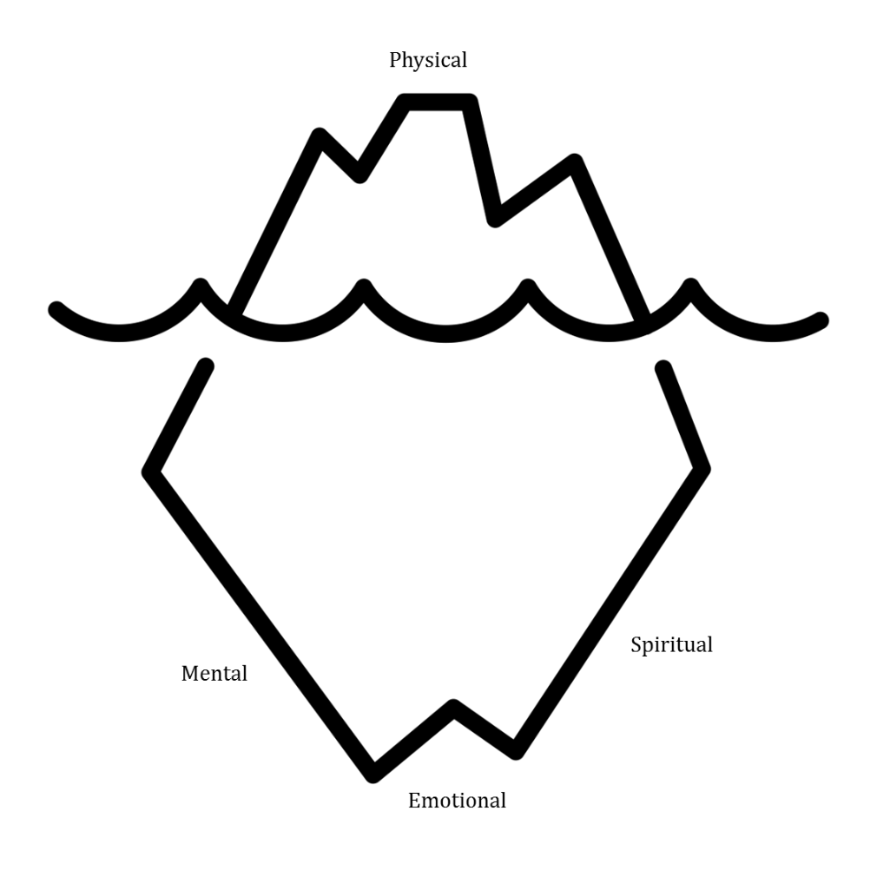

Ask participants to share their cessation or reduction journey thus far focusing on their strengths and the positive impact of changes using the four core areas of health as a guide. As participants share, write their responses on the flip chart under each of the core areas of health. Highlight the connections between shared experiences and reflections.

**Materials:** You will need flip chart and markers.

## Your Next Steps

**Approximate Time:** 10 minutes

**Goal:** Planning next steps of the journey

To end the sessions, it is important to review the concepts discussed over each of the sessions. These concepts included:

* Triggers and coping strategies
* Strategies to challenge counter thoughts
* Preparing for high risk situations
* Identifying individual/family/community supports and resources
* Planning for the tobacco cessation or reduction journey within a social determinants of health framework

We have provided one approach you can use to review each of these concepts.

#### Planning Next Steps

**Instructions:** As a group, review and discuss the plans that have been made throughout the sessions in regards to strategies, supports, and resources for tobacco cessation or reduction. As participants speak, write down their responses on flip chart paper. Ask the group if they foresee any challenges or have concerns with their plans. Invite participants to provide feedback and make adjustments as necessary.

**Materials:** You will need flip chart and markers.

## Our Celebration

**Approximate Time:** 40 minutes

**Goal:** Celebrating courage

Celebrating the courage it can take to quit, reduce, or simply attend a tobacco cessation group is very important. This session should focus on celebrating all achievements of the participants – including those who may not have quit or reduced.

#### A Celebration of Courage

**Instructions:** Host a celebration, feast, or ceremony to celebrate participants. If possible, provide traditional food. If participants have not quit or reduced, they will still be celebrated for attending and continuing on the journey. You may consider inviting participant’s family, friends, and community members to the celebration to discuss how they can help to support participants once the sessions are finished.

At the ceremony, present each of the participants with a certificate acknowledging their achievements over the course of the sessions. If appropriate, you may also want to offer a gift of acknowledgment. You may consider inviting an Elder or community member to attend, share teachings, acknowledge their support, and hand out the certificates and gifts to participants.

**Materials Required:** You will need any materials or refreshments required for the celebration, copies of the *Certificates* (refer to *Helper’s Resources*), and gifts of acknowledgement (if appropriate). If you are inviting an Elder or community member to attend, contact them before the celebration and prepare them in advance. If you are inviting participant’s family members, friends, or other supporters, they will also need to be contacted in advance.

## Wrap-up and Closing

**Approximate Time:** 5 minutes

This can be done orally as part of the session.

If you are handing out session evaluations (refer to *Helper’s Resources* for a sample Evaluation template), encourage participants to complete the evaluation. **Tip:** if you choose to hand out a paper copy have the participants fill it out while still in the session before you close.

As part of the closing, reiterate the opening words of welcome. Thank the group for having the courage to participate. End with a closing prayer (if applicable) or other good wishes.

*Image provided courtesy of Cancer Care Ontario*

# References

CAN-ADAPTT: Canadian Action Network for the Advancement, Dissemination and

Adoption of Practice-Informed Tobacco Treatment (2011). Canadian Smoking Cessation Clinical Practice Guideline. Toronto, ON: Centre for Addiction and Mental Health.

Dermody, S., Wardell, J., & Hendershot, C. (2015). Group Cognitive Behavioural Therapy for

Smoking Cessation Manual. Toronto, ON: Centre for Addiction and Mental Health.

Felitti, V.J., Anda, R.F., Nordenberg, D., Williamson, D.F., Spitz, A.M., Edwards, V., Koss, M.P.,

& Marks, J.S. (1998). Relationship of childhood abuse and household dysfunction to many of the leading causes of death in adults. The Adverse Childhood Experiences (ACE) Study. *American Journal of Preventive Medicine, 14*(4), 245–258.

Greenberger, D., & Padesky, C.A. (1995). Mind Over Mood. New York, NY: The Guilford

Press.

Government of Nunavut (n.d.). Inuit Societal Values. Retrieved from:

<http://www.gov.nu.ca/information/inuit-societal-values>

Miller, W. R., & Rollnick, S. (2013). Motivational Interviewing: Helping People Change. New

York, NY: The Guilford Press.

Marshall, A. (2004). Two-Eyed Seeing. Retrieved from:

<http://www.integrativescience.ca/Principles/TwoEyedSeeing/>

Sobell, L.C., & Sobell, M.B. (2011). Group therapy of substance use disorders: A motivational

cognitive behavioural approach. New York, NY: The Guildford Press.

1. You may be wondering why we have spelled wholistic with a “w”. Wholistic refers to the whole body, which takes into consideration the whole person – mind, body, spirit, family, community, and the environment – all which make up the “self”.