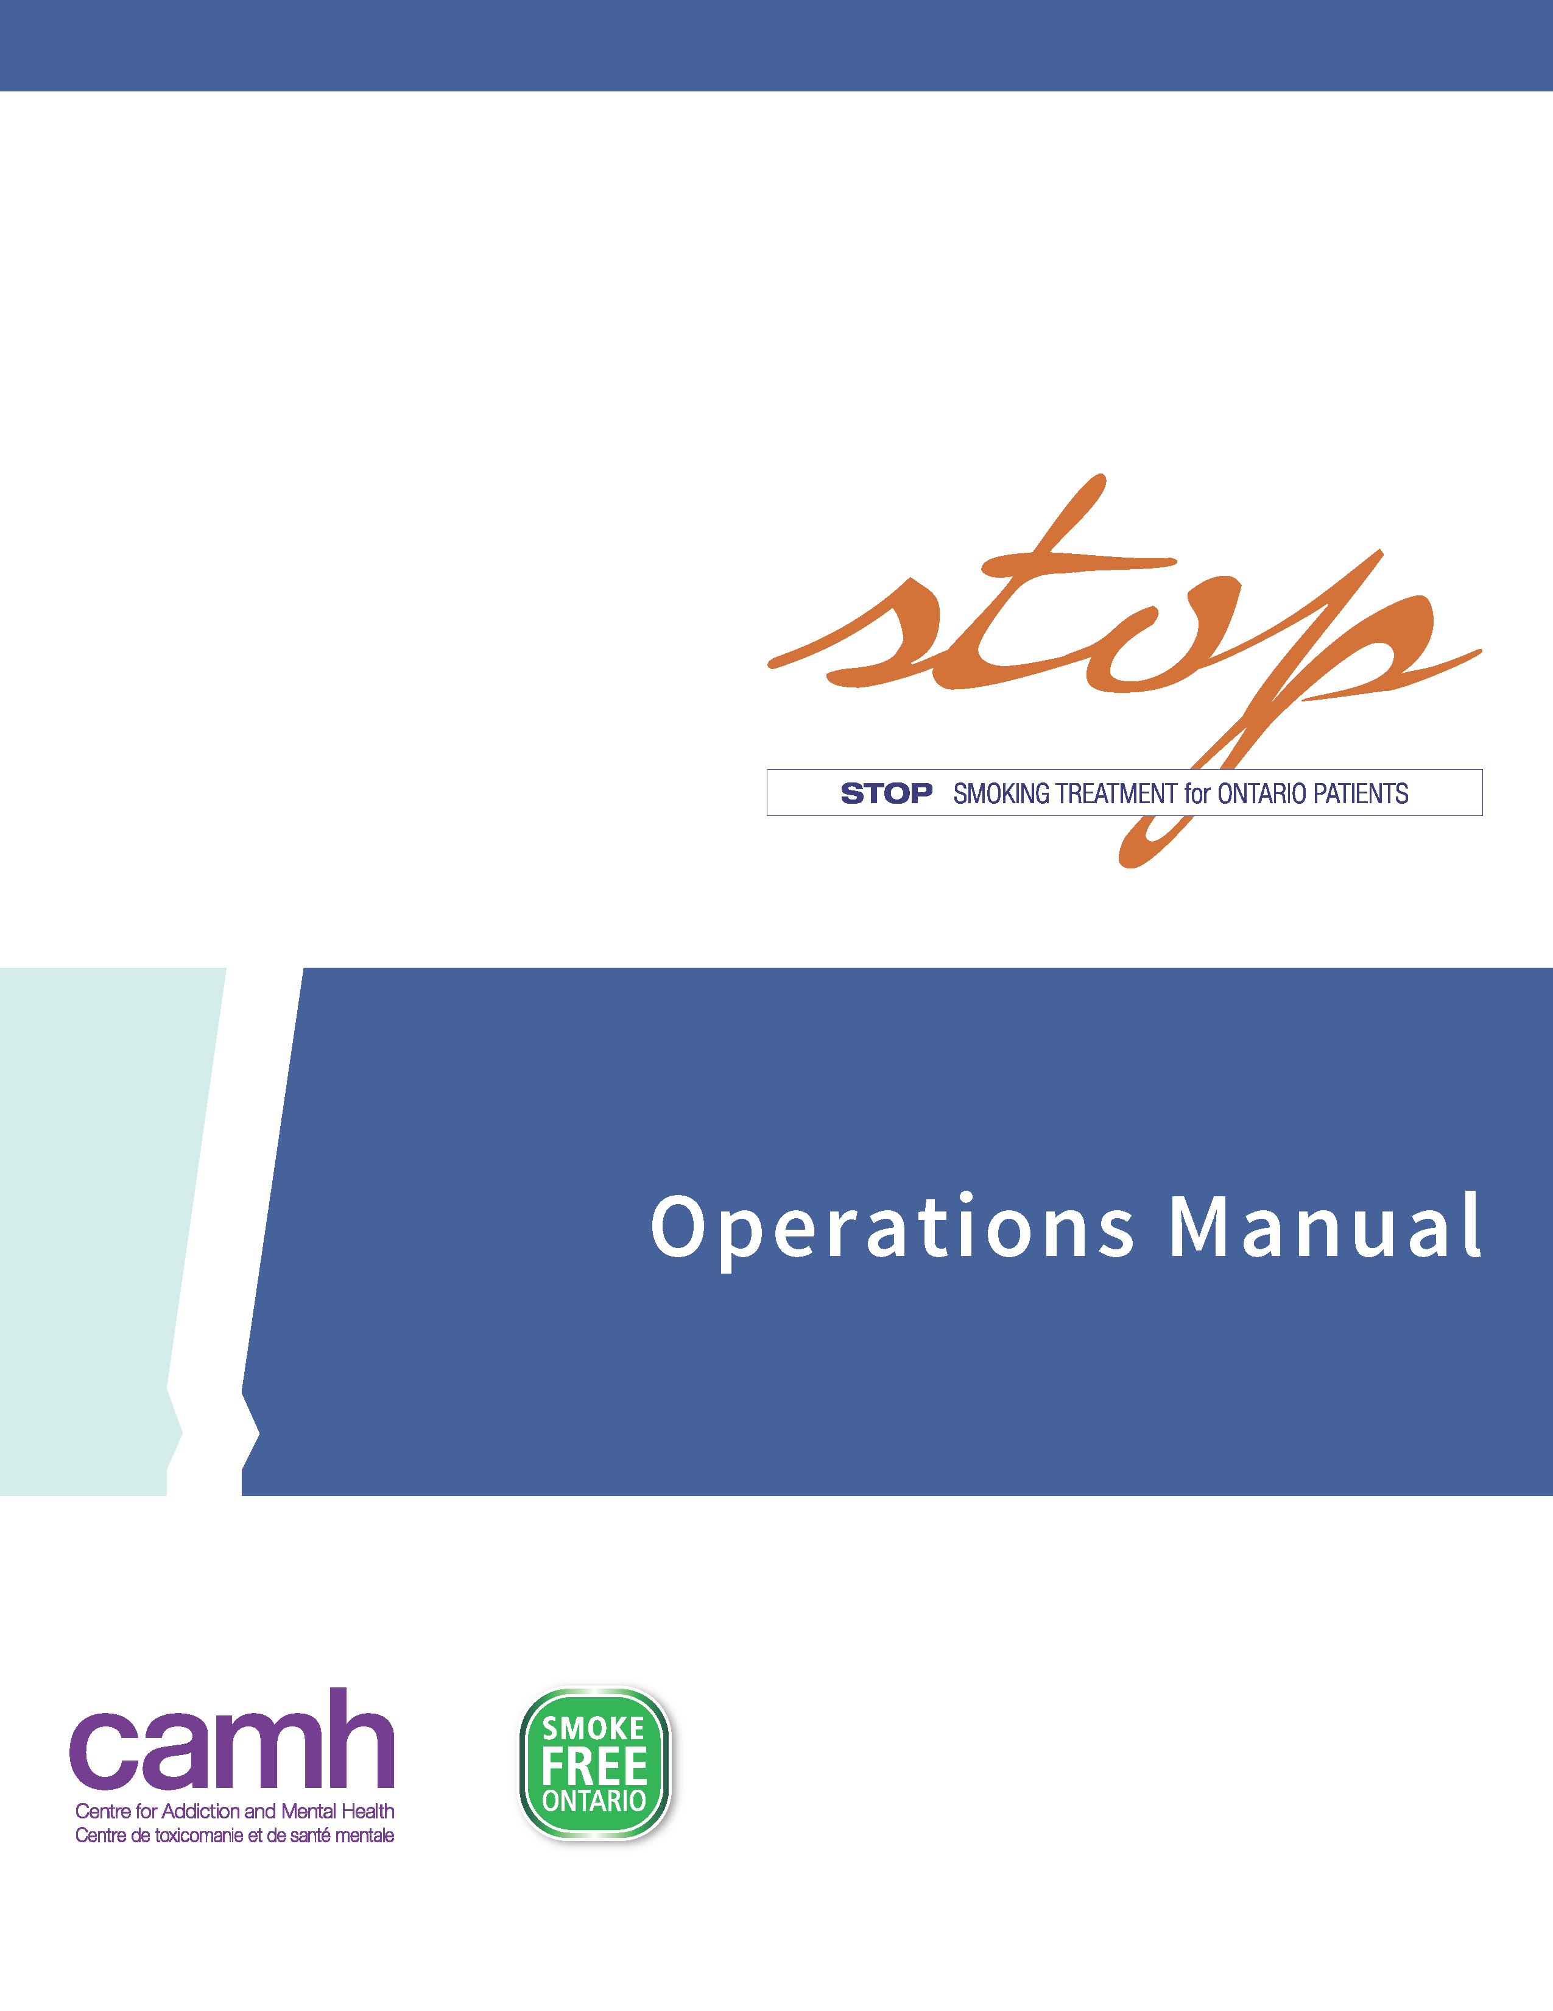



***A Program aimed at improving access to Nicotine Replacement Therapy and cessation counselling for individuals at Aboriginal Health Access Centres and Indigenous Health Organizations***

**STOP with AHACs Program**

**Manual**

**22 September2023**

Table of Contents

Introduction 3

Definitions and Abbreviations 4

Program Requirements 5

Program Implementation 6

Roles and responsibilities 6

STOP Program Eligibility Criteria 8

STOP Program Enrollment 9

Documentation 9

Discontinuation from the STOP Program or Withdrawing Consent 12

Re-Enrolling Participants into the STOP Program 12

Provision of NRT and Medication Management 13

Guidelines for the Provision of NRT 14

NRT Inventory and Ordering 15

NRT Order Form 18

Data Collection and Evaluation 20

Practitioner Resources 22

Supplements 23

Supplement 1: Behavioural Counselling Guideline Algorithm: STOP Program (Brief Intervention Form) 24

Supplement 2: Algorithm for Tailoring Pharmacotherapy for Smoking Cessation 27

Supplement 3: Guide to Using Nicotine Replacement Therapy (NRT) Products: STOP Program 28

**Program Lead:**

**Dr. Peter Selby**

Tel: 416-535-8501 ext.36859

Peter.Selby@camh.ca

**Program Co-Lead:**

**Dr. Laurie Zawertailo**

Tel: 416-535-8501 ext.77422

Laurie.Zawertailo@camh.ca

# Introduction

Thank you for choosing to partner with the **STOP (Smoking Treatment for Ontario Patients) Program**! Your partnership has helped make STOP the largest commercial nicotine cessation initiative in Ontario, helping over 375,000 people to make a quit attempt through the Program.

The STOP with AHACs Program partners with Aboriginal Health Access Centres (AHACs) and Indigenous Health Organizations to improve access to commercial tobacco/nicotine product cessation treatments for people who wish to quit or reduce. Additionally, the program aims to increase the capacity of healthcare practitioners working in these settings by offering co-created and culturally adapted trainings available through our TEACH Program. STOP operates within the Centre for Addiction and Mental Health (CAMH) and is funded by the Ontario Ministry of Health.

This initiative complements existing investments under the Smoke-Free Ontario Strategy and helps to build a comprehensive system designed for Indigenous people in Ontario using evidence-based treatments. By enhancing cessation supports through AHACs and Indigenous Health Organizations, and in partnership with the multidisciplinary teams at these organizations, more people will get the help they need.

Throughout implementation, STOP staff will schedule regular surveys, questionnaires, and check-ins with AHAC and Indigenous Health Organization practitioners and other staff as needed. This will help STOP evaluate the effectiveness and appropriateness of the STOP Program within the unique AHAC and Indigenous Health Organization context and help identify supports and barriers to implementation. We use these evaluation results to inform future program improvements while the program is still being implemented.

This Operations Manual is a resource intended to communicate details related to the delivery and implementation of the STOP with AHACs Program within your organization. We use the term ‘participant’ in this Operations Manual to refer to patients, clients and community members at your organization who are participating in the STOP Program.

# Definitions and Abbreviations

* **CAMH** = Centre for Addiction and Mental Health
* **STOP** = Smoking Treatment for Ontario Patients
* **TEACH** = Training Enhancement in Applied Cessation Counselling and Health
* **NRT** = Nicotine Replacement Therapy (e.g., patch, gum, inhaler, lozenge or mouth spray, as available)
* **CHC** = Community Health Centre
* **FHT** = Family Health Team
* **AHAC** = Aboriginal Health Access Centre
* **Partnering Organizations**: Organizations (e.g., CHCs, FHTs, AHACs) collaborating with the STOP Program to provide commercial tobacco/nicotine cessation treatment (NRT and counselling support) to their patients.Within each organization, there may be multiple locations (sites) participating. We will also use the term “site” in this manual to refer to these organizations.
* **STOP Participants**: People who are part of your organization who wish to quit or reduce their commercial tobacco/nicotine use and are either referred or self-refer to enroll in the STOP Program (may also be referred to as patients or clients).
* **STOP Practitioners**: Health practitioners at your organization who have received formal training in smoking cessation and are trained in implementing the STOP Program protocol at their site(s). *Practitioners who will be providing NRT have an obligation to perform all duties in compliance with the rules and regulations of their organization and professional bodies.*
* **Program Collaborator**: The designated main point of contact between your organization and the STOP team; may also be a STOP practitioner.
* **STOP Program Staff**:People who work directly for the STOP Program. They are based at CAMH in Toronto and can include the Program investigators, Program manager, coordinators, research analysts/assistants, and administrative staff.

# Program Requirements

**Here are the first steps to implementing the STOP Program:**

1. Submit a signed Program Implementation Agreement with CAMH. CAMH will share a pdf version of the Agreement with the site, which must be reviewed and signed by the Executive Director (or equivalent signing authority) at the partnering organization.
2. Complete an Initial Discussion (structured interview – see data collection and evaluation section below) to review the implementation plan and logistical details at each site, including any site-specific concerns or adjustments.
3. Have at least one practitioner at the partnering organization complete the STOP training requirements for implementation (see below). A Medical Directive *may* also need to be prepared and signed by a lead physician (or other qualified personnel) to authorize all practitioners to provide NRT as required by the organization.
4. Secure locked space on your premises to store the Nicotine Replacement Therapy products (should be stored separately from pharmaceutical samples to avoid accidental use).

**There are required trainings for all practitioners implementing the STOP Program:**

* Formal Smoking Cessation Counselling Training (such as TEACH, RNAO, OMSC or equivalent). For those who do not have such training, the TEACH (Training Enhancement in Applied Cessation Counselling and Health) Project at CAMH offers a Certificate Program (see [www.teachproject.ca](http://www.teachproject.ca)) which includes an Interprofessional Comprehensive Course on Treating Tobacco Use Disorder. Alternatively, STOP offers a condensed online training option, Fundamentals of Tobacco Interventions (FTI). Please reach out to your STOP coordinator to register for the FTI training.
* Program Operations Training: This training is offered regularly via webinar by the STOP coordinator team and will detail how to implement the Program within your organization, manage the NRT provided by STOP and communicate with the STOP team. Please email a STOP coordinator for specific dates and times.

Once the partnering organization’s Implementation Agreement has been approved and staff have completed all of the required trainings, practitioners are ready to begin enrolling participants and order NRT. NRT Ordering is described below. Once NRT is ordered, STOP will arrange for it to be delivered.

# Program Implementation

**Overview of implementation options**

The appropriate implementation option (e.g., individual counselling, group sessions, combination) is determined based on the organization’s capacity and participant population. These options will be discussed between the Program collaborator and the STOP coordinator during the Initial Discussion.

*To maintain the collaborative nature of this Program, all sites have the option to discuss additional or alternative implementation options with the STOP Coordinator over the course of the implementation of their Program.*

It is up to the STOP practitioner to determine the appropriateness and type(s) of NRT used, on a case-by-case basis. STOP practitioners may choose to provide one-on-one tobacco/nicotine cessation counselling with participants or provide counselling in a group setting. However, the NRT treatment must be provided on an individual basis. The Program allows the provision of **up to four “weeks” of NRT at each visit (note: one box of NRT typically provides one week of treatment), to a maximum of 26 weeks of NRT per participant within 12-months of enrollment.** If it is within one’s scope of practice, this may include off-label NRT treatment (if approved by your organization). STOP practitioners can adjust the NRT dose and type at each visit, as necessary. Additional details regarding provision of NRT can be found below**.**

**Logistical Resources & Participant Engagement**

Once your organization receives all supplies including NRT, STOP practitioners can begin enrolling participants into the Program. The STOP coordinators are available to discuss and support organizations in developing strategies to encourage their participants to enroll in the Program. For example, STOP can provide organizations with waiting room posters and cards for this purpose.

**STOP Program Promotion**

The Program collaborator will seek the prior written approval of CAMH in respect of any communication activity or material developed for public distribution referencing or promoting the Program. CAMH staff will determine if Public Affairs’ prior approval will be required. All approved materials must include the following funding statement: *The Smoking Treatment for Ontario Patients (STOP) Program is funded by the Ontario Ministry of Health*.

## Roles and responsibilities

**STOP practitioners are responsible for:**

* Receiving training in smoking cessation counselling: Fundamentals of Tobacco Interventions (FTI) online course (no cost), TEACH Core Course certificate Program (course fee required) or other equivalent/accredited Program(s) (mandatory);
* Completing the STOP Operations Training webinar provided by our team;
* Informing participants (e.g., via referral or waiting room posters) of the availability of the STOP Program at your organization;
* Ensuring that all required Program documentation is completed accurately;
* Providing NRT to participants (if applicable) via your site’s inventory of NRT available through STOP;
* Tracking NRT inventory using the STOP Inventory Log
* Conducting follow-up visits with participants to provide additional counselling and administration of NRT, as applicable.

**Program collaborators are additionally responsible for:**

* Participating in the Initial Discussion with STOP staff to discuss Program implementation, in order to offer a feasible Program for their organization;
* Acting as the point-of-contact between their site and STOP staff;
* Communicating relevant STOP Program information to all STOP practitioners at their organization;
* Placing and receiving NRT orders and maintaining an accurate NRT inventory;
* Preparing and organizing shipments of forms to be sent back to STOP, if applicable;
* Ensuring that all STOP practitioners adhere to STOP Program guidelines and proper medication management of the NRT products;
* Participating in the evaluation of the Program;
* Notifying STOP staff of any concerns or issues related to the Program.

**STOP Staff at CAMH are responsible for:**

* Conducting the Initial Discussion, Operations Training and Knowledge-Exchange Practitioner Teleconferences;
* Working with collaborators to create a feasible Program for their site;
* Providing any necessary Program documents;
* Filling NRT orders for each implementing site;
* Arranging for courier shipments when needed;
* Providing support to each organization as needed;
* Troubleshooting operational issues as they arise;
* Performing all evaluations on Program data.

Questions from STOP practitioners and collaborators can be directed to [stop.ahacs@camh.ca](mailto:stop.ahacs@camh.ca).

## STOP Program Eligibility Criteria

Participants interested in enrolling in the STOP Program need to meet some basic criteria. Specifically, the STOP with AHACs Program is available to participants who:

**Inclusion Criteria**

* Are currently using commercial tobacco/nicotine product(s) (not including NRT) or maintaining a recent quit attempt (within the last 30 days), for which the STOP practitioner deems NRT an appropriate treatment option.
* Are registered at your organization: please follow your standard scope of practice regarding this.
* Live in Ontario: Since the Program is provincially funded by the Ontario Ministry of Health, participants must live in Ontario.

Please Note: The above criteria are specifically for enrolling in STOP; your organization may have additional policies or directives that implementers will need to be familiar with and adhere to.

All data collection forms and medication management guidelines and procedures are described in the sections below. Additional NRT can be ordered at any time using the appropriate ordering systems.

# STOP Program Enrollment

## Documentation

Presented below are all participant-level data collection instruments that organizations are required to collect for this Program’s evaluation needs. All of the documentation will be provided by the STOP Program.

There are **three** mandatory forms that all partnering sites will use to document participant information for the STOP Program. Hard/e-copies of the forms will be sent to each partnering site for use. Forms can be maintained either on paper or electronically.

1. **Information Form:** To ensure informed participation, all organizations are required to have participants review, complete and keep for their records an information form prior to them enrolling in the Program. This is the first form to be completed by the practitioner with new participants (or re-enrolled participants – see below). One copy must be given to the participant for their records and the other copy must be securely stored at the organization for their records.
2. **Visit Form for Follow-Up Visits**: To be completed by the practitioner at any visit when NRT is provided. All visit forms need to be stored at the organization for their records.
3. **NRT Inventory Log**: To track medication (i.e., NRT) use by Program participants. Used by all practitioners who receive, provide or transfer NRT; the log is kept in the same place as the NRT and is updated every time the NRT inventory changes.

It is important to remember that participants must review the Information Form and one completed copy must remain at the organization. At all visits during which the participant receives NRT, a Visit Form must be completed.

While these forms will be stored by each organization, STOP may request access to them as necessary.

*The terms “patients” and “clients” are used interchangeably on these forms. For example, “Patient ID” is the same as “Client ID”.*

**NOTE: Please use PEN to complete all paper forms!**

**Documentation orders**

Please contact the STOP team for to obtain copies of all documents.

**Information Form**

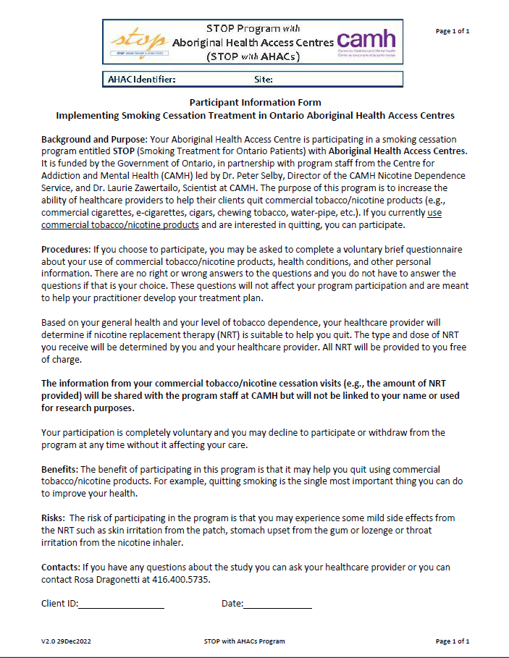

**Visit Form**

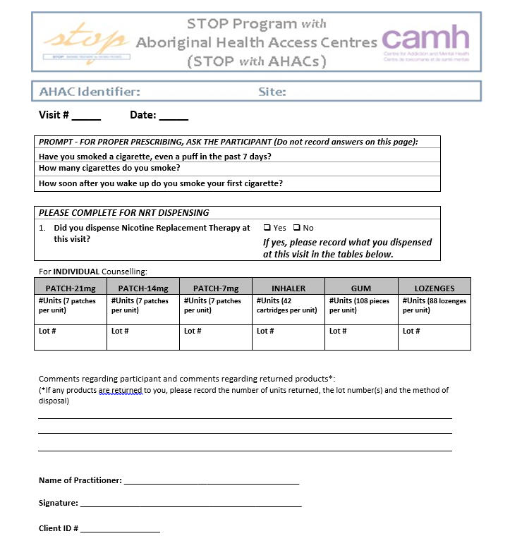

## Discontinuation from the STOP Program or Withdrawing Consent

Due to the long-term nature of this Program, participants are not considered ”withdrawn” or “dropped out” if they discontinue use of NRT, fail to attend follow-up appointments, or relapse. Their 26 weeks of NRT available through STOP does **not** have to be consecutive. For example, if a participant relapses and does not receive NRT for some period of time, they are **not** removed from the Program. They are allowed to return to the STOP Program at any time if they choose to, provided they have not used up their full 26 weeks of NRT and are within one (1) year from their enrollment date.

However, if a participant wishes to formally withdraw from participating in the STOP Program, please inform your STOP Coordinator. Please note that once a participant is withdrawn from the Program, they can no longer receive NRT provided by the STOP Program. STOP practitioners have the right to terminate clinical care for a STOP participant in certain circumstances, such as violent or harassing behaviour.

## Re-Enrolling Participants into the STOP Program

Consent to participate in the STOP Program is valid for one (1) year from the date of enrollment. Participants who are still involved in the STOP Program one year after enrollment and are eligible to join the program, will be required to enroll again (i.e., complete a new Information Form, etc.). This section also applies to participants who have withdrawn their consent to participate, but wish to re-enroll in the Program.

**Examples where a participant would need to re-enroll into the STOP Program:**

* Participant has been enrolled for one full year (from the date of enrollment on the original information form), **continues to use tobacco/nicotine (or quit for no more than 30 days)**, and wishes to continue with treatment.
* Participant has explicitly withdrawn consent within the one (1) year from the time of enrollment, but **is still using tobacco/nicotine** and wishes to enroll in the Program again. The exception would be if a participant had reached 26 weeks of NRT already before they withdrew.

**To re-enroll a participant into the STOP Program, please take the following steps:**

* The practitioner will need to complete a new Information Form with this participant, which is to remain at the organization, and also provide a copy for the participant.
* Please add “**R1-**” to the beginning of the original Client ID# (e.g., **R1-**12345) to indicate that the participant has re-enrolled in the Program for the first time (use R2- for second re-enrollment, etc.).
* Start completing the forms as you would for any newly enrolled participant. Please ensure you have the new Client ID with the “**R1-**” prefix on all forms.

*At a participant’s first visit after re-enrolling, you can ask whether they have any leftover NRT from their original enrollment. If the product has not expired, ask them to use up that NRT first before providing any more products (or at least take this amount into consideration when deciding how much to provide).*

It is **extremely important** that re-enrolled participants have the “**R1-**” prefix written on all of their forms.

Please note: the re-enrollment procedure is not intended to extend the 26-week limit. If the participant reaches the 26-week limit, please do not re-enroll them right away; they will have to wait until a full year has passed (since the day they initially enrolled) in order to re-enroll.

# Provision of NRT and Medication Management

This section will introduce you to guidelines related to the provision of NRT for tobacco/nicotine product cessation as part of the STOP Program. STOP has developed guidelines for the provision of NRT (below), which are consistent with current evidence in smoking cessation treatment, as well as our goals for providing long-term tobacco/nicotine cessation support to our participants. Please refer to **supplements** “STOP Program Sample NRT Algorithm” and “Guide to Using Nicotine Replacement Therapy Products”.

**Please note:** administering NRT for any tobacco/nicotine product other than cigarettes is currently considered off-label. While off-label dispensing for this indication is permitted by the STOP Program, it must be within your clinical scope of practice to do so. **Please follow your own organization’s rules and guidelines regarding off-label dispensing of NRT.**

The STOP Program may offer the following products*:

* Patch (21mg, 14mg and 7mg)
* Inhaler (10mg; 4mg delivered)
* Gum (2mg)
* Lozenge (2mg)

*\*Inventory is subject to change*

We encourage STOP practitioners to use their clinical judgment in deciding the most appropriate type(s) and dose(s) of NRT to meet each participant’s needs and to develop a plan to taper down the dose over time, if needed. Off-label dispensing is permitted by the STOP Program (e.g., dispensing NRT for cessation treatment of tobacco/nicotine products other than cigarettes, dispensing of more than 21 mg of NRT per day). In some cases, such as a high NRT dosage, physician oversight may be required. **In all cases, please follow your own organization’s rules and guidelines regarding off-label dispensing of NRT**.

Please note: the products we supply, while at no cost to partnering organizations, are not samples and should not be provided as such.

## Guidelines for the Provision of NRT

The following rules and guidelines must be followed when providing NRT to participants:

1. **Provide a maximum of 4 weeks at a time:** This is to encourage participants to come back for regular visits to benefit from the counselling component of the STOP Program delivered by the implementing practitioner. In addition, the purpose of this rule is to minimize NRT waste. Exemptions may be granted only in special circumstances - please email STOP in advance with the reason for this request in order to obtain approval.

Please note: Weeks are defined in terms of treatment period and not dosage of NRT, as treatment is tailored to the individual.

1. **Provide a maximum of 26 weeks of NRT within one year:** The 26 weeks of treatment does not have to be consecutive.
2. **Provide only 1 type of short-acting NRT at a time:** Short-acting NRT includes the nicotine gum, lozenge and inhaler; only one type should be provided at each visit to reduce the chance of waste and the participant receiving more than they will use.

Please note: short-acting products are designed for breakthrough cravings only and should not be used as the main source of nicotine replacement for most participants. If a participant is unsure as to which type of short acting NRT they prefer, STOP practitioners can give individual pieces of the STOP products to participants to try. Please follow the steps outlined in the “Inventory Log” section to document NRT products used for this purpose.

**IMPORTANT:** If any errors are made when dispensing NRT (e.g., wrong NRT provided, deviation from protocol etc.), please contact your STOP Coordinator immediately for troubleshooting and resolution.

#### **Finding the LOT number**

When dispensing Individual NRT products, the practitioner needs to record the LOT number on the Inventory Log and the Visit Form. The LOT number can be found on the side of a product box, next to the expiry date. The LOT number is recorded for safety reasons to track the NRT in case of a product recall. In addition to recording the LOT number, please check the expiry date prior to providing NRT to participants.

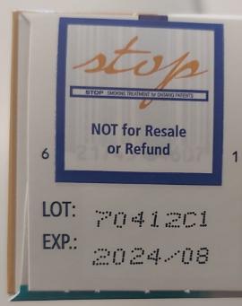

Please note: a STOP sticker covers the barcode to deter participants from trying to return it for a refund.

**Returned and Expired Medication**

Participants may decide to return NRT products to a STOP practitioner due to an adverse reaction, a decision not to use NRT, or another factor. **If a product is returned, it cannot be provided to another participant, even if the box is unopened.** **Please** **clearly label the box as “Returned”**.

If you notice that an NRT product is going to expire before you can provide it to a participant, or if the expiry date has already passed, please remove this product from your inventory and your Inventory Log. Again, **please clearly identify the product as “Expired”** if necessary so that it is not accidentally given out.

**Returned and expired products should not be thrown in the garbage.** If you have the proper facilities to dispose of these products, you may do so. In this case, you must provide the product quantities, lot numbers and expiry dates to a STOP coordinator first. If you do not have safe disposal, you may send all returned and expired products to CAMH.

**If you are concerned about any products that are set to expire within the next three (3) months, please contact your STOP coordinator.**

**NRT Recall**

This section describes the process and steps to follow in the event that any alert, recall, safety notification, advisory, or warning is issued or communicated by the Supplier to CAMH for an NRT product used in the STOP Program.

The following steps will be followed:

* Upon learning about any recall from the Supplier, CAMH will send an email communication as soon as possible to all affected partnering organizations with the affected lot number(s) of products.
* STOP practitioner(s) at the organization will be responsible for contacting their participants and requesting that they:
  + stop using the product and
  + return any remaining product to the site as soon as they can.
* CAMH will communicate any instructions for safely disposing of and/or sending the NRT back to CAMH.
* CAMH will work with Supplier to ship replacement NRT as soon as possible to the organization for distribution to affected participants.
* Partnering organizations will then connect with each participant to arrange for the new product to be picked up.

# NRT Inventory and Ordering

STOP staff will place the order for your first NRT shipment, based on the number of participants expected within the first month of the Program (as determined by the Initial Discussion). Practitioners are responsible for placing subsequent NRT orders using the **online ordering system** (see below).

Please note the following regarding NRT ordering and delivery:

* NRT orders are placed through the online STOP with AHACs ordering form (see below)
* Please allow 1-2 weeks for delivery to your organization
* Once NRT is delivered to the partnering organization, staff will be required to store the NRT in a secure, locked space, separated from pharmaceutical samples, until it is provided to a participant. The newly delivered products should be placed behind the old stock to ensure you are providing the earliest-expiring products first.

Consistent with good medication management practices, NRT is shipped from our distributor based on the expiry date. Accordingly, STOP practitioners are required to provide products with the **earliest expiry dates first.**

Please note: **products expire on the last day of the month listed on the expiry date**. As long as the product is used by the participant before that date, it does not count as “expired.” For example, if the expiry date says EXP 07 2025, the last date it can be used is July 31, 2025.

**Inventory Log**

This **mandatory form** is used by all partnering sites to document STOP Program NRT inventories. Hard/e-copies of the forms will be printed and sent to each site upon request. The Inventory Logs are to be updated by all practitioners who receive, administer, or transfer NRT; the log should be kept in the same place as the NRT and must be updated every time the inventory changes.

Inventory Logs are used to record and manage your NRT inventory in order to place NRT orders in a timely fashion. The Inventory Log is intended to reflect the amount of each product at a given time, and ideally should be kept in the same space as the NRT (e.g., on the door of the cabinet in which the NRT is stored).

In order to maintain accurate and representative Inventory Logs, there are several situations that should be documented:

* When a new NRT shipment is received by your organization
* When NRT product(s) is provided and needs to be removed from the inventory
* If removing NRT to provide for trial use (“samples”) ***\*for enrolled participants only***
* If NRT has expired and needs to be removed from inventory
* If sharing NRT inventory with other subsites at your organization and product is *leaving* your site
* If sharing NRT inventory with other subsites at your organization and product is *received* from another site

These situations are described below:

**Adding or removing products from your inventory**

* When product is coming in to your site (e.g., receiving a shipment from STOP staff at CAMH), indicate the origin of the NRT (e.g., “IN – CAMH”) and record the new total of NRT (current inventory + newly received products)
* Please date and initial after every transaction
* When NRT is provided to a participant, do not enter the number of boxes you dispensed instead, subtract the amount you dispensed from the previous line and enter the new total(s)
* Trial boxes: if opening a trial box (to provide ***one or a few*** test pieces to an ***enrolled STOP participant*** during a visit), ***subtract*** one box of the NRT product that you will be opening for this purpose and enter the new total(s) on the Inventory Log
* **The last line should always reflect the total amount of NRT available at your site** (see below)

**IMPORTANT:** If any errors are made when dispensing NRT (i.e., wrong NRT provided, deviation from protocol etc.), please contact your STOP Coordinator immediately for troubleshooting and resolution.

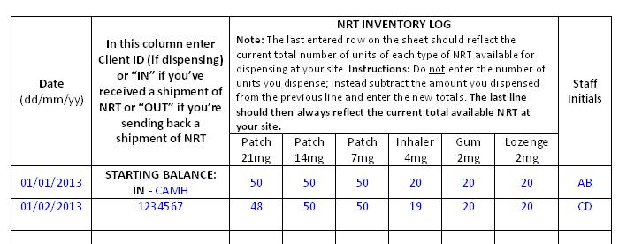

**Logging expired NRT**

If you observe that an NRT product has expired, please remove this product from your inventory and document this in the inventory log. The product should be discarded appropriately (sent back to CAMH/destroyed on site at a local pharmacy or via medical disposal). Please email STOP the product type, lot #, and expiry date of the expired product(s). Please document this transaction as “OUT - expired” (to indicate that the product has left your inventory). In order to calculate your new total inventory, subtract the amount of product that has expired and enter the new total(s). You should also clearly identify the product as expired so that it is not accidentally dispensed (e.g., write on the product boxes themselves).

**Sending NRT to another site**

If you are part of a multi-site organization and another site requires NRT that you have in stock, please indicate this on your Inventory Log prior to delivering this product (e.g., “OUT - Site 2” reflects that the product has left your site and is being delivered to site 2). If you receive products from another site, please indicate this on your Inventory Log and add the new products to your current inventory totals (i.e. “IN - Site 3”).

## NRT Order Form

Orders are placed using the **online ordering form** found here**:**

[**https://edc.camhx.ca/redcap/surveys/?s=JXA8W4CRX4**](https://edc.camhx.ca/redcap/surveys/?s=JXA8W4CRX4)

To place an order, please ensure that all information is complete and correct. **Please note that an updated inventory log needs to be attached or emailed to the STOP team in order for STOP staff to process the order.**Orders typically arrive within 1-2 weeks.

At CAMH, our staff will review all of the requests and place the actual orders with our supplier. Ideally, **your new request plus your current inventory should last for about two months [i.e., Your New Request = (your Average Monthly Usage x 2) – (your Current Inventory)]**. Please keep to no more than two months’ onsite to minimize waste.

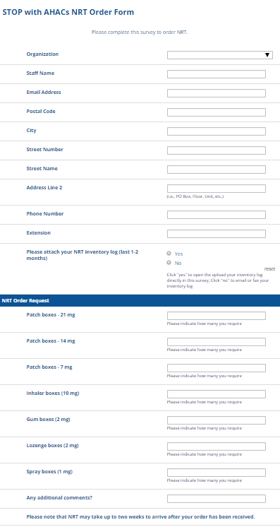

# Data Collection and Evaluation

**Confidentiality**

Confidentiality is of utmost importance for this Program and as such, all efforts will be made to ensure and maintain the confidentiality of all participants. Organization staff will ensure that all participant data are maintained and stored in confidence as per Good Clinical Practice Guidelines for health records. Furthermore, participants will be assigned a unique ID# unrelated to their OHIP number by their AHAC/Indigenous Health Organization. Further discussion regarding organization confidentiality policies may occur at the initial discussion as necessary.

*Protecting data*: Data will be stored in computerized files that are password-protected. Hard copies will be kept in locked filing cabinets at CAMH or at each organization.

*Transferring data*: Encrypted external hard drives (e.g., USB memory sticks) will be used to transfer any data and/or Secure File Transfer via e-mail where applicable and appropriate.

**Formative Evaluation and Practitioner Check-In**

An additional specific objective of the STOP with AHACs model is to determine how effectively and appropriately the STOP Program can be adapted to an AHAC/Indigenous Health Organization setting to meet the needs of the staff and participants.

In order to evaluate how the Program implementation is working at a clinician level in a time-frame where barriers can be identified and minimized, STOP staff (or appropriate partners) will schedule regular surveys, questionnaires and check-ins with practitioners, collaborators and (for example) Executive Directors or their designates. Executive Directors may be contacted at scheduled times in order to identify organization-level barriers and supports to implementing this Program or cessation practices in general, as well as to identify organization-level changes that implementing this Program may be supporting/enhancing.

The evaluation will focus on the following three overarching themes:

1. How and to what extent is the project affecting the provision of commercial tobacco/nicotine product cessation by staff?
2. How and to what extent is the project influencing the development of cessation policies and practices within the organization?
3. How can the STOP with AHACs Program further improve the delivery of the intervention?

|  |  |
| --- | --- |
| **Potential Information Sources** | **Description** |
| Capacity Assessment Survey | A capacity assessment survey will be completed to gather information on the capacity of organizations to implement the Program. The capacity assessment also provides a partial set of baseline data at the organizational level. |
| Initial Discussion (Interviews) | A structured interview with each organization will be conducted. The purpose of these interviews is to confirm that each organization has proper procedures in place to administer the Program and also, to gather contextual baseline information related to each organization. |
| AHAC Baseline Survey | The purpose of the baseline questionnaire is two-fold: to determine the Evaluation needs of participating organizations; and secondly, to complete the set of baseline data at the organizational level (building on the Capacity Assessment Survey responses). |
| AHAC follow-up Survey | A follow-up survey for organizations will be implemented on a periodic basis to monitor changes in practices and policies at the organizational level. Follow-up surveys will also assess attitudes, capacity and practices of staff in the area of commercial tobacco/nicotine product cessation. |

## 

**Terminating Program Agreement**

Upon notice of termination of this Agreement, the Program collaborator and/or STOP practitioner will take all reasonable steps as are necessary for closure of the Program with its participants.

* Program collaborator will stop enrolling any new participants at least a month (30 days) prior to the termination date.
* All participants that are currently enrolled in the STOP Program should be notified that the site is terminating its implementation of the STOP Program.
* Program collaborator will coordinate with CAMH to assess the number of participants currently in treatment and to plan safe winding down of treatment for these participants. All participants will be promptly notified of this plan for treatment.
* All remaining NRT on site at all locations should be returned to CAMH before the end of the agreement.
* CAMH staff will update all contact information so that communication from STOP will cease upon end of the agreement date.

#### 

# Practitioner Resources

The STOP Program has additional resources to share with practitioners to assist them in delivering the Program.

* Behavioural Counselling Guideline Algorithm (**Supplement 1**)
* STOP Program Sample NRT Algorithm (**Supplement 2**)
* Guide to Using Nicotine Replacement Therapy (NRT) Products (**Supplement 3**)
* Resources for practitioners can be found on the STOP Implementer resource page: <https://www.nicotinedependenceclinic.com/en/stop/implementer-resources>
* [Lower-Risk Nicotine User Guidelines (LRNUG)](https://www.nicotinedependenceclinic.com/en/lower-risk-nicotine-user-guidelin-es)
* [Vaping Cessation Guidance Resource](https://www.nicotinedependenceclinic.com/en/Documents/Vaping%20Cessation%20Guidance%20Resource.pdf)
* **Knowledge Exchange Teleconferences for Practitioners:** An opportunity for STOP to share resources, new research findings or Program updates as well as an opportunity for implementers of the Program to ask questions and bring forward case studies for discussion.
  + 1st Wednesday of the month (1-2pm)*
  + Minutes will be distributed after each session

*Subject to change. Reminder emails are sent out to all STOP practitioners.

* TEACH resources on smoking cessation intervention:
  + “teachproject” videos on Youtube
  + Join the Mailing List: email [teach@camh.ca](mailto:teach@camh.ca)
* Useful webinars that discuss various issues (e.g., the importance of addressing alcohol use among smokers in primary care; how to conduct an evidence-based intervention) can be found on our website: <https://www.nicotinedependenceclinic.com/en/teach/Pages/TEACH-Webinars.aspx>

# Supplements

**Supplement 1:** Behavioural Counselling Guideline Algorithm (Brief Intervention Form)

**Supplement 2:** STOP Program Sample NRT Algorithm

**Supplement 3:** Guide to Using Nicotine Replacement Therapy (NRT) Products

## Supplement 1: Behavioural Counselling Guideline Algorithm: STOP Program (Brief Intervention Form)

This form is intended to guide practitioners with delivering a brief behavioural intervention to their patient as part of nicotine cessation treatment. It provides a framework for delivering the counselling.

Patient ID:________ Patient Initials_______ Date: ____________

1. Have you started any new medication or stopped any previously taken medication since your last visit? ❑ No ❑ Yes

2. Have you experienced any adverse events since last visit?

❑ No ❑ Yes, describe: _________________________________

*\*If Serious Adverse Event (SAE), notify STOP within 7 days*

3. Carbon Monoxide level: ____________ppm Time since last cigarette: __________min/hrs/days

4. # of cigarettes currently smoked ______cpd / cpw

5. What changes have you made to your smoking since our last appointment?

* Quit smoking ❑ No change ❑ Relapsed or increased
* Reduced number of cigarettes tobacco use from last visit

|  |  |
| --- | --- |
| ❑ Congratulations on your success! That’s great. | * Tell me about your tobacco use (use notes) * Lapses can be used as a learning experience |
| * What benefits have you noticed since   quitting/reducing? (breathe easier, more  energy, can smell, taste, etc).   * _________________________________ * _________________________________ * _________________________________   ❑ What success have you noticed? (can delay  cigarettes, not thinking about it all the time, 5  days without smoking, etc).   * + Duration of abstinence   + Reduction in withdrawal   + _________________________________   + _________________________________   + _________________________________ * Did you encounter any problems or do you anticipate any problems?   + Depression   + Weight gain   + Alcohol   + Other smokers   + ______________________________   + ______________________________ | * What problems did you encounter?   + Depression   + Weight gain   + Alcohol   + Other smokers   + ________________________________   + ________________________________   + ________________________________ * What challenges do you anticipate?   + ________________________________   + ________________________________   + ________________________________ * How much of the medication did you use in the last week? * _____   ______________________________________  ______________________________________  ______________________________________ |

6. Are you getting additional counselling or support for quitting smoking? Indicate all supports:

* ________________________________________________________________________________
* ________________________________________________________________________________
* ________________________________________________________________________________

7. Have you used any NRT or other smoking cessation aids?

❑ Patch ❑ Gum

❑ Inhaler ❑ Lozenge

❑ Zyban / Wellbutrin ❑ Other: _____________________________________

8. If patient did not use **all** of the provided Program medication, indicate why

❑ N/A, used all ❑ experienced side effect(s): __________________________________

❑ forgot to take it ❑ other: ___________________________________________________

Relapse Prevention

You’ve done great so far. It’s helpful to think about a few things to help you to continue reducing or staying quit. Do you think any of the following might be a problem for you?

|  |  |
| --- | --- |
| Problems | Responses |
| * Do you have enough support for quitting smoking? * No * Yes | * Would it be helpful to touch base by phone for extra support? * Can you identify anyone that can provide support for you? * You might want to call the Smokers’ Helpline for extra support or see your family doctor. |
| * Is negative mood or depression a problem for you while quitting? * Yes * No | * If you are having a lot of trouble with your mood, do you think you might want to see your family doctor for some help?___________________________________________   _______________________________________________  _______________________________________________ |
| * Are you experiencing strong or prolonged withdrawal symptoms? * Yes * No | * If you are experiencing prolonged craving or other withdrawal symptoms, you may want to look at your NRT dose. Do you think you need a higher dose of NRT? * YES   + Adjust the dose and type of NRT provided. * NO   + How else might you cope with these cravings? |
| * Have you experienced any weight gain or anticipate gaining weight because of quitting smoking? * Yes * No | * Recommend starting or increasing physical activity; discourage strict dieting. * Reassure patient that some weight gain after quitting is common and appears to be self-limiting. * Emphasize the importance of a healthy diet. * Maintain the patient on NRT. * Refer the patient to a specialist or Program. |
| * Are you experiencing low motivation to continue quitting or are you feeling deprived? * Yes * No | * Reassure the patient that these feelings are common. * Recommend rewarding activities. * Probe to ensure that the patient is not engaged in periodic tobacco use. * Emphasize that beginning to smoke (even a puff) will increase urges to smoke and make quitting more difficult. |

Notes: _____________________________________________________________________________

____________________________________________________________________________________

____________________________________________________________________________________________________________________________________________________________________________________________________________________________________________________________________________________________________________________________________________________________________________________________________________________________________________________________________________________________________________________________________________________________________________________________________________________________________________________________________________________________________________________________________________________________________________________________________________________________________________________________________________________________________________________________________________________________

❑ Schedule next appointment: __________________________________________________

Signature: _______________________________ Date:___________________________

## Supplement 2: Algorithm for Tailoring Pharmacotherapy for Smoking Cessation

This NRT Pharmacotherapy Algorithm is available for download on the Nicotine Dependence Services website here: <https://www.nicotinedependenceclinic.com/en/teach/Documents/Pharmacotherapy%20Algorithm%20JAN2018%20updated.pdf>

Please note: that there are no currently available evidence-based guidelines or algorithms for administering NRT for cessation treatment of tobacco/nicotine product(s) other than cigarettes.

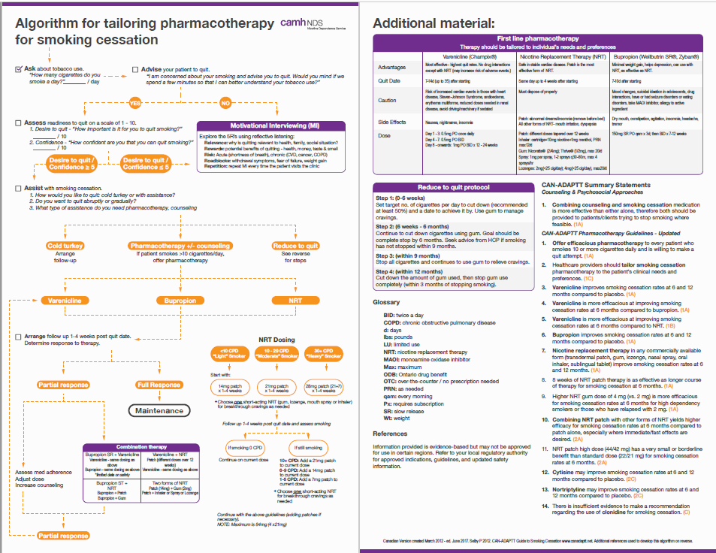

## Supplement 3: Guide to Using Nicotine Replacement Therapy (NRT) Products: STOP Program

**Nicotine Patch (21mg/14mg/7mg):**

* Apply to clean, dry, and non-hairy area of the upper body
* Can secure with medical tape, sock, or an armband
* Wear for 24 hours
* Side effects:
* Localized irritation
  + Remove the entire residual adhesive when removing the patch.
  + Move the patch around to minimize irritation.
  + Use steroid spray before applying the patch if necessary. Can use an over the counter hydrocortisone cream after patch is removed, if necessary.
* Sleep disturbance and vivid dreams (due to presence of nicotine in body overnight)
  + If combination therapy, take the patch off at night. In the morning, put the patch on and use a short acting NRT (gum, lozenge, or inhaler) for the first 30 minutes to control the withdrawal symptoms until the patch kicks in.

OR

* + If no combination therapy, take the patch off at night and set 2 alarm clocks 30 minutes apart. When the first one rings, put the patch on and go back to sleep. By the time the second alarm rings 30 minutes later, the patch would be effective.

**Nicotine Gum (2mg):**

* Works by buccal absorption
* Use the Chew, Chew, Park strategy:
  + Park for 30 seconds adjacent to gums
  + Repeat and move to different gum location (to minimize localized irritation)
  + Effective for 20-30 minutes
* Do not consume acidic drinks/foods, such as alcohol and coffee (wait 15 minutes to use gum)
  + Alters absorption and reduces effectiveness of the gum

**Nicotine Lozenge (2mg):**

* Works by buccal absorption
* Rest the lozenge adjacent to gums, move occasionally (to minimize localized irritation)
  + Effective for 20-30 minutes
* Do not consume acidic drinks/foods, such as alcohol and coffee (wait 15 minutes to use gum)
  + Alters absorption and reduces effectiveness of the gum

**Nicotine Inhaler (10mg, 4mg of nicotine delivered):**

* Do not inhale deeply (takes practice), works by buccal absorption
* How to open/fill/close:
  + Line up etch marks to open and close
  + Insert Cartridge and puncture seal
* Nicotine will be depleted from cartridge in 24 hours even if not used
* Cartridge lasts for 20 minutes of continuous usage

**Nicotine Mouth Spray (150mg, 1mg/spray):**

* Works by buccal absorption
* How to use:
  + Using your thumb, slide down the black button until it can be pushed slightly inward
  + While pushing in, slide upward to unlock the top of the dispenser and release button
  + Must be primed before the first use or if not used for more than 2 days
  + Point the nozzle as close to your mouth as possible, spray into the mouth while avoiding lips
  + Close mouth and do not swallow for a few seconds after spraying
  + Do not inhale while spraying
  + Close the spray after each use
* Use one spray first, a second one if craving does not disappear after a few minutes
* Typically, use 1-2 sprays every half hour. Maximum dose is two sprays at a time.
* May use up to 4 spray per hour, but do not exceed 64 sprays in a 24 hour period
* Do not eat/drink 15 minutes before and after using the nicotine mouth spray

**Links to TEACH Nicotine Replacement Therapy (NRT) Instructional Videos:**

* Nicotine Patch: <https://www.youtube.com/watch?v=uCbH1-qi7eA>
* Nicotine Gum: <https://www.youtube.com/watch?v=MAFuka7li68>
* Nicotine Lozenge: <https://www.youtube.com/watch?v=Tol4jhlNgxk>
* Nicotine Inhaler: <https://www.youtube.com/watch?v=UIyInRGafqs>
* Nicotine Mouth Spray: <https://www.youtube.com/watch?v=_DJSoXQNlfI>

**Tobacco/nicotine cessation/reduction and caffeine consumption:**

* Please note: nicotine makes the body to break down caffeine faster. So, when someone quits or reduces their use of tobacco/nicotine product(s), their body does not break down caffeine as much. Therefore, caffeine consumption should be reduced to avoid potential for caffeine toxicity. Symptoms of caffeine toxicity include anxiety and fidgeting, which are similar to nicotine withdrawal symptoms. Therefore, caffeine toxicity symptoms can be mistaken for nicotine withdrawal and may seem as if the NRT is not working. Please ensure that this information is discussed with the participant and appropriate suggestions with respect to their caffeine intake are communicated.