STOP/INTREPID Teleconference: Wednesday, August 6, 2025 @ 1-2 PM EST.
General meeting link

Next Teleconference: Wednesday, September 3rd, 2025 @ 1-2 PM EST

Teleconference Summary (details below):
- Updated URLs – Any bookmarks with the old nicotinedependenceclinic URL should be updated as they are no longer getting redirected. For any questions, please email us.
- Foundational Health Educator Workshop - The TEACH Project is excited to offer our in-person Foundational Health Educator Workshop at CAMH in Toronto. Check out the website for more details!
- NEW! STOP Drop-in Session – Optional 1hr session will be held on Wednesday, August 13th by the STOP team for operational support.
- STOP Implementer Resources – Let’s chat about existing resources on the Intrepid Lab website and how to organize the resources to help you best.
- Clinical Q&A with Dr. Peter Selby – We will be hosting a clinical Q&A with Dr. Peter Selby at our next teleconference, mark your calendars and bring all your questions!
- INTREPID Lab is now on BlueSky, follow us today https://bsky.app/profile/intrepidlab.ca or @intrepidlab.ca

Land Acknowledgment:
- Identify the land you are joining us from today (https://www.whose.land/en/)

Review of STOP Portal Accounts:
- The STOP team is continually reviewing its STOP Portal security protocols. To this end, we are requesting that personal/non-organizational emails (e.g., gmail, yahoo, hotmail) used to access the STOP Portal be avoided.
  - If you have a work email that you may use to access the STOP Portal instead, let us know so we can update your account.
  - If you provided a personal email due to your workplace blocking notifications from STOP.Program@camh.ca, please let us know/speak to your organization’s IT department.
  - If you don’t have an organizational email at your clinic or agency, please contact us. In these cases, we will need to make alternate arrangements (e.g., quarterly communications to verify your account).

Updated URLs:
- Please note that ‘nicotinedependenceservices’ URLs no longer redirect to our new webpage. Please update your bookmarks to https://intrepidlab.ca/en.

Foundational Health Educator Workshop:
The TEACH Project is excited to offer our in-person Foundational Health Educator Workshop at CAMH in Toronto. A key step toward challenging the Certified Tobacco Educator (CTE) and Certified Respiratory Educator (CRE) exams, recognized by the Canadian Network for Respiratory Care. Check out the flyer below for more details!

Why attend?
- Strengthen your expertise in health promotion and education
- Gain hands-on experience with educational tools and resources
- Network with like-minded professionals in the field
- Complete course requirements for the CTE or CRE exam!

Who can attend? Open to all learners – spots are limited!
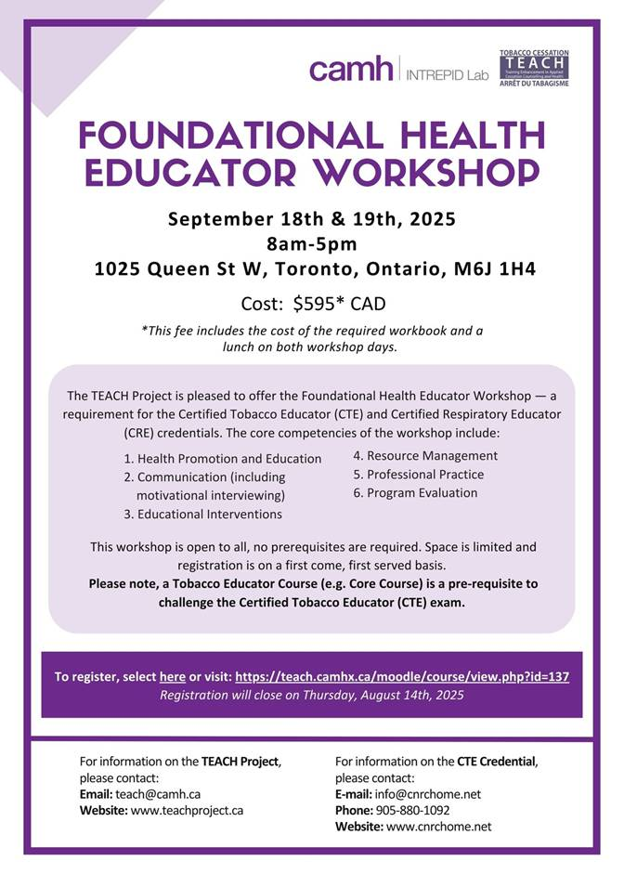
Don’t miss out on this chance to advance your career and make a lasting impact in the health educator community.

Q: Where can we find hotel information?
A: While hotel is not covered with the course fees, please reach out to teach@camh.ca for hotel recommendations nearby, as well as any other questions.

STOP Implementer Resources – Discussion and Whiteboard Activity:
Using Webex’s whiteboard feature, we asked practitioners to provide their feedback on the existing implementer and patient resources on the INTREPID Lab website.

The pages that were looked at were:
- https://intrepidlab.ca/en/stop/implementer-resources
- https://intrepidlab.ca/en/resources-for-providers
- https://intrepidlab.ca/en/Pages/Patients-Caregivers-alternate.aspx

Comments/suggestions were as follows:
- Practitioners access these resources regularly and share with their clients
  - Those who were unaware of these resources indicated they would benefit from reminders
- Strong preference for all resources to be added directly to the STOP Portal
- Request for STOP to highlight specific resources and share with practitioners before any final decisions be made about removing/changing them

Thank you for everyone’s participation and patience as we navigated the Webex whiteboard! We still encourage feedback from anyone that was not in attendance.

Q&A:
Q: Can the Patient Resources from the INTREPID Lab website be added directly to the STOP Portal?
A: We are looking into whether this is feasible but for now, please continue to access them through the INTREPID Lab website.

Q: Can the general public (e.g., non-STOP clients) use the resources on the INTREPID Lab website?
A: Yes, all resources on the website are available to the public.

Q: Where can we find information on how to use the NRT products? Are there any demos, one-pagers, etc.?
A: We are working on creating some new demo videos that will be accessible through the Patient Dashboard and available to practitioners.

Q: If we are unable to assist clients in vaping cessation, can we refer them elsewhere?
A: Yes, you can refer them elsewhere. We do not have specific sites/programs available for vaping referrals, but if the client is in Toronto, they can be referred to CAMH. If clients are 21 years old and under, please refer them to Youth-VAST.

News:
- The Thriving Minds Hub has launched!

CAMH, SickKids and GH-CCMH launches Thriving Minds, a one-stop online information hub to navigate youth mental health services | CAMH

- Updated Cancer and Palliative Care Resources from Ontario Health
  - Refreshed educational resources to support culturally safe cancer prevention, screening, and palliative and end-of-life care for First Nations, Inuit, Métis and urban Indigenous communities
  - Resources were developed in collaboration with Indigenous partners and organizations to ensure they are culturally appropriate, relevant and responsive to community needs
    - These include cancer screening resources, palliative care fact sheets, youth vaping and cannabis posters, and more

Clinical Q&A with Dr. Peter Selby

- Dr. Selby will be hosting a Q&A session during our next teleconference (Wednesday, September 3rd) – please come prepared with your clinical questions!

NEW! STOP Drop-in Support Session

The STOP Team will host a 1hr support session monthly for practitioners needing assistance with the STOP Portal or other operational issues.

Next session: Wednesday, August 13 from 10 a.m. to 11 a.m.
Click here for link to join

Anyone is welcome and no question too small to answer!

2025 teleconference schedule:
​January 8*  *Changed due to New Year’s Day | ​February 5 | ​March 5 | ​April 2
​May 7 | ​June 4 | ​July 2 | ​August 6
​September 3 | ​October 1 | ​November 5 | ​December 3

STOP on the Net participant quote:
“I am currently on day 7 of my quit smoking journey and just wanted to say thank you for the patches and the gum. They have been a massive help during this time. I feel like I will be successful with this and just wanted to send a grateful thank you!”

Attendance:
360 Degrees NPLC
Algonquin FHT
Anishnawbe Muskiki AHAC
Arnprior and District FHT
Athens FHT
Black Creek CHC
Bridgepoint FHT
Burlington FHT
Byward FHT
Carepoint CHC
Caroline FHT
Central Brampton FHT
Clinton FHT
CMHA Algoma
CMHA Durham
CMHA Huron-Perth
CMHA Toronto
De dwa da dehs nyes AHAC
Durham CHC
Durham Regional Health
Fort William FHT
Georgian Bay FHT
Group Health Centre
Guelph FHT
Haldimand FHT
Hamilton FHT
Health for All FHT
KFL&A PHU
Kingston CHC
Leeds and Grenville FHT
Niagara North FHT
North Bay NPLC
North Durham FHT
North Muskoka NPLC
North York FHT
Owen Sound FHT
Prime Care FHT
Quintin Warner AA
Rainbow Valley CHC
Scarborough A FHT
Stratford FHT
Summerville FHT
Sundridge Medical Centre
Taddle Creek FHT
Thunder Bay PHU
Tsi Kanonhkhwatsheri:yo
Tungasuvvingat Inuit AHAC
Univi Health Centre
Upper Canada FHT
Upper Grand FHT
Vaughan CHC
West Elgin CHC
West Nipissing CHC

