**STOP/INTREPID Teleconference**: Wednesday, July 2, 2025 @ 1-2 PM EST.

[**General meeting link**](https://camh.webex.com/camh/j.php?MTID=mc4605326350fc582c07876c20645d918)

**Next Teleconference: Wednesday, August 6th, 2025 @ 1-2 PM EST**

**Teleconference Summary (details below)**

1. **Updating Visit Forms –** Reminder that visit forms can be edited directly in the STOP portal.
2. **Review of STOP Portal Accounts –** Discussion of which emails should or should not be used.
3. **Consent to Future Studies –** Discuss with patients the potential to join or opt out of additional research studies at CAMH.
4. **Let’s Chat STOP Implementer Resources –** How do you, as a practitioner, find support? Do you find the [current website](https://intrepidlab.ca/en/stop/implementer-resources) valuable?
5. **NEW! STOP Drop-in Session –** Optional1hr session hosted monthly by STOP team for operational support.
6. INTREPID Lab is now on **BlueSky**, follow us today <https://bsky.app/profile/intrepidlab.ca> or @intrepidlab.ca

# Land Acknowledgment:

* Identify the land you are joining us from today ([**https://www.whose.land/en/**](https://www.whose.land/en/))

# STOP Program updates:

**Updating Visit Forms**

* Practitioners and Main Collaborators are now able to edit Visit Forms on the Portal
* **This feature should be used when**:
  + Correcting minor edits on visit forms (ex. accidentally entered the wrong number of NRT boxes than what was dispensed, accidentally entered wrong number of weeks dispensed, input wrong lot numbers, correcting date of visit)
* **For other scenarios:** please continue to contact the STOP team (ex. Beyond 26 weeks contact [stop.program@camh.ca](mailto:stop.program@camh.ca))

Sample screenshot & steps to edit visit form:

1. Click “Open” to open the visit form.
2. Make minor edits only – all edits are tracked in an audit trail.
3. Click “Finish & Submit” once you’re done!

**Review of STOP Portal Accounts**

* The STOP team is continually reviewing its STOP Portal security protocols. To this end, we are requesting that personal/non-organizational emails (ex., gmail, yahoo, hotmail) used to access the STOP Portal be avoided.
  + If you have a work email that you may use to access the STOP Portal instead, let us know so we can update your account.
  + If you provided a personal email due to your workplace blocking notifications from STOP.Program@camh.ca, please let us know/speak to your organization’s IT department.
  + If you don’t have an organizational email at your clinic or agency, please contact us. In these cases, we will need to make alternate arrangements (e.g., quarterly communications to verify your account).

**Q: What if our organization uses Gmail, Yahoo, Hotmail, etc. as our organizational email? What if certain sites do not have organizational emails?**

A: The main goal of reviewing emails linked to the STOP Portal is to decrease privacy risks. Practitioners who use personal emails to log into the Portal can potentially access patient information even when they leave their organization, which we want to avoid. As long as practitioners’ email accounts are deleted once they leave the organization, there should be no issues. If your site does not provide organizational emails, please reach out to the STOP team.

**Consent to Future Research Studies**

* During enrollment, when asking patients if they can be contacted for future research studies, **please explain what this entails** (ex., additional opportunities to quit, free NRT, behavioural support)
  + 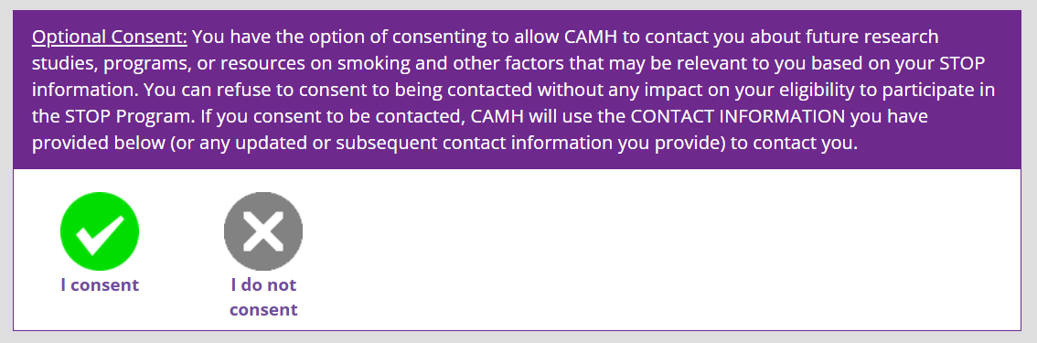We want to ensure that their interest is captured correctly and that we are reaching out to patients who understand what they have opted into.
* Active research projects at INTREPID Lab can be found on [our website](https://intrepidlab.ca/en/Pages/Patient-Research.aspx).

Portal Q&A:

**Q: If someone created a STOP Portal account years ago, will they have to use a new email to enroll now?**

A: Patients should be able to self-enroll; the system will only block it if they have an existing/active enrollment. Practitioner accounts that have been inactive for over a year are deleted automatically.

**Q: Does the Portal prompt practitioners to complete a patient’s visit form after they self-enroll? Are non-clinical staff allowed to fill out these visit forms?**

A: The self-enroll feature allows patients to fill out registration/baseline on their own, but they must connect with practitioners in the clinic to receive NRT. Non-clinicians can support in an administrative capacity, but it must be clinicians who dispense the NRT to patients.

**Q: Do practitioners have access to patients’ previous enrollments?**

A: If the patient was enrolled in a different organization, practitioners will not have access to that information as STOP sites are each considered separate entities. If the patient enrolled at your site, their previous enrollments are accessible (August 2022 onwards).

**NEW!** **STOP Drop-in Support Session**

The STOP Team will host a 1hr support session monthly for practitioners needing assistance with the STOP Portal or other operational issues.

First session: **Wednesday, July 16 from 10 a.m. to 11 a.m.**

[**Click here for link to join**](https://urldefense.com/v3/__https:/camh.webex.com/camh/j.php?MTID=m7777f5d7ea99cdebed07f10abca78813__;!!FxkXuJIC!e6kCVriAM-p1ktOMqbarvne1wRZnRIhVOTO998KZDyCJVK4cjKRfoYDIE-WOWPKTkEfTbL21X0cYXM6BNA8qLg$)

*Invite will be shared for those who are interested.*

*Anyone is welcome and no question too small to answer!*

**TEACH Course on treating youth vaping**

TEACH is currently offering a cost-free course focused on how to support youth who vape.

The next cohort will take place from **Aug 4-Aug 29**; each course is 4-weeks in length and is self-study.

**NOTE**: July registration is now closed, but **August registration remains OPEN**.

**Q: Was this the same TEACH vaping course that was offered last year?**

A: No, the vaping course offered last year focused on adults. This new course provides additional information on vaping cessation for youth populations, but there may be some overlap.

**Q: Who should we email to register for the course?**

A: Please email [TEACH@camh.ca](mailto:TEACH@camh.ca) to register.

General Q&A:

**Q: Where can practitioners find the booklets that patients can use to track their quitting progress?**

A: CAMH's “My Change Plan” booklet is available [here](https://intrepidlab.ca/en/teach/Documents/My%20Change%20Plan%20Edition%208.pdf). The Canadian Cancer Society may also have their own version – practitioners can email [info@cancer.ca](mailto:info@cancer.ca) for their booklets.

**Q: Is Pregnets the best website for pregnant smokers? Where can we find an algorithm for NRT use for pregnant/breastfeeding patients?**

A: Yes, Pregnets has resources for pregnant smokers, as well as those that are post-partum. There is also an algorithm on [CAN-ADAPTT](https://intrepidlab.ca/en/canadaptt/PublishingImages/Pages/CAN-ADAPTT-Guidelines/Pregnant%20and%20Breastfeeding%20Women.pdf).

# 2025 teleconference schedule:

|  |  |  |  |
| --- | --- | --- | --- |
| ​January 8*  *Changed due to New Year’s Day | ​February 5 | ​March 5 | ​April 2 |
| ​May 7 | ​June 4 | ​July 2 | ​August 6 |
| ​September 3 | ​October 1 | ​November 5 | ​December 3 |

STOP on the Net participant quote:

*“Thank you for inviting me to do your survey. I’m happy to say that the program was successful for me. I have not smoked for six and one half months. The cravings are rare and the lozenges help with that. I have no intention of going back smoking, I know a freedom now that I could not even comprehend before.*

*Thank you for all your help, could not have done it without !”*

Attendance:

360 Degrees NPLC

Algoma PHU

Algonquin FHT

Almaguin Highlands FHT

Anishnawbe Muskiki AHAC

Arnprior and District FHT

Atikokan FHT

Bancroft FHT

Black Creek CHC

Blue Sky FHT

Bridgepoint FHT

Burlington FHT

Carepoint CHC

Carlo Fidani RCC

Caroline FHT

Central Brampton FHT

Chatham Kent FHT

City Centre CHC

City of Kawartha Lakes FHT

Clinton FHT

CMHA Algoma

CMHA Durham

CMHA Huron-Perth

CMHA Toronto

De dwa da dehs nyes AHAC

Durham Regional Health

Fort William FHT

Georgian Bay FHT

Grandview Medical Centre

Group Health Centre

Guelph FHT

Haldimand FHT

Hamilton PHU

Hastings Prince Edward

Health for All FHT

Huronia NPLC

Inner City FHT

Inner City Health Associates

KFL&A PHU

Kingston CHC

Kirkland District FHT

Leeds and Grenville FHT

Leeds and Grenville PHU

London FHT

Lower Outaouais FHT

Mackay Manor AA

Matawa First Nations

Niagara North FHT

North Bay NPLC

North Durham FHT

North Lambton CHC

North Muskoka NPLC

North Western PHU

PAARC AA

Queen Square FHT

Rama First Nations

Sandy Hill CHC

Scarborough A FHT

Scarborough Centre CHC

Seaway Valley CHC

South Georgian Bay CHC

Southwestern PHU

Stratford FHT

Summerville FHT

Sundridge Medical Centre

St Michael’s Homes

Taddle Creek FHT

Thunder Bay PHU

Two Rivers FHT

Univi Health Centre

Upper Canada FHT

Vaughan CHC

Vitanova Foundation

Wabano AHAC

Whitewater Bromley CHC