**STOP/INTREPID Teleconference**: Wednesday, May 7, 2025 @ 1-2 PM EST.

[**General meeting link**](https://camh.webex.com/camh/j.php?MTID=mc4605326350fc582c07876c20645d918)

**Next Teleconference: Wednesday, June 4, 2025 @ 1-2 PM EST.**

**Teleconference Summary**

1. **988– Canada’s Suicide Crisis Helpline –** 988 provided an overview of the helpline model, the network partners, and how to help promote the crisis line. See attached PDF presentation. For more information, please email [sari.paje@camh.ca](mailto:sari.paje@camh.ca).
   * *A recording of this presentation can be found* [***here***](https://urldefense.com/v3/__https:/camh.webex.com/camh/ldr.php?RCID=4235ded38fe2b793e3f2df8f2ac53d70__;!!FxkXuJIC!cd52HmSI1-NaQjEh2gVdFOuLisqdO_S4suhkZfI5BADRknlM48Xugv0GGinELRowk5DalXJ1-BM8YfmT0CQqnA$) *(password: QyTRAvF8)*
2. **STOP Unified Access Portal Updates** – The STOP team demonstrated some of the upcoming changes that will be implemented on the STOP portal to streamline self-enrollment and improve user experience.
3. INTREPID Lab is now on BlueSky, follow us today @IntrepidLab.ca

# Land Acknowledgment:

* Identify the land you are joining us from today ([**https://www.whose.land/en/**](https://www.whose.land/en/))

# STOP Program updates:

**Updates to the STOP Portal Login process for Patients**

* We are streamlining the Portal login process for participants from STOP and STOP on the Net as well as program implementers. The goal is to improve self-enrollment capabilities for clients to make appointment times more efficient.
* **Expected Launch Date:** Evening of Friday, May 16, 2025
* **The self-enroll link for STOP patients will continue to be** [www.joinstopprogram.ca](http://www.joinstopprogram.ca).
* **What to expect:**
  + **Simple Login:** Existing users (practitioner or client) can log in with a username and password on the homepage. Password field will show up once you hit “Enroll/Login.”

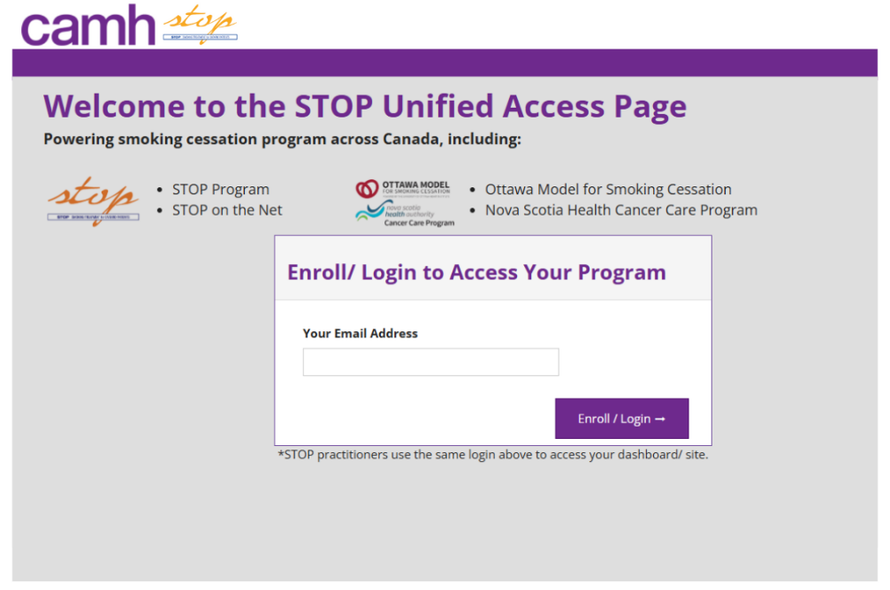

**Figure 1.** Updated STOP Portal Login to take in effect on the evening of Friday, May 16, 2025.

* + **Easier Enrollment for participants:** Users are automatically directed to the right program and site based on the link they use (i.e. self-enrollment for STOP and STOP on the Net) and their email.

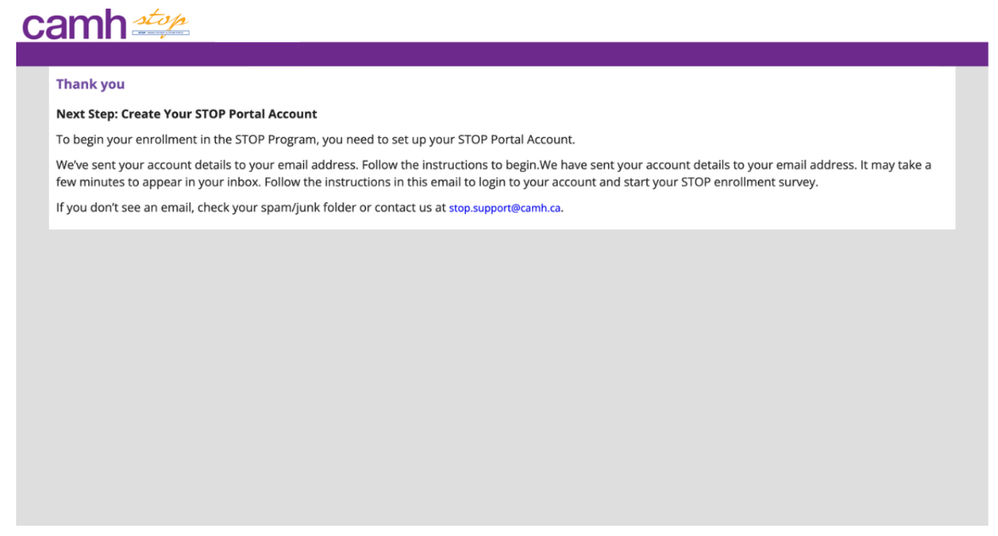

**Figure 2.** Pop-up message if a new client attempts to self-enroll in the STOP program. User will be directed to their email to create a STOP portal account. Once the account is set up, client will automatically be directed to STOP registration survey.

* **STOP on the Net Patient Dashboard:** For STOP on the Net users, there is a new option to view their Portal account to access helpful resources and program details, including links to demonstration videos on each of the NRT types

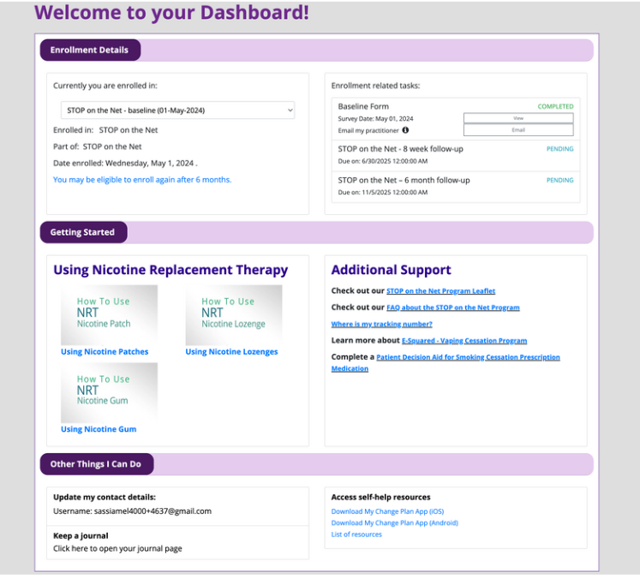

**Figure 3.** (NEW!) STOP on the Net Patient dashboard for eligible participants to access additional resources (videos on how to use NRT, other available programs, My Change Plan App) to support them on their quit journey.

Portal Changes Q&A:

**Q: Will the self-enroll link be the same or is there a new link we should send clients?**

A: Yes, it is the same link for client self-enrollment.

**Q: Will we be forced to type in a password every time we use the Unified Access page?**

A: This depends on your browser. If your browser allows password saving, then it should automatically populate (if it has already been saved).

**Q: Can you please provide more detail about the OMSC Program and the STOP Portal?**

A: The STOP Program assists Ottawa Heart in fulfilling kit orders for their Ottawa Model Program. These data are not linked to the STOP Program in any way.

**Q: Will this update allow clients to sign up/complete questionnaires on their cell phones, instead of only through tablets/computers like before?**

A: Self-enrollment for the STOP Program has always been available on mobile.

988 Presentation Q&A:

**Q: Do you have access to interpreters?**

A: Yes, 988 has access to interpreters as needed and they are available for over 200 languages.

**Q: The website currently states that orders for 988 promotional items are paused. When will this be resolved?**

A: 988 is in the process of updating their ordering system. Please email [sari.paje@camh.ca](mailto:sari.paje@camh.ca) regarding orders and they will send an update whenever the system is back.

**Q: Can you present 988 at FHT internal meetings?**

A: Please reach out to [sari.page@camh.ca](mailto:sari.page@camh.ca) and this can be coordinated.

*A recording of this presentation can be found* [***here***](https://urldefense.com/v3/__https:/camh.webex.com/camh/ldr.php?RCID=4235ded38fe2b793e3f2df8f2ac53d70__;!!FxkXuJIC!cd52HmSI1-NaQjEh2gVdFOuLisqdO_S4suhkZfI5BADRknlM48Xugv0GGinELRowk5DalXJ1-BM8YfmT0CQqnA$) *(password: QyTRAvF8). Full transcript can be accessed by clicking the middle icon in the top right corner of the screen.*

General Q&A:

**Q: Do you have a one-pager outlining the three different kit types for STOP on the Net?**

*A:* At this time, we do not have a one-pager with the kit types. However, we shared a slide during the February teleconference that includes that information. Please see below.

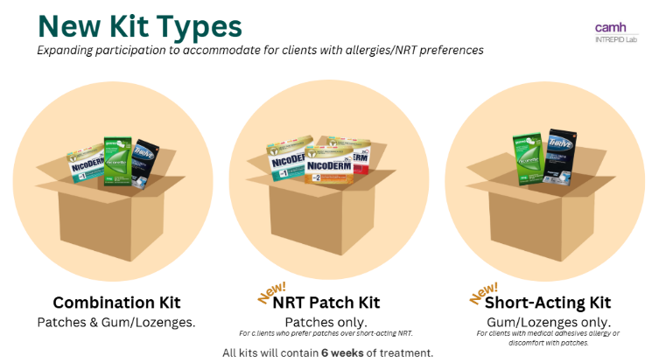

**Q: Can we dispose of NRT at our onsite pharmacy? Which email should we send the lot numbers/expiry/product quantities to?**

A: Yes, if you can safely dispose of NRT at your location or a local pharmacy, please do so. You will need to do an inventory adjustment to remove the NRT from your online stock. Please include the lot #s in the comment field of the adjustment. No need to send STOP a separate email.

**Q: Are we able to return soon-to-expire NRT to STOP so it can be used?**

A: We unfortunately cannot accept or use NRT that has been sent out to external organizations.

**Q: Since nicotine spray has trace amounts of alcohol, is there a risk for those with alcohol use disorders to use it for smoking cessation?**

A: From our clinician scientist at the INTREPID Lab, the only reason not to use the spray is if the person is on disulfiram or Antabuse.

News:

[***Financial Coverage of Smoking Cessation Medications in Canada***](https://urldefense.com/v3/__https:/www.partnershipagainstcancer.ca/topics/coverage-smoking-cessation-aids-canada/__;!!FxkXuJIC!c1WadjQrd06q8Y8W0qUYvMISkHlk_K2XJAHvaOTtCW-YXTaCDjri9iJgVWd_UBWFgkA8Gn59pmyNzYuJ8fv5nyFWQqaJZhA04ZFJIC2eKajq$)

The Canadian Partnership Against Cancer is pleased to announce the publication of [*Financial coverage of smoking cessation medications in Canada, 2024*](https://urldefense.com/v3/__https:/www.partnershipagainstcancer.ca/topics/coverage-smoking-cessation-aids-canada/__;!!FxkXuJIC!c1WadjQrd06q8Y8W0qUYvMISkHlk_K2XJAHvaOTtCW-YXTaCDjri9iJgVWd_UBWFgkA8Gn59pmyNzYuJ8fv5nyFWQqaJZhA04ZFJIC2eKajq$). This updated resource, now in digital format, summarizes the publicly funded programs that provide financial coverage of smoking cessation medications in Canada. Coverage and access to smoking cessation medications have improved, particularly for people with cancer, since the last update of the resource in 2021.

# 2025 teleconference schedule:

|  |  |  |  |
| --- | --- | --- | --- |
| ​January 8*  *Changed due to New Year’s Day | ​February 5 | ​March 5 | ​April 2 |
| ​May 7 | ​June 4 | ​July 2 | ​August 6 |
| ​September 3 | ​October 1 | ​November 5 | ​December 3 |

STOP participant quote:

*“Just wanted to let you guys know how much me and my wife appreciate your program. We both wanted to quit for multiple reasons, the main being our first son. If it weren’t for the program I'd still be smoking. It was cheaper to smoke than to quit. Especially after being laid off because of these tariffs. So thank you so much for the help.”*

Attendance:

360 Degrees NPLC

Access Alliance CHC

Almaguin Highlands FHT

Athens FHT

Barrie and Community FHT

Black Creek CHC

Blue Sky FHT

Bramalea CHC

Brant County CHC

Capreol NPLC

Central Brampton FHT

Central CHC

Centre of Hope

Centretown CHC

CHIRS

City Centre CHC

City of Lakes FHT

Clinton FHT

CMHA Algoma

CMHA Durham

CMHA Huron Perth

CMHA London

CMHA Ottawa

CMHA Toronto

Cummer Lodge

De dwa da dehs nyes AHAC

Dufferin Area FHT

Durham CHC

Eastern Ontario PHU

Elm Grove Living Centre

Espanola FHT

Fort Frances FHT

Fort William FHT

Georgina NPLC

Grandview Medical Centre

Guelph FHT

Hamilton FHT

Hamilton PHU

Health for All FHT

Inner City FHT

Inner City Health Associates

Kawartha Lakes CHC

KFL&A PHU

Kingston CHC

Kirkland District FHT

Leeds and Grenville PHU

London FHT

Lower Outaouais FHT

Maitland Valley FHT

Napanee CHC

North Bay NPLC

North Durham FHT

North Huron FHT

North Lambton CHC

North Muskoka NPLC

North York FHT

North Western PHU

Owen Sound FHT

PAARC AA

Parkdale CHC

Rainbow Valley CHC

Rideau CHC

Sauble FHT

Scarborough A FHT

Seaway Valley CHC

Sharbot Lake FHT

Southwestern Ontario AHAC

Stonegate CHC

Summerville FHT

Superior FHT

Stratford FHT

St. Mary’s Hospital

St Michael’s Homes

Taddle Creek FHT

Thunder Bay PHU

Two Rivers FHT

Upper Canada FHT

Wellington Terrace LTC

West Main Pharmacy