STOP/INTREPID Teleconference: Wednesday, March 4, 2025 @ 1-2 PM EST
General meeting link

Next Teleconference: Wednesday, April 1, 2026 @ 1-2 PM EST

Teleconference Summary (details below)
- STOP Program Updates – last call for SOTN-PHU invoices, updated security measures, inhaler supplies, and changes to intake assessment.
- TEACH Updates – upcoming TEACH Educational Rounds on motivational interviewing and vaping.
- MC-NRT Study
- Smoke Break Webinar: Practical Strategies to Improve the Health of 2S/LGBTQIA+ People Who Smoke – Tuesday, March 17th 11:30am-12:45pm
- Upcoming – STOP Drop-In Session Wednesday, March 11th 10-11am
Land Acknowledgement:
- Identify the land you are joining us from today (https://www.whose.land/en/)

STOP Program Updates

Inhaler Supply Update
- We are continuing to experience a delay in receiving Nicorette Inhalers from our manufacturer.
- As such, you may have noticed some reductions in the number of inhalers being shipped, so that we are able to provide all of our STOP Partners with enough product. Our apologies for the inconvenience.

STOP Portal Updates

Portal Security
- To keep aligned with best practices for data security, we will be upgrading STOP Portal security in the coming months to ensure data remains protected and secure. Things we’ve instituted or are considering:
  - Portal accounts are now locked after 3 months of inactivity
  - Accounts deleted after 18 months of inactivity
  - More frequent communication between sites and STOP staff
  - Regular reviews/audits of access (for example if implementers don’t use an organizational email)
  - Adding multifactor authentication
- In the meantime, please keep the following in mind:
  - Connect with the STOP team whenever there are staffing changes, so we can delete inactive Portal accounts.

Q: Currently, STOP Portal accounts are deleted after 18 months of inactivity. Can this timespan be increased?
A: No. Security measures such as this are reviewed by the CAMH security team and are based on best practices for healthcare data. STOP can easily recreate accounts when providers return from extended/parental leave.

User Experience/Interface Changes
- Some minor updates were made to the STOP Portal and should be now noticeable, including:
  - Added an “eye” functionality on password field so users can see what they are typing
  - Progress indicators (i.e. a loading bar or circle) will be more visible and similar
  - Widget on Feedback Report is removed. Now users will automatically download the report into the format selected
  - First row and column on the inventory log pages are frozen
  - Tables will show which column values are sorted by
  - Validation added for NRT orders to prevent ‘negative orders’

Intake Assessment Changes
- In the upcoming weeks, there will be some changes to our intake assessment. Included in some of these changes are removing the following:
- Cannabis questions (except for the past 30 days of cannabis use)
- Lifetime use of e-cigarettes
- Questions on exercise and fruits and vegetable use
- Income and marital status
- Immigration status
- Transportation and referral question
- Additional questions will be removed for SOTN (i.e. co-morbities and PHQ 1&2)
- The Pathway showing assisted guidance and the self-monitoring tracking sheet will be removed. Resources for risk factors will remain on the portal resources drop-down.

Q: When will the PDF versions of the updated intake forms be available?
A: These will be available for download on the STOP Portal when the online questionnaires are updated. STOP will also send reminder emails with the PDFs attached.

TEACH Updates

Guiding Change: Using Motivational Interviewing to Address Vaping
Wednesday, March 11th 12pm to 1pm ET

This month’s TEACH Educational Rounds will be presented by Rosa Dragonetti and will feature principles of Motivational Interviewing (MI) and their relevance to vaping cessation, how MI can be used to assess readiness and facilitate collaboration on cessation strategies, and how various MI skills (e.g., OARS, change talk) can be used in conversations about vaping.

Register here: https://redcap.link/Mar2026TERReg.
Registration closes Tuesday, March 10th at 11:59pm ET.

Q: Will this webinar be recorded?
A: Yes, all of the TEACH Educational Rounds are recorded and uploaded onto the INTREPID Lab Youtube channel.

MC-NRT Study
What is the study about?
The goal of the MC-NRT Study is to investigate how quitting in a specific menstrual cycle phase (follicular or luteal) can affect the success of the quit attempt. Research shows that it is harder for women to quit smoking compared to men, and the study aims to find a solution to this problem.
Eligibility:
- Individuals aged 18-40 with a regular menstrual cycle, currently not on hormonal birth control;
- Willing to quit within 15-60 days from enrollment on one of the dates selected by the study team (we are timing quit dates to a menstrual cycle phase) and have access to Internet.
Interested in further promotion?
- If you are interested in receiving free promotional materials for your clinic/office waiting room or require additional information, please email MCNRT.study@camh.ca.

Smoke Break Webinar: Practical Strategies to Improve the Health of 2S/LGBTQIA+ People Who Smoke
Tuesday, March 17th from 11:30am to 12:45pm

Composed of a presentation, panel discussion, and Q&A, this webinar will provide attendees with practical harm reduction strategies to meet 2SLGBTQIA+ folks where they are at in their quit smoking journeys.

This webinar will:
- Explore the interconnections between stress, violence, trauma, and smoking/vaping
- Deepen understanding of why traditional smoking cessation approaches don’t work for many 2S/LGBTQIA+ people
- Gain practical strategies for trauma-informed and non-judgmental 2S/LGBTQIA+ care
- Learn about the benefits of a harm reduction approach and how to apply it
- Get information about the Smoke Break program and how to refer your 2S/LGBTQIA+ clients

Register here: https://smokebreak.cbrcevents.net/access/start/.

News

Are cigarettes cool again?; Matt Galloway (CBC’s The Current) discusses ‘cig-fluencers,’ cigarettes in pop culture, and what it may mean for smoking rates

- Galloway shares his conversations with Calgary-based social media manager, Jared Oviatt – the owner of Instagram account @cigfluencers, where he reposts photos of celebrities smoking – and Grace Kong, associate professor in the Department of Psychology at Yale
  - Jared describes the cigfluencers page as “a mood board, a collection, if you will, of hot people smoking cigarettes,” and comments that the appeal to young people is that it makes smoking look ‘chic’ and normalizes it among the famous figures they admire
  - Grace acknowledges that smoking rates among young people are at a historic low, suggesting that though smoking is becoming prevalent in pop culture, it is not translating into real-life behaviours; however, since tobacco use trends can abruptly change, the ‘positive’ portrayal of smoking may indeed influence youth to smoke more, on a more subtle, cognitive level
- Transcript available here: https://www.cbc.ca/radio/thecurrent/thursday-february-26-2026-episode-transcript-9.7107493

B.C. to adopt permanent daylight saving time, after springing forward one more time

- British Columbia is adopting year-round daylight saving time and clocks will spring forward by one hour for the last time on Sunday, March 8th
  - For four months of the year (November to March), B.C.’s new time will match Alberta and the parts of B.C. on Mountain Time and remain one hour ahead of their neighbours south (Washington, Oregon, California)
- Though BC was initially waiting for American states in the west to get on board with this change, Premier David Edy believes it is now time for BC to do what works best for them
- He comments on the motivations behind this new policy, including the goal to limit disruptions and schedule changes caused by the time change, as well as ensuring stable, predictable schedules for everyone year-round

Fun Poll
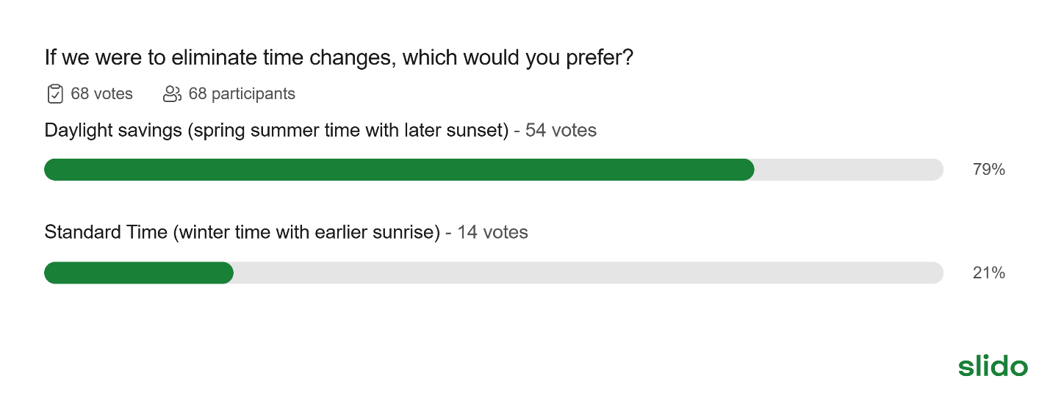

STOP Drop-in Support Session

The STOP Team will host a 1hr support session monthly for practitioners needing assistance with the STOP Portal or other operational issues.

First session: Wednesday, March 11th, from 10 a.m. to 11 a.m.
Click here for link to join

Anyone is welcome and no question too small to answer!

2026 teleconference schedule:

​January 7 | ​February 4 | ​March 4 | ​April 1
​May 6 | ​June 3 | ​July 8*  changed due to Canada Day | ​August 5
​September 2 | ​October 7 | ​November 4 | ​December 2

STOP on the Net participant quote:

“This program was so very helpful I have been quit now for 16 months. 30-year plus smoker. Did patches for 12 days and then done.”

Attendance:

Athens FHT
Bancroft FHT
Bluewater Area FHT
Bramalea CHC
Bridgepoint FHT
Burlington FHT
Carepoint CHC
Caroline FHT
Central Brampton FHT
Chatham-Kent CHC
CHIRS
City of Lakes FHT
City of Kawartha Lakes FHT
Clinton FHT
CMHA Algoma
CMHA Durham
CMHA Huron Perth
CMHA Toronto
Dufferin Area FHT
Durham Regional Health
Eastern Ontario PHU
Essex County NPLC
Grand Erie PHU
Grandview Medical Centre
Group Health Centre
Guelph FHT
Haldimand FHT
Hamilton FHT
Hamilton PHU
Hamilton-Niagara CHC
Happy Valley FHT
Health for All FHT
Huronia NPLC
Kawartha Lakes CHC
Kingston CHC
Kirkland District FHT
Leeds and Grenville FHT
Leeds and Grenville PHU
Listowel Wingham FHT
London InterCHC
Loyalist FHT
Maitland Valley FHT
Middlesex-London PHU
Napanee Area CHC
North Durham FHT
North Muskoka NPLC
North York FHT
Northeastern Manitoulin FHT
Northeastern PHU
Ottawa Valley FHT
Owen Sound FHT
PAARC
Queen’s FHT
Rainbow Valley CHC
Sauble FHT
Scarborough A FHT
Seaway Valley CHC
Sherbourne Health
Smithville FHT
Somerset West CHC
South-East Ottawa CHC
Southeast PHU
South Georgian Bay CHC
Southwestern PHU
Summerville FHT
Superior FHT
Thames Valley FHT
Thunder Bay PHU
Tsi Kanonhkhwatsheri:yo
Twin Bridges NPLC
Univi Health Centre
Upper Canada FHT
Wabano AHAC
Waterloo Regional Health
West Champlain FHT
West Nipissing CHC
Windsor Essex CHC
Woodbine FHT

