STOP/INTREPID Teleconference: Wednesday, October 1, 2025 @ 1-2 PM EST.
General meeting link

Next Teleconference: Wednesday, November 5, 2025 @ 1-2 PM EST

Teleconference Summary (details below)
- Chronic Pain in STOP – INTREPID Lab’s Sabrina Voci will discuss findings from one of our published research papers.
- STOP Program Updates – New accessibility features on our website, donations of Thrive Gum, and more.
- Youth-VAST and SOTN Promotion – Discuss possible marketing strategies/suggestions with practitioners.
- STOP Drop-in Session – Optional 1hr session hosted monthly by STOP team for operational support.

Land Acknowledgement:
- Identify the land you are joining us from today (https://www.whose.land/en/)

Chronic Pain in STOP – Presentation

Voci S, Veldhuizen S, Ivanova A, Smith A, Selby P, Zawertailo L. The role of chronic pain in smoking cessation: results from a large smoking cessation program in primary care. Nicotine & Tobacco Research. 2025:ntaf145

- Chronic pain often co-occurs with tobacco dependence and people with chronic pain report more difficulty and lower confidence in quitting
- This study examined whether self-reported chronic pain diagnosis was associated with smoking cessation outcomes
- Patients in the STOP Program (enrolled between 2016 and 2019) were asked about their lifetime chronic pain diagnosis and past 30-day opioid use at enrolment, then about their 30-day smoking abstinence at 6-month follow-up
- At enrolment:
  - 35% reported a lifetime diagnosis of chronic pain by a healthcare professional; 72% current use of medication for condition
  - 37% with chronic pain diagnosis reported past 30-day opioid use; 5% without a chronic pain diagnosis
- At 6-month follow-up:
  - Chronic pain was associated with 10% reduced odds of quitting smoking at 6-month follow-up
  - Past 30-day opioid use was associated with 15% reduced odds of quitting smoking
- Both self-reported lifetime chronic pain diagnosis and past 30-day opioid use were independently associated with a modestly decreased response to NRT plus behavioural support
- Further research is needed to understand how and for whom chronic pain and opioid use impact cessation outcomes

Q: Did we look at the specific conditions that led to the clients’ chronic pain?
A: We did not have the specific conditions that led to the clients’ chronic pain available in the dataset. However, we controlled for any medical diagnoses that were available (e.g., diabetes, cancer, heart disease). In future research, it may be useful to collect more details about their chronic pain experience, as the nature of the pain condition may also have an impact on their smoking.

STOP Program Updates

Thrive Gum Distribution
- We have 3000 boxes of soon to expire Thrive Gum (exp: Feb 2026) that we’d like to donate to shelters (and other organizations). Please reach out to the STOP team if you know places that would be interested!
  - Note: they cannot be an existing STOP site

NEW Autocomplete Feature
- When completing an enrollment and entering the addresses for patients, the addresses should now have the option to autocomplete (only available on SOTN previously).
  - As you start to enter the street number and name, a drop down will appear for you to select the correct address. The remainder of the address, including postal code field will autopopulate.

INTREPID Lab Website
- A new accessibility tool has been added to the INTREPID Lab website. It can be accessed by clicking the button on the bottom left of the webpage (Figure 1). A list of its features is also available below (Figure 2). Please take a look and let us know if there are any issues.
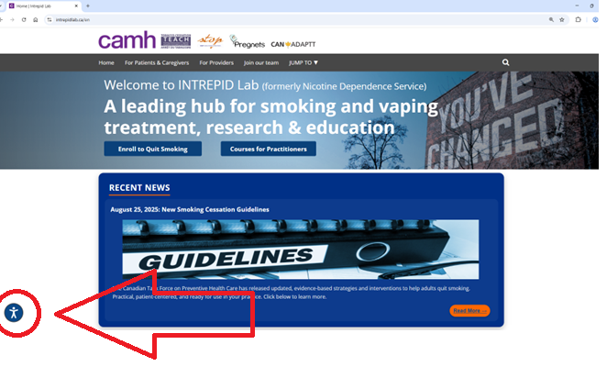

Figure 1. INTREPID Lab webpage featuring the new accessibility button (left) that provides the following features (Figure 2)

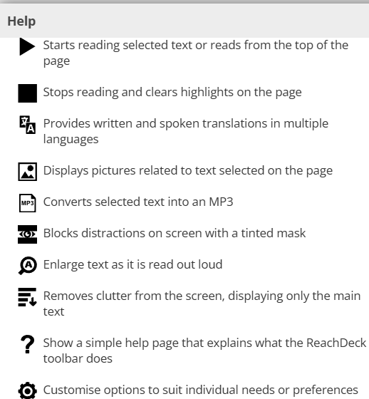

Figure 2. A list of the accessibility features available on our website.

Marketing and Promotion

Youth-VAST
- Youth-VAST offers free, confidential virtual or in-person treatments for youth in Ontario (ages 12 to 21) struggling with nicotine/vaping use, alcohol use, substance use, and/or excessive technology use
- The STOP team is open to any marketing suggestions and/or new promotional strategies!

Q: Does Youth-VAST have French-speaking staff?
A: Yes, Youth-VAST has bilingual care coaches.

Q: Can Youth-VAST use CAMH’s language interpretation services?
A: Yes, Youth-VAST does provide CAMH language interpretation services for youth. Services available upon request.

Q: Can Youth-VAST clients choose if they will receive one-on-one support or join group sessions?
A: After youth clients book their initial appointments (through the website), they will meet individually with a care coach. Based on the outcomes of this assessment, they may continue to receive one-on-one support or join group sessions.

SOTN
- With fall and winter months approaching, the STOP Team is also looking to further promote the STOP on the Net program to individuals who cannot access the onsite STOP Program.
- Please share the attached poster widely!

Q: What would prevent clients from accessing the onsite STOP Program? Should we recommend STOP on the Net (SOTN) in these scenarios?
A: There are a few circumstances that would prevent clients from accessing onsite treatment. For example, most sites do not accept non-rostered clients and/or do not enroll non-rostered clients into the STOP Program. In addition, some clients live far away from the closest STOP site and cannot travel to their appointments. In these cases, STOP on the Net is a good alternative. Note: since SOTN has no practitioner interaction, NRT use is on-label only.

Q: Can clients enroll without an email?
A: No. It requires an email, and emails cannot be shared between different clients.

Q: Is there a number that clients can call for support?
A: No direct phone number, but clients can reach out to stoponthenet@camh.ca if they have questions.

Q: Is STOP on the Net impacted by the Canada Post strike? Is pick-up still an option?
A: We’ve switched to Purolator, so there should be no disruptions. Pick-up is not an option and physical addresses are preferable.

Q: How do we order STOP on the Net posters (for promotion/distribution purposes at our site)?
A: Please email STOP.Program@camh.ca and we can arrange a shipment.

General Q&A:

Q: Is the STOP Program open to all nicotine and tobacco users (e.g., cigars, pipes)?
A: Yes, for the regular, on-site STOP Program (with practitioner interaction), anyone who is using nicotine and/or tobacco products may be eligible, as long as organization’s policies are followed for the use of off-label dispensing. For STOP on the Net and any sites using the mail-out model of the STOP Program, only cigarette users are eligible; without practitioner interaction, NRT use must be on-label.

Q: Are the registration and baseline forms in the dropdown menu of the Portal up to date?
A: Yes, these are the most updated versions. Note: due to the length of the forms, some questions might be omitted from the paper/PDF copies and only appear when completed online.

Q: Can STOP provide registration and baseline forms in languages other than English and French?
A: STOP will not be able to translate these forms into other languages for the foreseeable future. However, Google Chrome has a ‘translate page’ feature that may work on the STOP Portal. Feel free to share what languages your clients are speaking – we will keep it in mind for future developments.

Q: For STOP Program NRT shipments, will delivery time remain the same with Purolator?
A: NRT delivery to STOP partner organizations always uses Purolator. Mail-out model and SOTN traditionally use Canada Post, but switched during labour disruption. In either case, please expect the delivery time to be up to 2 weeks, especially around holiday times.

Q: Are email addresses required for STOP Program enrollment?
A: If the client is enrolling onsite with a STOP Provider, email is not required. However, if the client is self-enrolling (online), then an email is needed to complete the process.

Q: Can clients use their family member/caregiver’s email addresses for self-enrollment?
A: As long as both the client and the email user consent to this arrangement, there should be no issues. At the time of follow up (3, 6 and 12-months), the owner of the email should not answer the follow up without the client/patient present.

Q: Is pick-up available for STOP sites that use the mail-out model?
A: Pick-up is not allowed for mail-out sites. Mail-out sites can transition to an onsite model, to provide more tailored treatment to patients if they are interested.

Q: Clients who self-enroll at mail-out model STOP sites expect follow-up appointments (due to the messaging used in the self-enrollment email). How can we best address this?
A: The self-enrollment emails are the same across all STOP Program enrollments and therefore, generic language is used. Advise your clients that they will see this message and let them know beforehand that STOP follow up appointments aren’t an option at your site.

News:

How kids are getting hooked on sports betting
- On an episode of CBC’s The Current, Matt Galloway discusses sports betting and its risks with Dr. Shawn Kelly, a pediatrician and adolescent addictions specialist
- Read the editorial on CMAJ here: Protecting Canada’s youth from the risks of exposure to gambling advertising

INTREPID Lab placed second for the 2025 CAMH Education Achievement Award
- This award celebrates outstanding leadership in mental health education and this year’s theme, Healing through Partnership: Coproduction and Equity in Mental Health Education, aligns with existing initiatives and projects within the lab
- A special shout-out and thank you to the TEACH team for their continued dedication and outstanding work!

STOP Drop-in Support Session

The STOP Team will host a 1hr support session monthly for practitioners needing assistance with the STOP Portal or other operational issues.

First session: Wednesday, October 22 from 10 a.m. to 11 a.m.
Click here for link to join

Invite will be shared for those who are interested.
Anyone is welcome and no question too small to answer!

2025 teleconference schedule:

​January 8*  *Changed due to New Year’s Day | ​February 5 | ​March 5 | ​April 2
​May 7 | ​June 4 | ​July 2 | ​August 6
​September 3 | ​October 1 | ​November 5 | ​December 3

STOP Program participant quote:

“I originally set my stop smoking for Sept. 15. Just to let you know I stopped as of Sept. 6, my last cigarette was at 8:30 am. So far so good!”

Attendance:

360 Degrees NPLC
Access Alliance CHC
Algonquin FHT
Almaguin Highlands FHT
Athens FHT
Barrie FHT
Black Creek CHC
Bridgepoint FHT
Brockton and Area FHT
Carlo Fidani RCC
Central Brampton FHT
Centretown CHC
Chatham-Kent FHT
CHIRS
City of Kawartha Lakes FHT
City of Lakes FHT
CMHA Toronto
Dufferin Area FHT
Durham Regional Health
Englehart and District FHT
Espanola FHT
Fort William FHT
Georgian Bay FHT
Grand Erie PHU
Grandview Medical Centre
Great Northern FHT
Group Health Centre
Guelph FHT
Haldimand FHT
Hamilton FHT
Hamilton PHU
Happy Valley FHT
Health for All FHT
Inner City FHT
Kingston CHC
Kirkland District FHT
Leeds and Grenville FHT
Leeds and Grenville PHU
Loyalist FHT
Maitland Valley FHT
Niagara North FHT
North Bay NPLC
North Cochrane AA
North Durham FHT
North Huron FHT
North Lambton CHC
North York FHT
Owen Sound FHT
Queen Square FHT
Queens FHT
Quintin Warner AA
Rainbow Valley CHC
Sandy Hill CHC
Sauble FHT
Scarborough A FHT
Smithville FHT
South East Grey CHC
Southlake FHT
Southwestern PHU
Stratford FHT
Summerville FHT
Sundridge Medical Centre
St Michael’s Homes
Taddle Creek FHT
Témiskaming CHC
Two Rivers FHT
Univi Health Centre
Upper Canada FHT
Vaughan CHC
Waterloo Regional Health
West Champlain FHT

